

CAPSTONE PROJECT REPORT
Report 3 – Software Requirements Specification

-Ho Chi Minh City, September 2026-
Table of Contents
I. Record of Changes 3
II. Software Requirement Specification 4
1. Product Overview 4
2. User Requirements 5
2.1 Actors 5
2.2 Use Cases 7
3. Functional Requirements 18
4. Non-Functional Requirements 99
4.1 External Interfaces 99
4.2 Quality Attributes 100
5. Requirement Appendix 100
5.1 Business Rules 100
5.2 Common Requirements 105
5.3 System Messages List 106

I. Record of Changes
Date | A*  M, D | In charge | Change Description
05/07/2026 | A | NamNM | Added AI Evaluation and Feedback Management use case specifications
08/07/2026 | A | HienNT | Added Authentication use case specification
12/07/2026 | A | TuPT | Added Profile Management use case specification
15/07/2026 | A | KhoaHD | Added System Messages List
18/07/2026 | M | NamNM | Updated Knowledge Base Management requirements based on mentor feedback
22/07/2026 | A | HienNT | Added Business Rules and Common Requirements content
25/07/2026 | M | TuPT | Revised Marketplace and Practice Management workflows
29/07/2026 | A | KhoaHD | Added System Administrator functional requirements
02/08/2026 | M | NamNM | Updated RAG Evaluation Management use cases
05/08/2026 | M | HienNT | Refined Requirement Appendix content per reviewer comments
08/08/2026 | A | TuPT | Added Subscription and Payment Management use case
12/08/2026 | M | KhoaHD | Updated Non-Functional Requirements - External Interfaces
13/08/2026 | M | NamNM | Finalized AI/RAG Processing functional requirements
23/09/2026 | M | Code review | Aligned current FE, BE and RAG requirements; documented implemented workflows and explicit gaps; preserved existing figures and diagrams.
*A - Added M - Modified D - Deleted

II. Software Requirement Specification

1. Product Overview
IQGS (Interview Question Generation System) is a web platform for HR interview-question creation and candidate practice. The deployed code has a Next.js frontend, an ASP.NET Core API and a private FastAPI RAG service. HR users build question sets from job descriptions or manual input; candidates practice published sets and review AI feedback. Administrative screens manage accounts, companies, plans, knowledge documents and runtime settings.
HR can enter a JD or upload a supported file, configure question types, skills, difficulty and count, and work through the Project Studio plan and approval flow. The backend coordinates generation jobs with the private RAG service. RAG validates and parses the JD, retrieves relevant SYSTEM knowledge plus only explicitly selected HR documents from PostgreSQL pgvector, then calls a configurable chat LLM. Chat generation can use Ollama or OpenRouter; embeddings remain on Ollama. The resulting plan and questions are reviewed and edited before a set is published.
HR can also create question sets manually, manage drafts and published sets, export sets when the subscription permits, and inspect practice activity. Publishing requires the current minimum question count; a published set must return to draft before editing.
Candidates browse published sets, save sets, start or resume timed practice, submit written answers and review per-question feedback and session results. Free subscriptions receive a limited feedback teaser; Premium entitlement controls full evaluation and related features. Candidates can manage CV, privacy consent, invitations, personal question sets and the AI Coach diagnostic and roadmap. HR sees eligible candidate recommendations and can shortlist, invite or send an offer when the backend rules allow it.
The subscription system serves HR and Candidate audiences with separate plan limits. The backend applies entitlement snapshots and usage gates. SePay handles paid upgrades through expiring orders and a verified, idempotent payment callback; the frontend also receives payment status through SignalR.

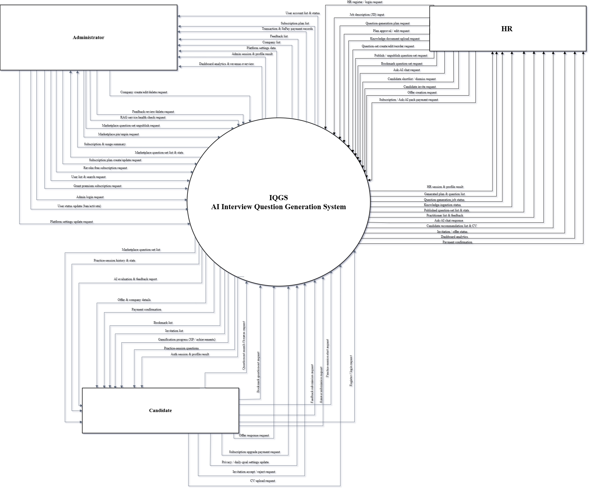Figure 1: Context Diagram (Link)

2. User Requirements

2.1 Actors
The principal human actors are Guest, Candidate, HR Manager and Administrator. Supporting services include the private RAG API, chat and embedding models, PostgreSQL/pgvector, Azure Blob Storage, email delivery and SePay. The table below defines the four human actors; these supporting services are implementation dependencies, not additional human roles.
 | Actor | Description
1 | Guest | An unauthenticated visitor who can view the landing page, browse subscription plan pricing, register as Candidate or HR, and initiate the login/forgot-password flow. Guests cannot access the marketplace, generate questions, or start practice sessions.
2 | Candidate | Authenticated Candidate. Can browse and save published sets, practice and review entitled AI feedback, manage CV and privacy consent, receive invitations, discover jobs and use AI Coach.
3 | HR | Approved HR account. Can use Studio and manual authoring, manage knowledge documents and question sets, inspect practitioners and candidate recommendations, invite candidates and send eligible offers.
4 | Administrator | Administrator. Manages accounts, companies, subscription plans, marketplace, SYSTEM knowledge documents, platform settings and AI/RAG runtime configuration.

2.2 Use Cases

2.2.1 Diagrams
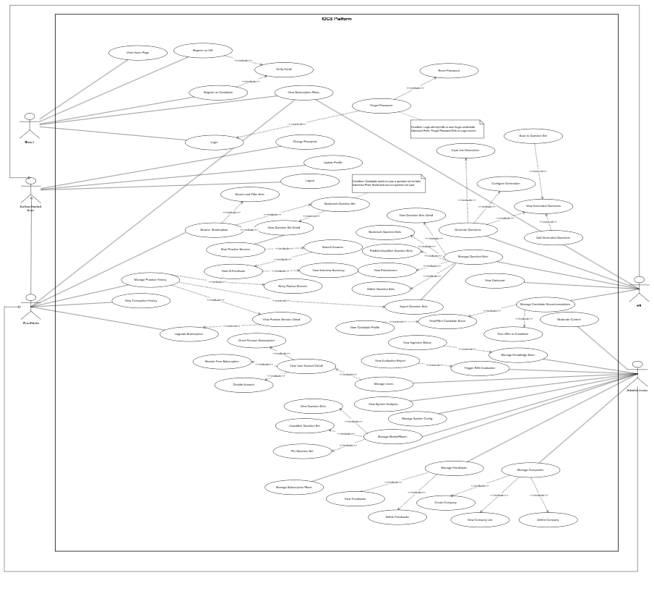
Figure 2: Use Case Diagram (Link)

2.2.2 Descriptions

UC ID | Use Case Name | Actors | Description
1 | View Home Page | Guest | Guest views the platform's public landing page.
2 | Register as Candidate | Guest | Guest registers a new Candidate account; includes Verify Email.
3 | Register as HR | Guest | Guest registers a new HR account; includes Verify Email.
4 | Login | Guest | Guest logs into the system; extended by Forgot Password.
5 | Verify Email | Guest | Guest verifies the registered email address; included by Register as Candidate and Register as HR.
6 | Forgot Password | Guest | Guest recovers access when login fails; extends Login and includes Reset Password.
7 | Reset Password | Guest | Guest resets the account password; included by Forgot Password.
8 | Logout | Authenticated User | Authenticated user logs out of the system.
9 | Update Profile | Authenticated User | Authenticated user updates their profile information.
10 | Change Password | Authenticated User | Authenticated user changes their password.
11 | View Subscription Plans | Guest, Candidate, HR | Guest, Candidate, or HR views the available subscription plans.
12 | Upgrade Subscription | Candidate | Candidate upgrades through the supported subscription and SePay payment flow when an upgrade is available.
13 | View Transaction History | Candidate | Candidate views their transaction history.
14 | Browse Marketplace | Candidate | Candidate browses the question set marketplace; includes Search and Filter Sets, View Question Set Detail, and Bookmark Question Set.
15 | Search and Filter Sets | Candidate | Candidate searches and filters question sets; included by Browse Marketplace.
16 | View Question Set Detail | Candidate | Candidate views the detail of a question set; included by Browse Marketplace, extended by Bookmark Question Set, and leads to Start Practice Session.
17 | Bookmark Question Set | Candidate | Candidate bookmarks a question set; extends View Question Set Detail and is included by Browse Marketplace.
18 | Start Practice Session | Candidate | Candidate starts a practice session from a question set; includes Submit Answers.
19 | Submit Answers | Candidate | Candidate saves answers during an active session; completion or expiry triggers evaluation under the current entitlement.
20 | View AI Feedback | Candidate | Candidate views the graded answers and feedback made available by the current subscription.
21 | View Interview Summary | Candidate | Candidate views a summary of the practice session; included by View AI Feedback.
22 | Manage Practice History | Candidate | Candidate lists and opens prior sessions and can retry an eligible published set.
23 | View Practice Session Detail | Candidate | Candidate views the detail of a past practice session; included by Manage Practice History and extends Upgrade Subscription.
24 | Retry Practice Session | Candidate | Candidate retries a past practice session; included by Manage Practice History.
25 | Input Job Description | HR | HR inputs a job description; included by Generate Questions.
26 | Configure Generation | HR | HR configures question generation settings; included by Generate Questions.
27 | Generate Questions | HR | HR generates interview questions; includes Input Job Description, Configure Generation, and View Generated Questions.
28 | View Generated Questions | HR | HR views the generated questions; included by Generate Questions, extended by Edit Generated Questions and Save to Question Set.
29 | Edit Generated Questions | HR | HR edits the generated questions; extends View Generated Questions.
30 | Save to Question Set | HR | HR saves generated questions to a question set; extends View Generated Questions.
31 | Manage Question Sets | HR | HR manages their question sets; includes View Question Sets Detail, Bookmark Question Sets, Publish/Unpublish Question Sets, View Practitioners, and Delete Question Sets; associated with Export Question Sets.
32 | View Question Sets Detail | HR | HR views the detail of a question set; included by Manage Question Sets.
33 | Bookmark Question Sets | HR | HR bookmarks question sets; included by Manage Question Sets.
34 | Publish/Unpublish Question Sets | HR | HR publishes or unpublishes question sets; included by Manage Question Sets.
35 | View Practitioners | HR | HR views the candidates who practiced a question set; included by Manage Question Sets.
36 | Delete Question Sets | HR | HR deletes question sets; included by Manage Question Sets.
37 | Export Question Sets | HR | HR exports an owned question set as Excel only when its subscription has CanExport. Candidate question-set export is not implemented.
38 | Manage Candidate Recommendations | HR | HR manages candidate recommendations; includes View/Filter Candidate Score and Give Offer to Candidate.
39 | View/Filter Candidate Score | HR | HR views and filters candidate scores; included by Manage Candidate Recommendations and extended by View Candidate Profile.
40 | View Candidate Profile | HR | HR views a candidate's profile; extends View/Filter Candidate Score.
41 | Give Offer to Candidate | HR | HR gives an offer to a candidate; included by Manage Candidate Recommendations.
42 | View Dashboard | HR | HR views their dashboard.
43 | Manage Users | Administrator | Administrator manages user accounts; includes View User Account Detail.
44 | View User Account Detail | Administrator | Administrator inspects an account and performs the supported grant, revoke or disable actions according to backend state rules.
45 | Grant Premium Subscription | Administrator | Administrator grants a premium subscription to a user; included by View User Account Detail.
46 | Revoke Premium Grant | Administrator | Administrator revokes an eligible Premium grant or returns the account to its applicable Free entitlement.
47 | Disable Account | Administrator | Administrator disables a user account; included by View User Account Detail.
48 | Manage Knowledge Base | Administrator | Administrator manages the knowledge base; extended by View Ingestion Status.
49 | View Ingestion Status | Administrator | Administrator views the ingestion status; extended by Manage Knowledge Base.
50 | View System Analytics | Administrator | Administrator views system analytics.
51 | Manage Subscription Plans | Administrator | Administrator manages subscription plans.
52 | Manage System Config | Administrator | Administrator manages system configuration.
53 | Manage Companies | Administrator | Administrator manages companies; includes Create Company, View Company List, and Delete Company.
54 | Create Company | Administrator | Administrator creates a company; included by Manage Companies.
55 | View Company List | Administrator | Administrator views the list of companies; included by Manage Companies.
56 | Delete Company | Administrator | Administrator deletes a company; included by Manage Companies.
57 | Manage Feedbacks | Administrator | Administrator manages feedback; includes View Feedbacks and Delete Feedbacks.
58 | View Feedbacks | Administrator | Administrator views feedback; included by Manage Feedbacks.
59 | Delete Feedbacks | Administrator | Administrator deletes feedback; included by Manage Feedbacks.
60 | Manage Marketplace | Administrator | Administrator manages the marketplace; includes View Question Sets, Unpublish Question Set, and Pin Question Set.
61 | View Question Sets | Administrator | Administrator views question sets in the marketplace; included by Manage MarketPlaces.
62 | Unpublish Question Set | Administrator | Administrator unpublishes a question set; included by Manage MarketPlaces.
63 | Pin Question Set | Administrator | Administrator pins a question set; included by Manage MarketPlaces.
64 | Manage Studio Projects | HR | Create and reopen an interview project and keep its JD, plan, generation settings and question runs together.
65 | Select HR Knowledge Sources | HR | Select owner-scoped knowledge documents for a Studio run; RAG omits HR retrieval when none are selected.
66 | Review and Approve Interview Plan | HR | Review, refine and approve a generated plan before starting its question run.
67 | Use Studio AI Chat | HR | Ask plan or question-generation questions within the Studio project and persist the conversation.
68 | Manage HR Knowledge Documents | HR | Upload, list, inspect ingestion status and delete owned knowledge documents.
69 | Compare Candidate Recommendations | HR | Filter, compare and inspect eligible candidates and their available practice records.
70 | Manage Hiring Actions | HR | Shortlist, dismiss or restore a recommendation, invite an eligible candidate and send an offer under backend state rules.
71 | Manage Candidate CV | Candidate | Upload or replace a CV, parse skills and update the candidate profile.
72 | Manage Recruiter Consent | Candidate | Enable or disable recruiter recommendation visibility in privacy settings.
73 | Use AI Coach | Candidate | Confirm goals, start a diagnostic, review the competency report and inspect suggested roadmaps.
74 | Generate Personal Practice Set | Candidate | Create a personal question set or submit a source file and poll the generation job.
75 | Discover Jobs | Candidate | Browse job listings and view job details in the candidate portal.
76 | View Leaderboard | Candidate | View gamification standings and progress exposed by the Candidate API.
77 | Manage AI Runtime | Administrator | Read or update supported RAG provider, model and retrieval settings and request configuration reload.
78 | Manage Competency Framework | Administrator | Maintain Coach role-family, framework and policy data through the administrator APIs.
79 | Manage Platform Marketplace | Administrator | Inspect published sets and pin or unpin eligible sets subject to platform limits.
80 | Review Platform Feedback | Administrator | List and manage submitted feedback through the administration interface.

3. Functional Requirements

3.1 System Functional Overview

3.1.1 Screens Flow
The existing diagram shows the main role workspaces. The implemented route groups are public pages, /candidate/*, /hr/* and /admin/*. Additional Studio, hiring, Coach and administration screens are specified in section 3.2.4; the existing diagram is retained as supplied.

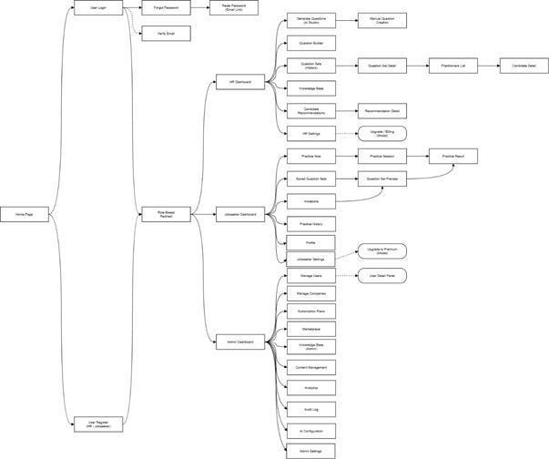
Figure 3.1.1: Screens Flow ( Link )

3.1.2 Screen Descriptions
The existing figures show selected screen layouts. Section 3.2.4 lists other implemented routes and workflows whose screenshots are not included here.
Table 3.1.2: Screen Inventory
No. | Actor | Screen | Main function
1 | HR | HR Dashboard | The HR dashboard reads owner-scoped activity and navigation data; it does not generate questions by itself.
2 | HR | Generate Questions — Studio | Project Studio stores interview projects, JD content, selected HR knowledge, chat, settings, plan approval and generation runs. BE calls the private RAG service for validation, retrieval and generation.
3 | HR | Manual Question Creation | Manual authoring creates an owned question set without invoking the RAG generation job or consuming its AI generation quota.
4 | HR | Question Set Management (History) | History retrieves HR-owned drafts and published sets, with details and management actions; export is subject to CanExport.
5 | Candidate | Candidate Dashboard | The dashboard reads the candidate's practice activity, recent results and navigation targets.
6 | Candidate | Question Set Marketplace (Practice Now) | The marketplace lists published question sets and applies the available search and filter controls.
7 | Candidate | Question Set Detail | The detail view reads the selected published set, questions visible under the current entitlement and practice eligibility.
8 | Candidate | Company Info Modal | The company modal displays company information associated with the question set without writing company data.
9 | Candidate | Practice Session (Mock Interview) | The practice screen stores answers in an owned in-progress session and uses the backend's time limit and subscription rules.
10 | Candidate | Exit Practice Confirmation Dialog | The exit dialog protects an in-progress session from an accidental navigation away.
11 | Candidate | Submit Session Confirmation Dialog | The submit dialog confirms the candidate's intention to finalize the active session.
12 | Candidate | AI Feedback & Result Report | The result reads stored answers, scores, available feedback and insight according to the active subscription snapshot.
13 | Candidate | Practice History | History lists the candidate's previous sessions and links each completed one to its result.
14 | Candidate | Saved Sets (Bookmarks) | Bookmarks are stored per candidate and reference published sets.
15 | Candidate | Interview Invitations | The invitation page reads invitations for the authenticated candidate and exposes the valid response actions.
16 | Candidate | Candidate Profile | The profile updates personal fields and CV; a replacement CV can be parsed for skills by the private RAG service.
17 | Candidate | Settings — General | General settings expose language, appearance and the notification controls implemented by the frontend.
18 | Candidate | Settings — Security | The Security tab submits a password change through the authenticated users API.
19 | Candidate | Settings — Privacy & Data | Privacy settings include AllowRecruiterRecommendation, which controls HR recommendation visibility.
20 | Candidate | Settings — Billing & Subscription | Billing reads the current plan and entitlement snapshot and presents an available upgrade flow.
21 | Candidate | Upgrade to Premium Modal | The upgrade modal starts the SePay payment flow and observes the backend's payment state.
22 | Candidate | Notification Bell | The notification bell summarizes available recent account activity and links to relevant candidate pages.
23 | Administrator | Admin Dashboard | The dashboard combines API-backed counts with any explicitly identified placeholder widgets.
24 | Administrator | User Management | The user list supports account inspection and administrative status or HR approval actions.
25 | Administrator | Knowledge Base Management | The knowledge page manages SYSTEM-scope documents and their indexing state.
26 | Administrator | System Configuration | System configuration displays the platform settings that are actually exposed by the backend.
27 | Administrator | Admin Dashboard | This second dashboard figure is another view of the same route, not a separate backend feature.
28 | Administrator | User Management | This second user-management figure shows the same account-management route with additional controls.
29 | Administrator | Company Management | Company management uses administrator APIs for creating, listing, editing and deleting company records.
30 | Administrator | AI / RAG Configuration | AI Config reads and updates supported RAG runtime settings, including chat provider, model and retrieval counts.
31 | Administrator | Platform Settings | Settings exposes platform-wide parameters and the tabs implemented in the frontend.
32 | Administrator | Subscription Plan Management | Plan management updates HR and Candidate plan definitions and future entitlements.
33 | Administrator | Knowledge Base Management (System-wide) | This second knowledge figure covers the same SYSTEM-scope corpus and document-status route.
34 | Administrator | Marketplace Management | Marketplace administration lists published sets and controls pinning within MaxPinnedSets.
35 | Guest | Public Home | The landing page explains the service and routes visitors to login or registration.
36 | Guest | Login | Email/password and supported Google or GitHub OAuth paths call /api/auth; the returned role selects the workspace.
37 | Guest | Candidate and HR Registration | Separate API endpoints register Candidate or HR; HR registration requires company information and later administrative approval.
38 | Guest | Verify Email | The verification form submits email and OTP to /api/auth/verify-email and supports a resend action.
39 | Guest | Recover Password | Password recovery requests a reset and submits a new credential through the auth API.
40 | Authenticated user | Account Profile and Password | Own-profile and password changes use /api/users/me endpoints with role-specific profile fields.

3.1.3 Screen Authorization
The frontend uses role route guards for the Candidate, HR and Administrator workspaces, and ASP.NET Core API controllers enforce role authorization. A frontend redirect is a usability measure; the API remains the authorization boundary. Public authentication and informational pages are available without a role.

No | Application Area (Route Prefix) | Guest | Candidate | HR | Administrator
1 | Public (/, /login, /register, /register/jobseeker, /forgot-password, /reset-password, /verify-email, /terms, /privacy) | Yes | Yes | Yes | Yes
2 | Candidate workspace (/candidate/*) | No | Yes | No | No
3 | HR workspace (/hr/*; Studio at /hr/generate-question) | No | No | Yes | No
4 | Administrator workspace (/admin/*) | No | No | No | Yes
Table 3.1.3: Screen Authorization Matrix
Company administration is available to Administrator; HR has its own company/profile settings. Route names in this matrix follow the current Next.js app directory.

3.1.4 Non-Screen Functions
The backend runs asynchronous generation and knowledge ingestion jobs through Hangfire. Registered recurring jobs check stuck knowledge ingestion every 15 minutes, expired practice sessions every minute and pending upgrade orders every 5 minutes. A legacy question-generation watchdog is registered but currently skips execution; it does not protect Studio runs.

No | Function | Trigger | Description
1 | Knowledge document ingestion | On HR or Admin upload | Queues an asynchronous RAG parse, chunk and embed operation, then records completion or failure through the internal callback.
2 | Plan generation | HR submits a JD or approves Studio input | Creates a generation plan through the backend and RAG service; Studio preserves approval and settings state.
3 | Question generation | HR starts an approved generation run | Generates questions asynchronously from the approved plan and selected sources; status is available for polling.
4 | Knowledge ingestion watchdog | Every 15 minutes | Fails knowledge documents stuck in Processing beyond the configured threshold (90 minutes by default).
5 | Expired practice session watchdog | Every minute | Finalizes in-progress sessions whose time limit has elapsed.
6 | Pending upgrade order expiry | Every 5 minutes | Expires unpaid SePay upgrade orders past their deadline. The separate legacy generation watchdog is registered but currently skips work.
Table 3.1.4: Non-Screen Functions (Background Jobs)

3.1.5 Entity Relationship Diagram

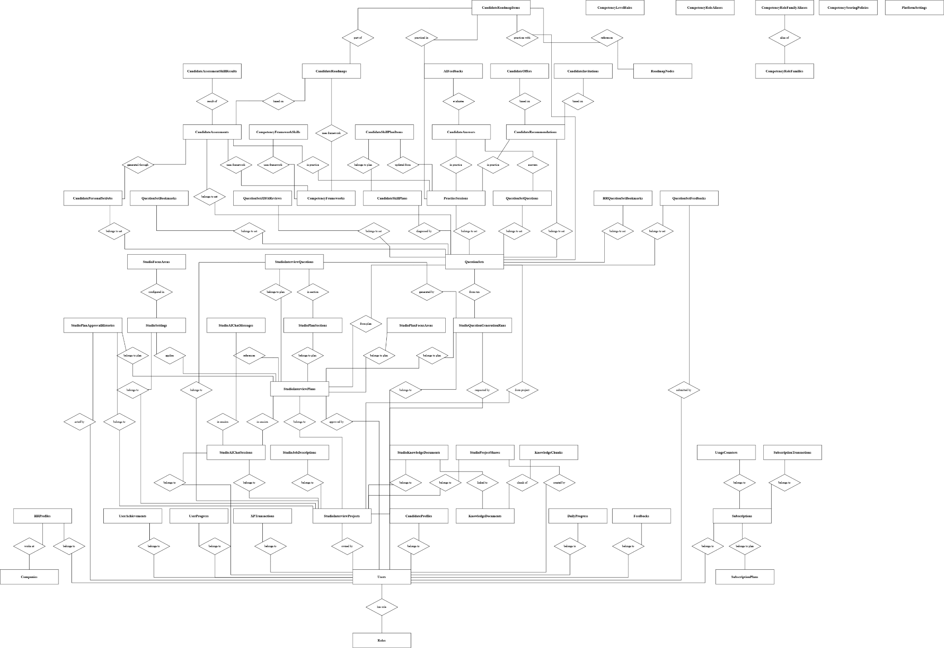
Figure 3.1.5: Entity Relationship Diagram (Core Schema) (Link)

Table 3.1.5: Entity Types Mapped by the Current EF Core Code
No | Entity | Purpose
1 | Role | Fixed authorization role used by account access checks.
2 | User | Account credentials, provider links, verification, status and role.
3 | Company | Company profile associated with HR users and question sets.
4 | Feedback | Feedback submitted by a platform user for admin handling.
5 | HRProfile | HR account details, company link and recommendation preferences.
6 | CandidateProfile | Candidate details, CV fields, skills, goals and recruiter consent.
7 | KnowledgeDocument | SYSTEM or HR knowledge file, owner, source metadata and ingest status.
8 | KnowledgeChunk | Parsed knowledge text, metadata and pgvector embedding.
9 | QuestionSet | Owned question-set metadata, status and publication details.
10 | QuestionSetQuestion | Ordered question content, answer method, criteria and citations in a set.
11 | CandidatePersonalSetJob | Asynchronous job for a candidate personal question set.
12 | CandidateSkillPlan | Cumulative AI Coach competency profile for a candidate.
13 | CandidateSkillPlanItem | Per-skill score, target, status and evidence in that profile.
14 | CompetencyFramework | Role, technology and level competency framework catalog entry.
15 | CompetencyFrameworkSkill | Skill definition, weight and target within a framework.
16 | CompetencyRoleAlias | Normalized role-name alias used to resolve a framework.
17 | CompetencyRoleFamily | Software-engineering role family used by adaptive Coach resolution.
18 | CompetencyRoleFamilyAlias | Alternate name used to resolve a role family.
19 | CompetencyScoringPolicy | Configurable global weights and thresholds for Coach scoring.
20 | CompetencyLevelRule | Global requirements for an achieved competency level.
21 | CandidateAssessment | Candidate AI Coach diagnostic or reassessment record.
22 | CandidateAssessmentSkillResult | Per-skill result belonging to a candidate assessment.
23 | CandidateRoadmap | Suggested or confirmed AI Coach learning roadmap.
24 | CandidateRoadmapItem | Topic or action item in a candidate roadmap.
25 | RoadmapNode | Catalog node used to recommend roadmap learning content.
26 | QuestionSetBookmark | Candidate bookmark of a question set.
27 | HrQuestionSetBookmark | HR bookmark of a question set.
28 | QuestionSetFeedback | Feedback associated with a published question set.
29 | QuestionSetJdFitReview | Latest JD-fit review and content hash for a question set.
30 | PracticeSession | Timed candidate attempt on a question set.
31 | CandidateAnswer | Candidate answer to a question in a practice session.
32 | AiFeedback | AI score and explanation attached to an evaluated answer.
33 | CandidateRecommendation | Candidate practice-based recommendation visible to eligible HR.
34 | CandidateInvitation | Invitation from HR to a candidate and its response state.
35 | CandidateOffer | HR offer, acceptance token and offer state.
36 | PlatformSettings | Platform-wide publication, marketplace and practice parameters.
37 | SubscriptionPlan | HR or Candidate plan template, price and limits JSON.
38 | Subscription | User's active plan period and entitlement snapshot JSON.
39 | UsageCounter | Consumption of a metered subscription feature.
40 | SubscriptionTransaction | Paid-upgrade order and payment-processing state.
41 | UserProgress | Candidate XP, level, streak and activity counters snapshot.
42 | XpTransaction | Idempotent audit record of an XP award or deduction.
43 | DailyProgress | Candidate XP and practice activity for one local date.
44 | UserAchievement | Achievement unlocked by a candidate.
45 | InterviewProject | Studio project containing the JD, plan, settings and questions.
46 | JobDescription | JD text and source stored within a Studio project.
47 | StudioKnowledgeDocument | Knowledge-document selection attached to a Studio project.
48 | AiChatSession | Conversation session for Studio AI assistance.
49 | AiChatMessage | Individual user or AI message in a Studio chat session.
50 | InterviewPlan | Studio generation plan and approval state.
51 | PlanSection | Structured section within an interview plan.
52 | PlanFocusArea | Skill or topic focus area within an interview plan.
53 | PlanApprovalHistory | Audit record of a Studio plan approval change.
54 | StudioSettings | Question-generation configuration for a Studio project.
55 | StudioFocusArea | Project focus area and weighting configured in Studio.
56 | InterviewQuestion | Editable question created within a Studio project.
57 | QuestionGenerationRun | Execution status and output of a Studio question run.
58 | ProjectShare | Sharing record and permission for a Studio project.

3.2 Web Application
The screens below were captured from the deployed web application on 23 September 2026 using the supplied HR, Candidate and Administrator test accounts. Routes and available actions were checked against the current frontend and backend code. A screenshot records the state reachable with these accounts; where data or a prerequisite is absent, the actual empty or gated state is identified instead of an invented screen.

3.2.1 Authentication and Public Entry
3.2.1.1 Sign In
Route: /login. Guest enters an existing account and is routed to the workspace for its role. The API authenticates the account; the frontend redirects after login.
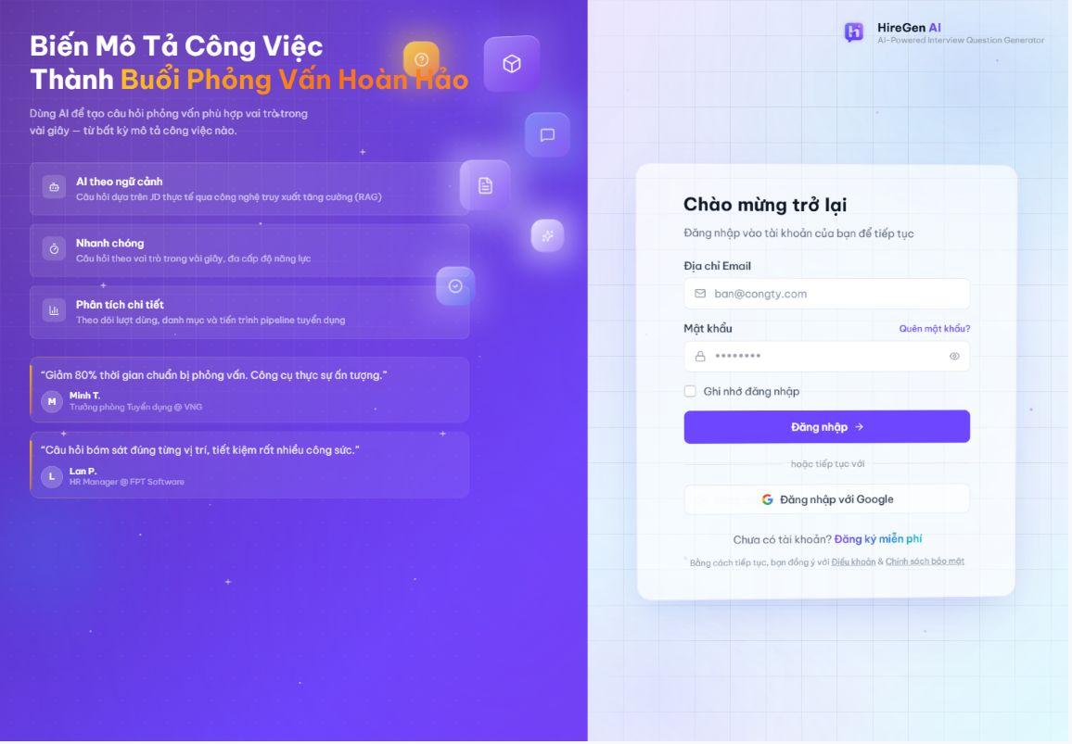
Figure 3.2.1. Sign-in form for Candidate, HR Manager and Administrator.
3.2.1.2 Candidate and HR Registration
Route: /register/jobseeker; /register. The two registration pages collect role-specific account information. Email verification and HR approval determine when an account can use protected workflows.
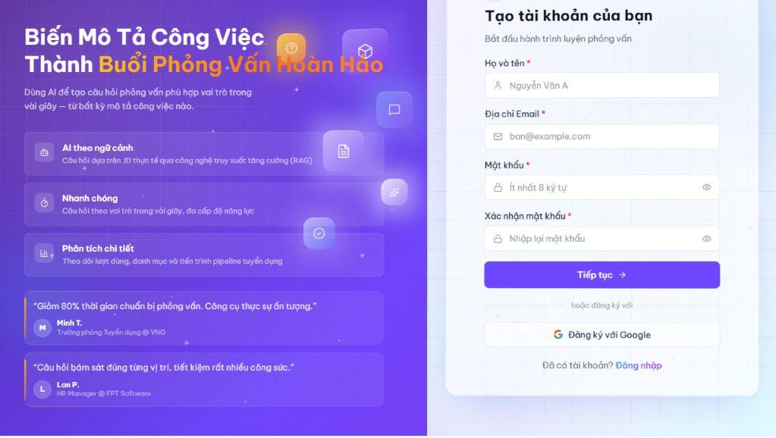
Figure 3.2.2. Candidate registration form.
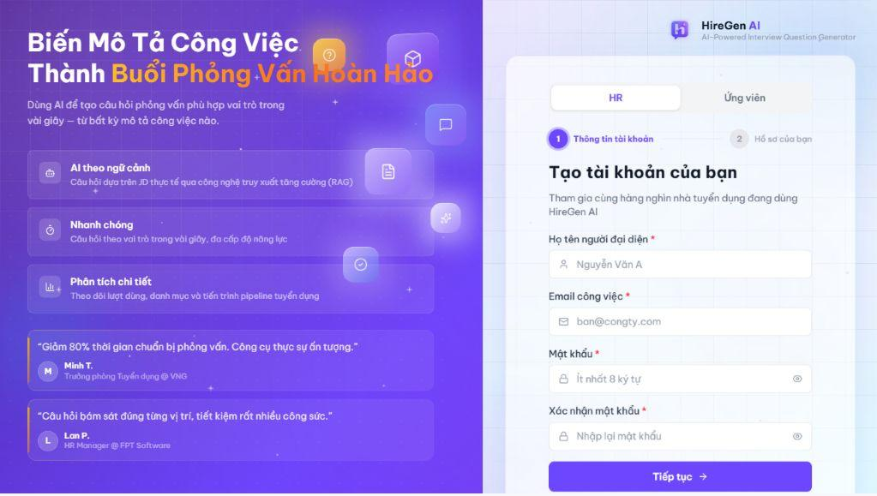
Figure 3.2.3. HR registration form.
3.2.1.3 Password Recovery
Route: /forgot-password; /reset-password. The recovery page accepts an email address and starts the reset process. The reset page is usable only with a valid reset token; no password was changed for this documentation capture.
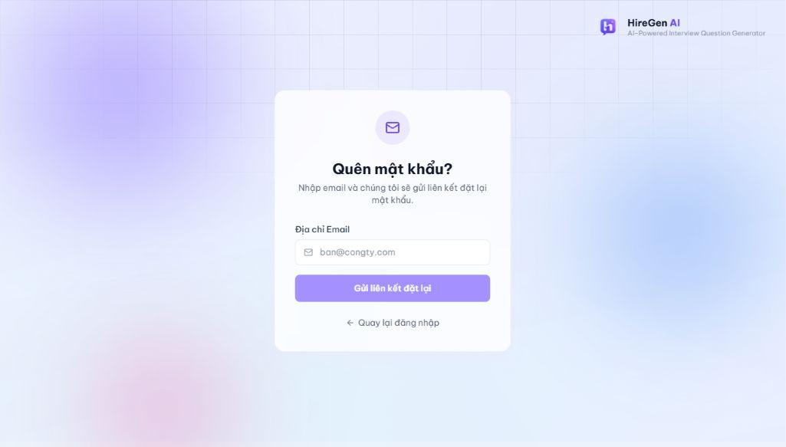
Figure 3.2.4. Forgot-password form.

3.2.2 HR Manager Workspace
3.2.2.1 Dashboard
Route: /hr/dashboard. Shows the HR recruitment funnel and question-generation activity, with links into Studio, question sets, talent and settings. The captured account has Premium access.
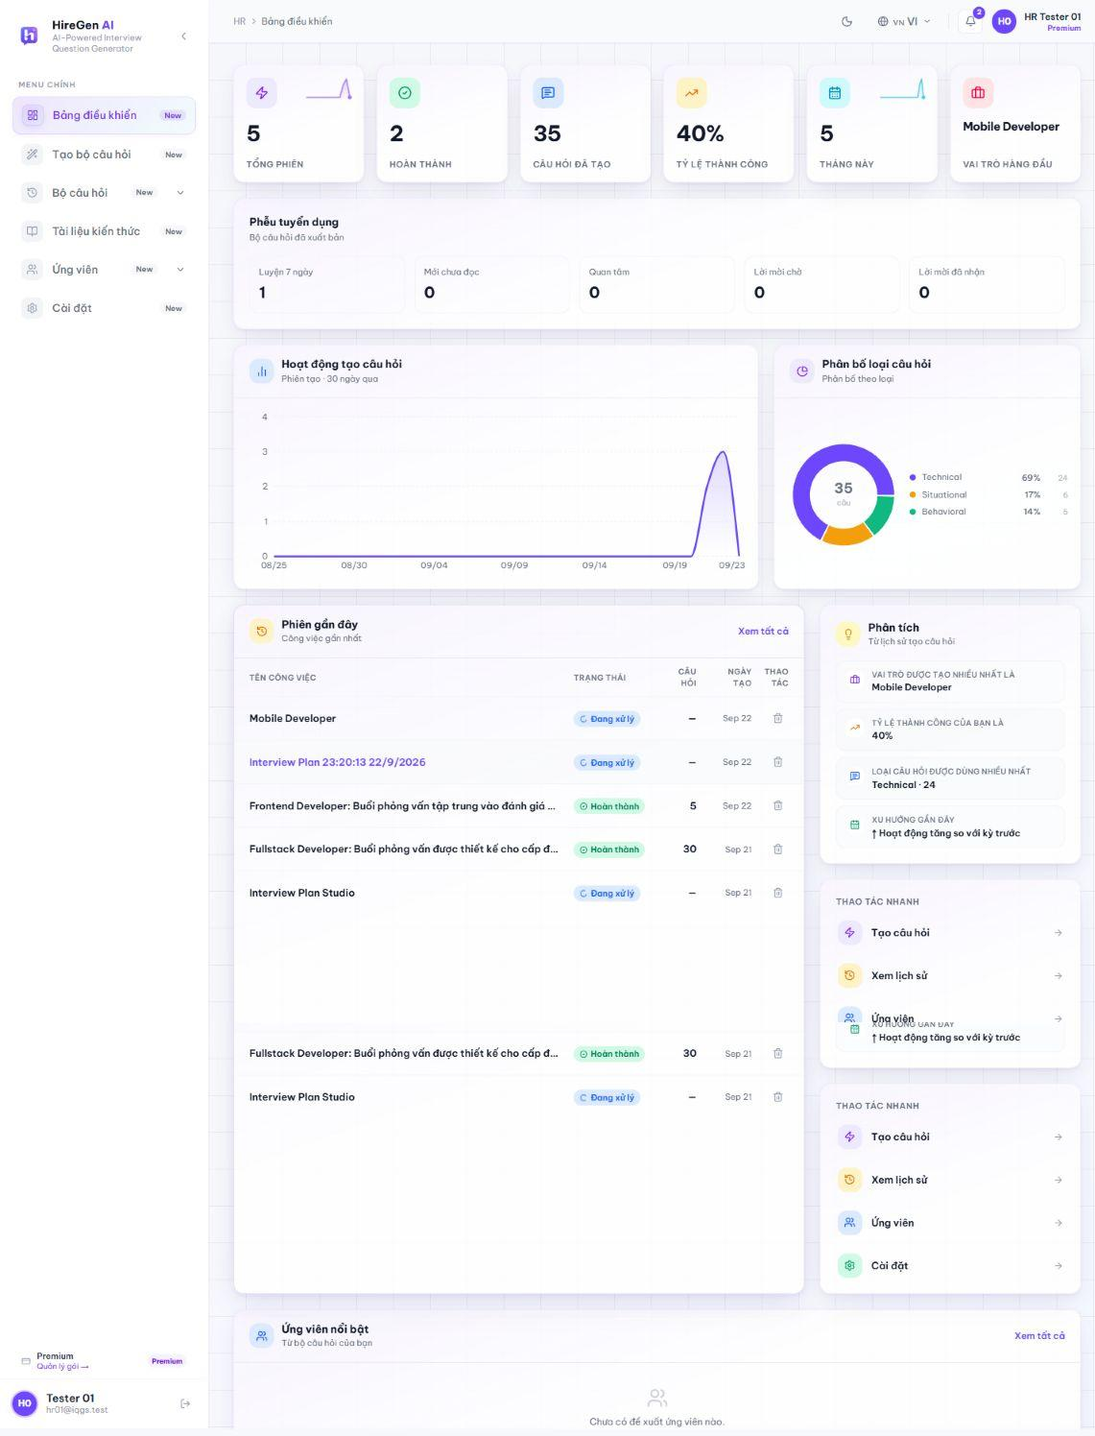
Figure 3.2.5. HR dashboard with activity and recruitment funnel.
3.2.2.2 Project Studio: Job Description and Knowledge
Route: /hr/generate-question. HR creates a Studio project, enters a job description and may select owned knowledge documents. The captured completed project shows the stored JD and detected skills. HR01 has no owned knowledge documents, as shown in the HR knowledge-library state below.
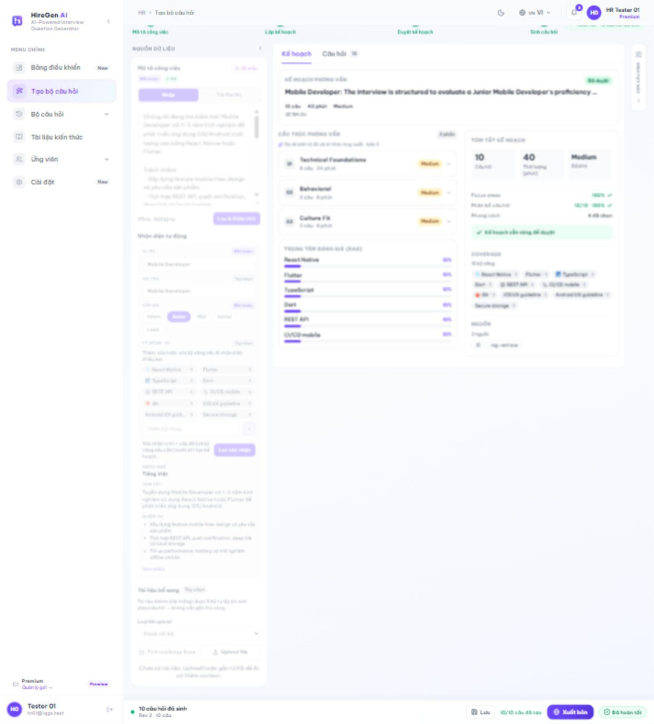
Figure 3.2.6. Stored job description and detected skills.
3.2.2.3 Project Studio: Plan and Approval
Route: /hr/generate-question. Studio generates an interview plan from the JD, displays sections and focus areas, and requires approval before generating questions. The captured plan is approved and contains ten question slots and RAG-derived focus areas.
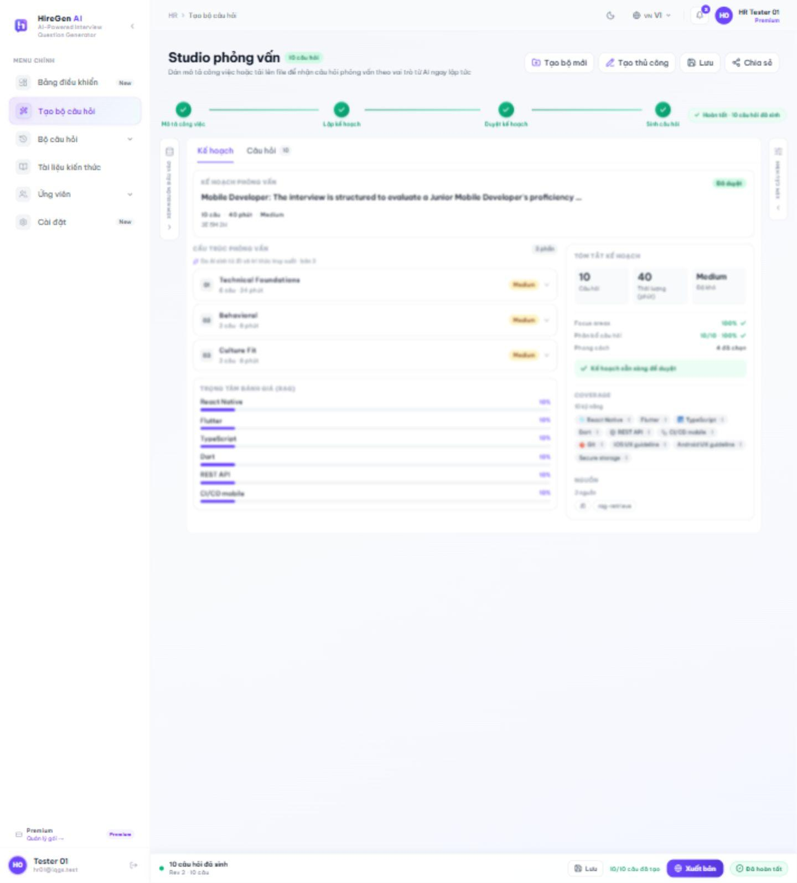
Figure 3.2.7. Approved interview plan and skill coverage.
3.2.2.4 Project Studio: Generate and Review Questions
Route: /hr/generate-question. After approval, Studio runs question generation asynchronously. HR reviews the generated questions and their RAG references, then edits or regenerates an individual question before publishing.
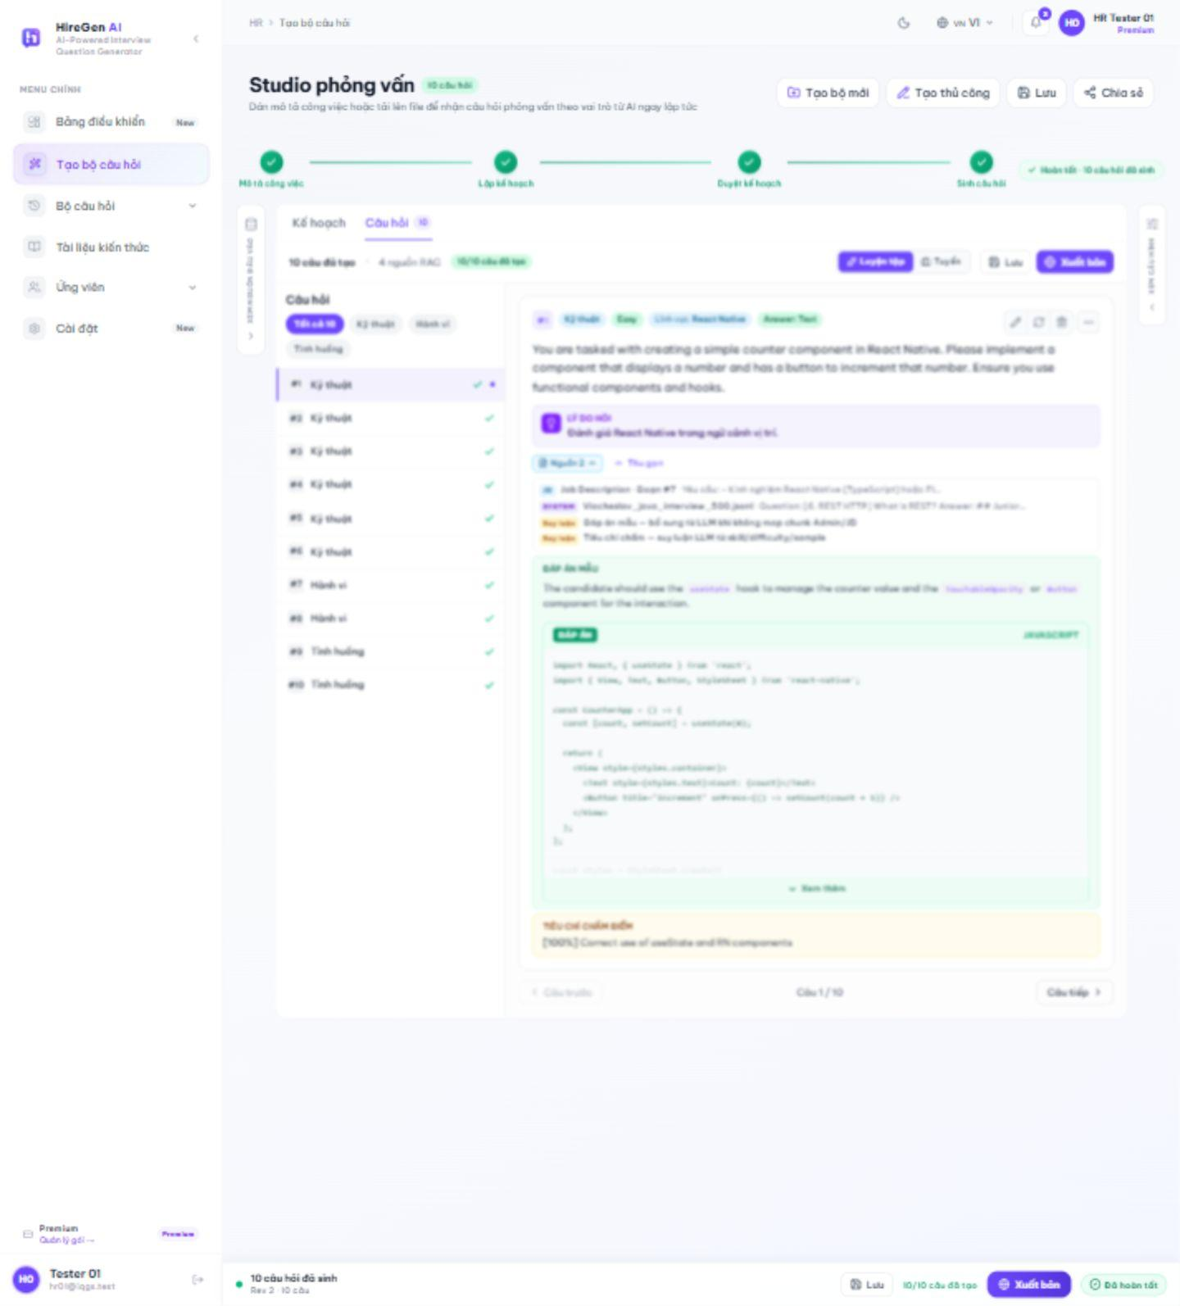
Figure 3.2.8. Generated questions and source references.
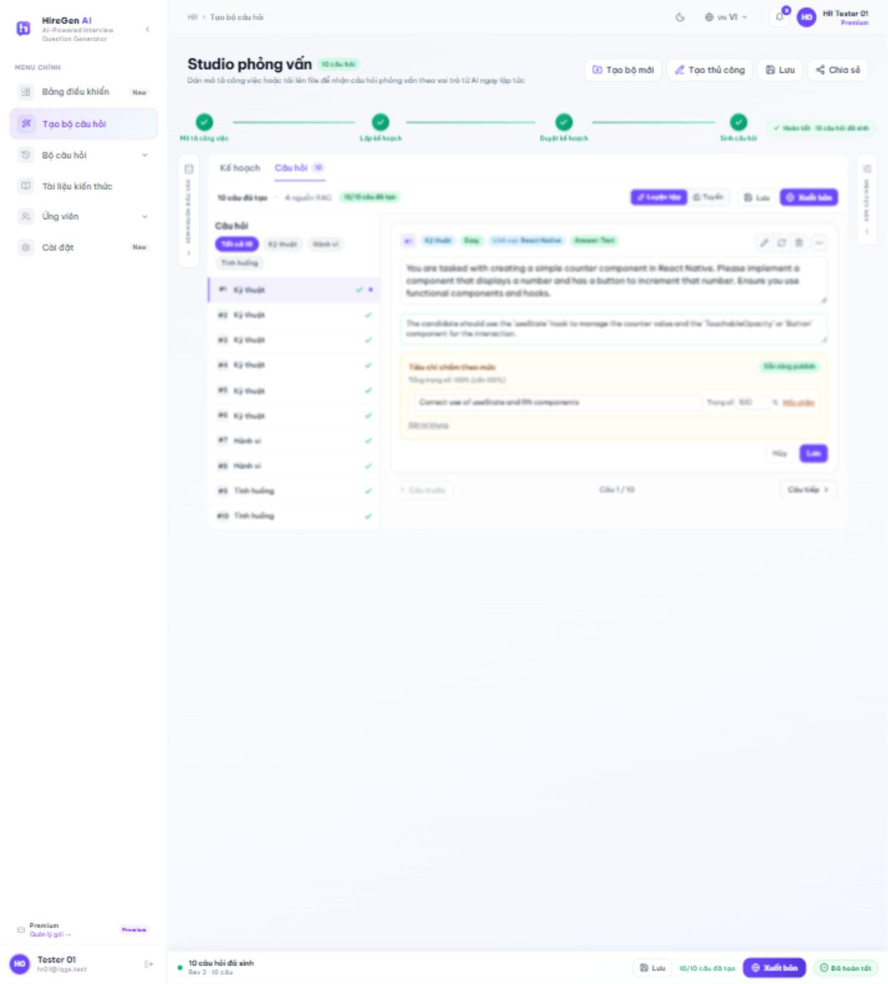
Figure 3.2.9. Edit a generated question.
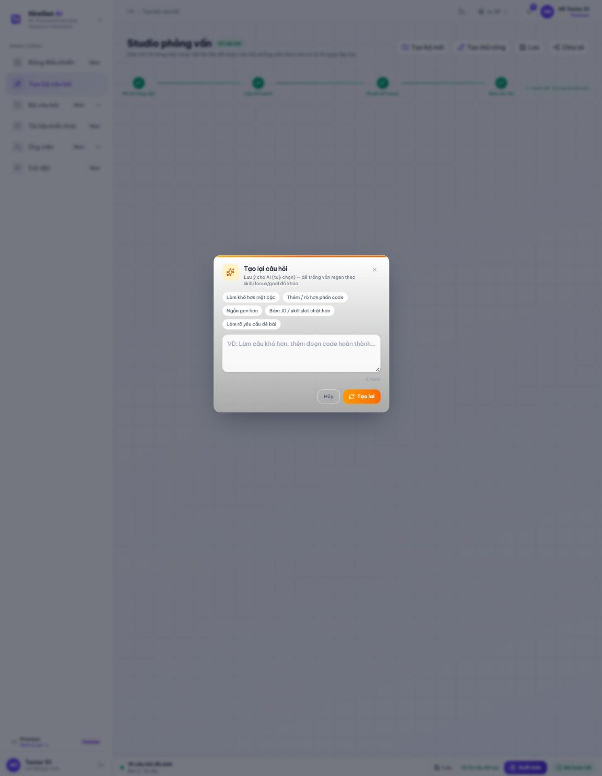
Figure 3.2.10. Regenerate a question.
3.2.2.5 Manual Question Builder
Route: /hr/generate-question/manual. The manual builder creates or selects a draft set, chooses question type and difficulty, and provides content, answer, rubric and optional classification fields. It does not invoke Studio generation.
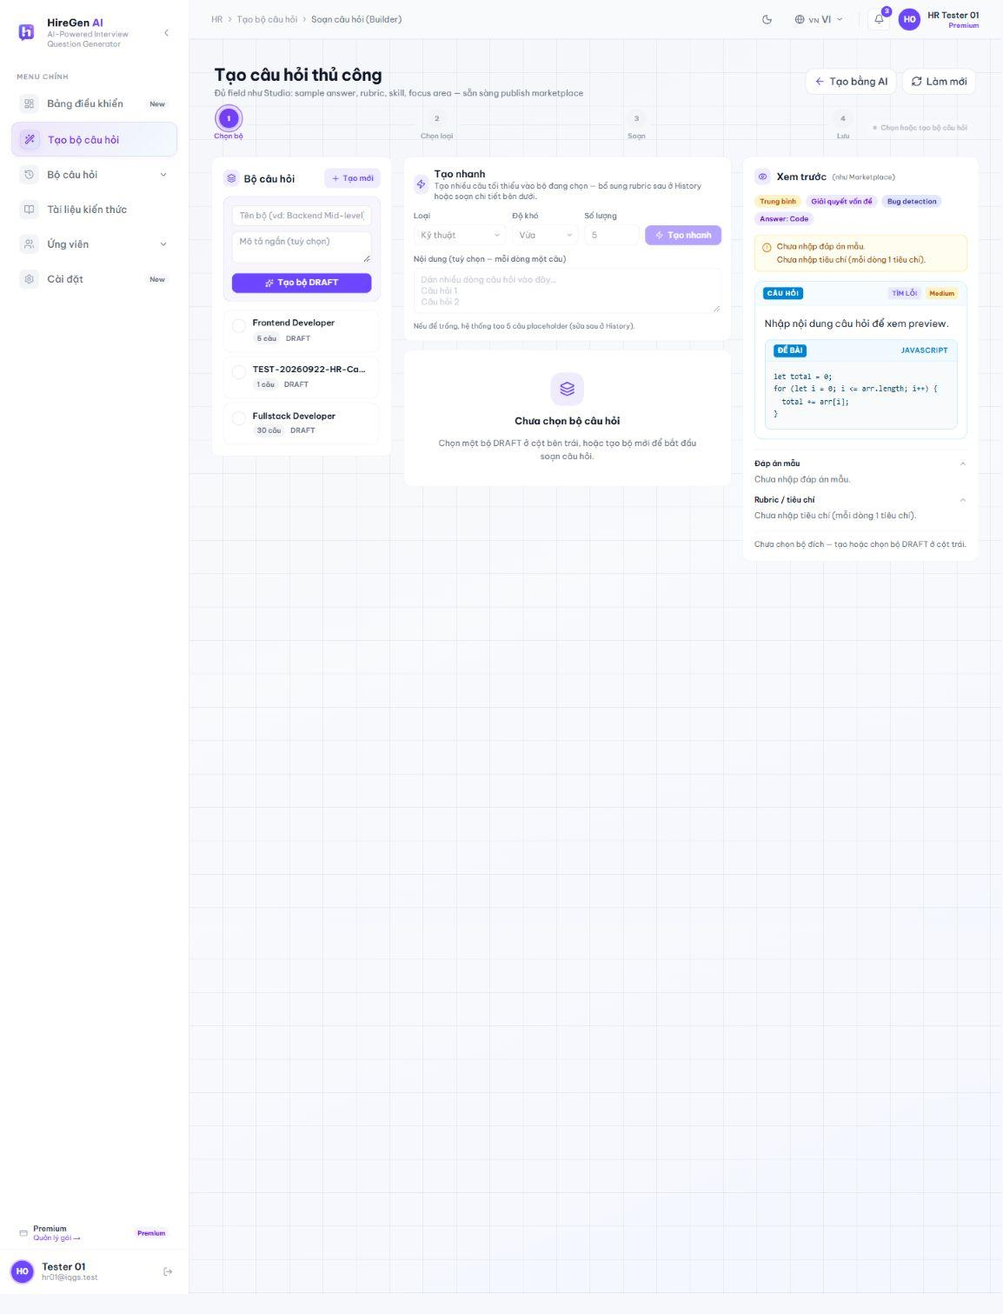
Figure 3.2.11. Manual builder before selecting a draft.
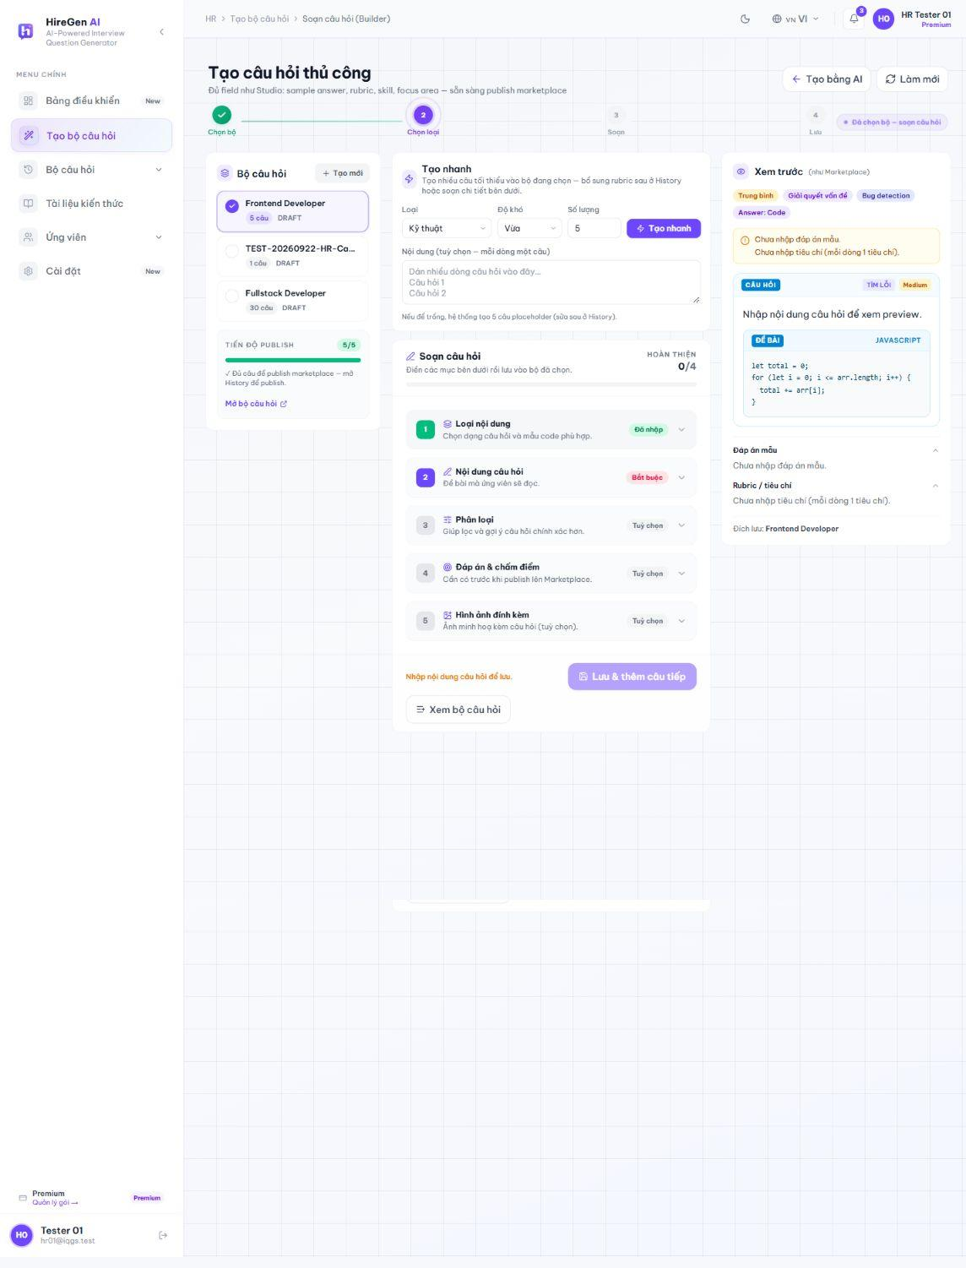
Figure 3.2.12. Manual builder with an existing draft selected.
3.2.2.6 Publish Practice or Hiring Set
Route: /hr/generate-question. The publish dialog separates practice and hiring use. Hiring publication exposes assessment duration and anti-cheat controls. The capture records the dialogs without publishing a new set.
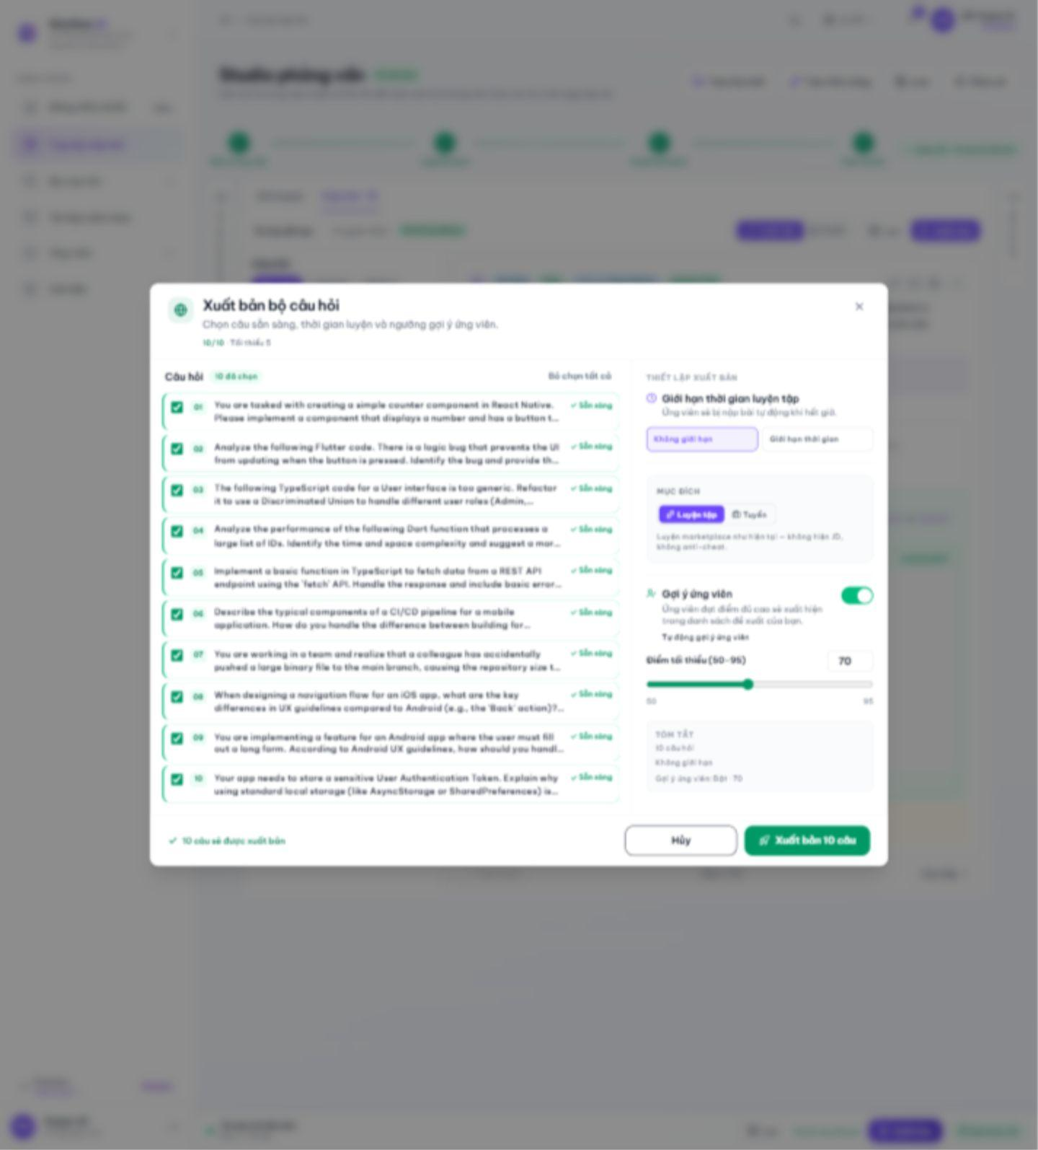
Figure 3.2.13. Practice publication settings.
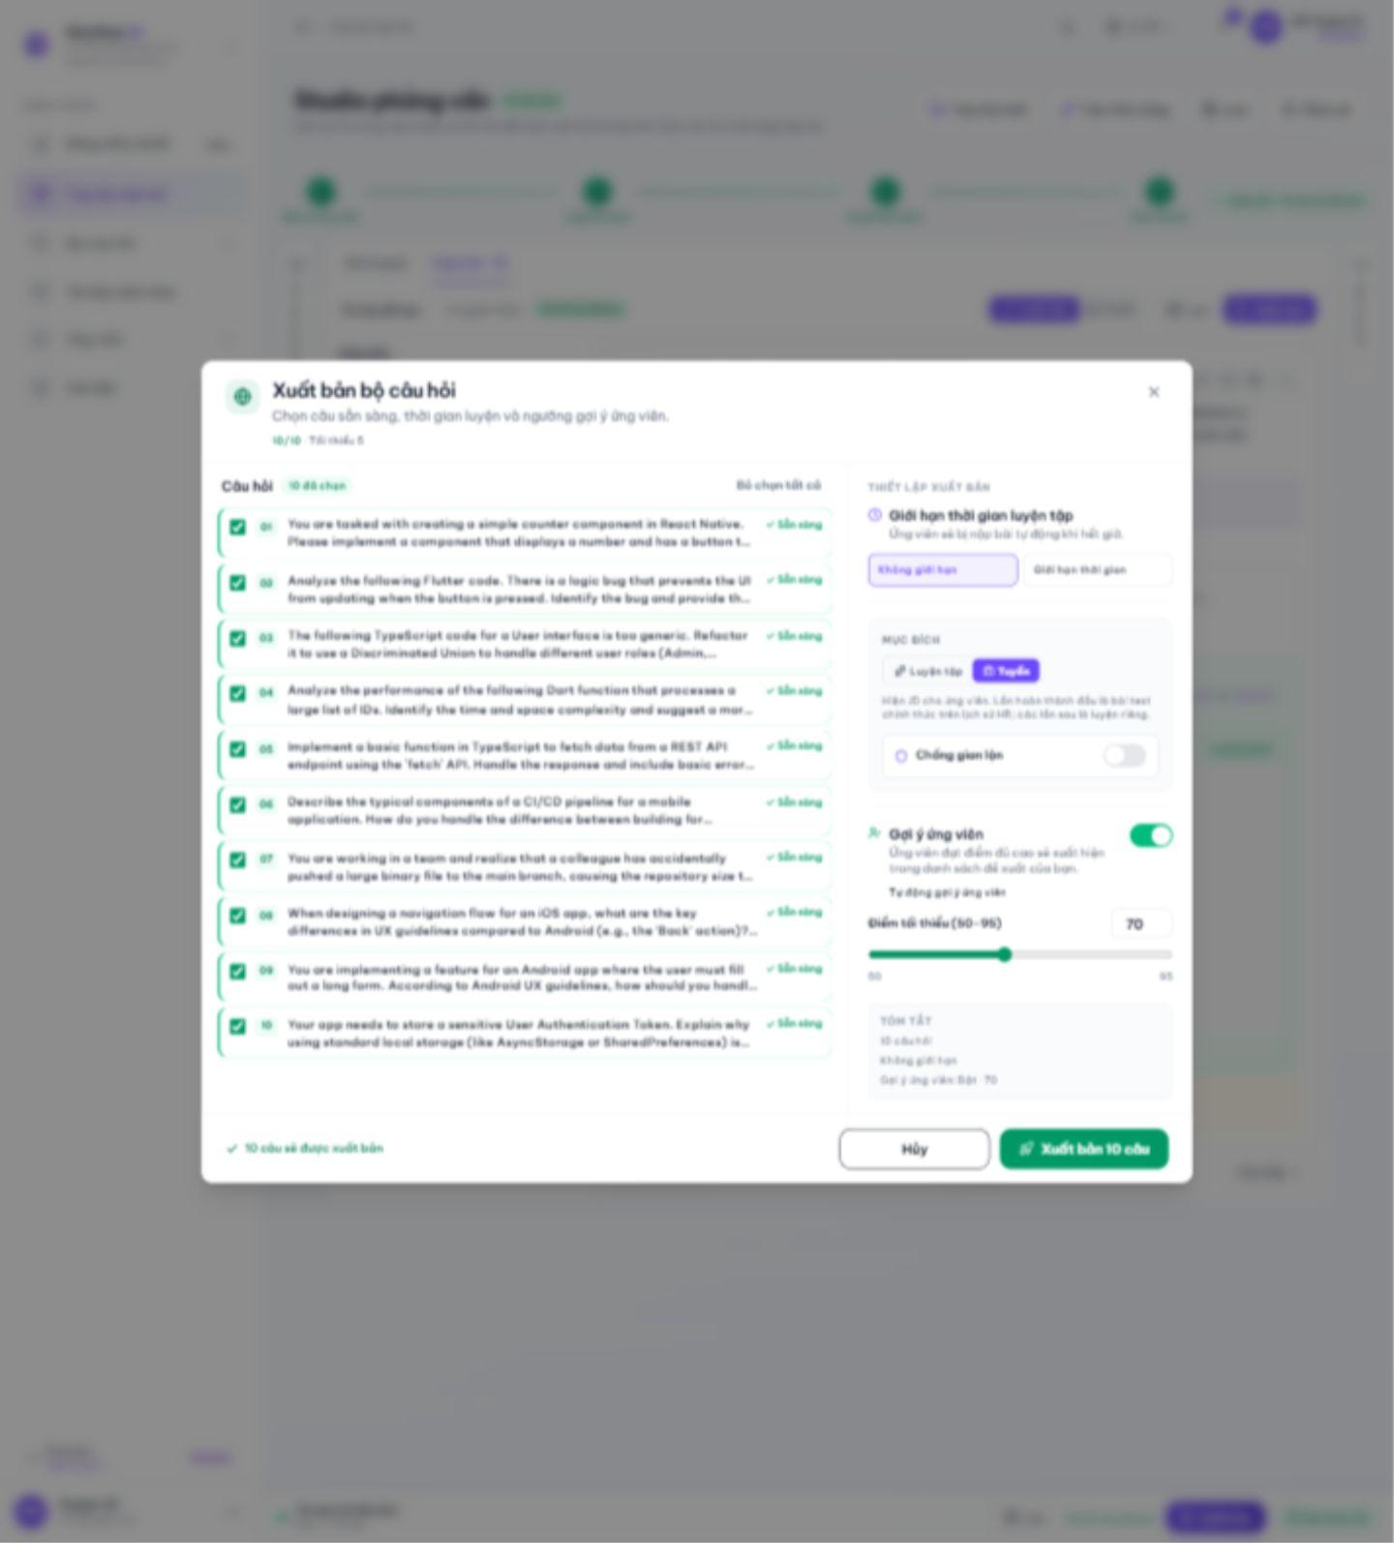
Figure 3.2.14. Hiring publication settings.
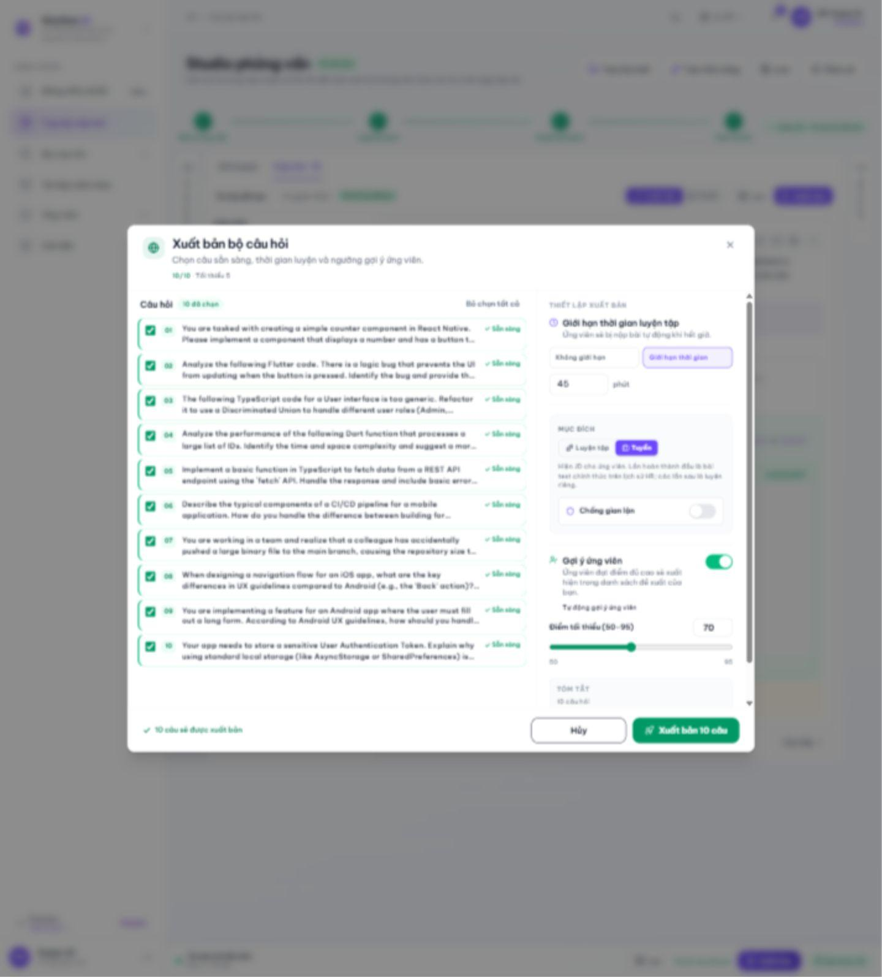
Figure 3.2.15. Hiring time-limit options.
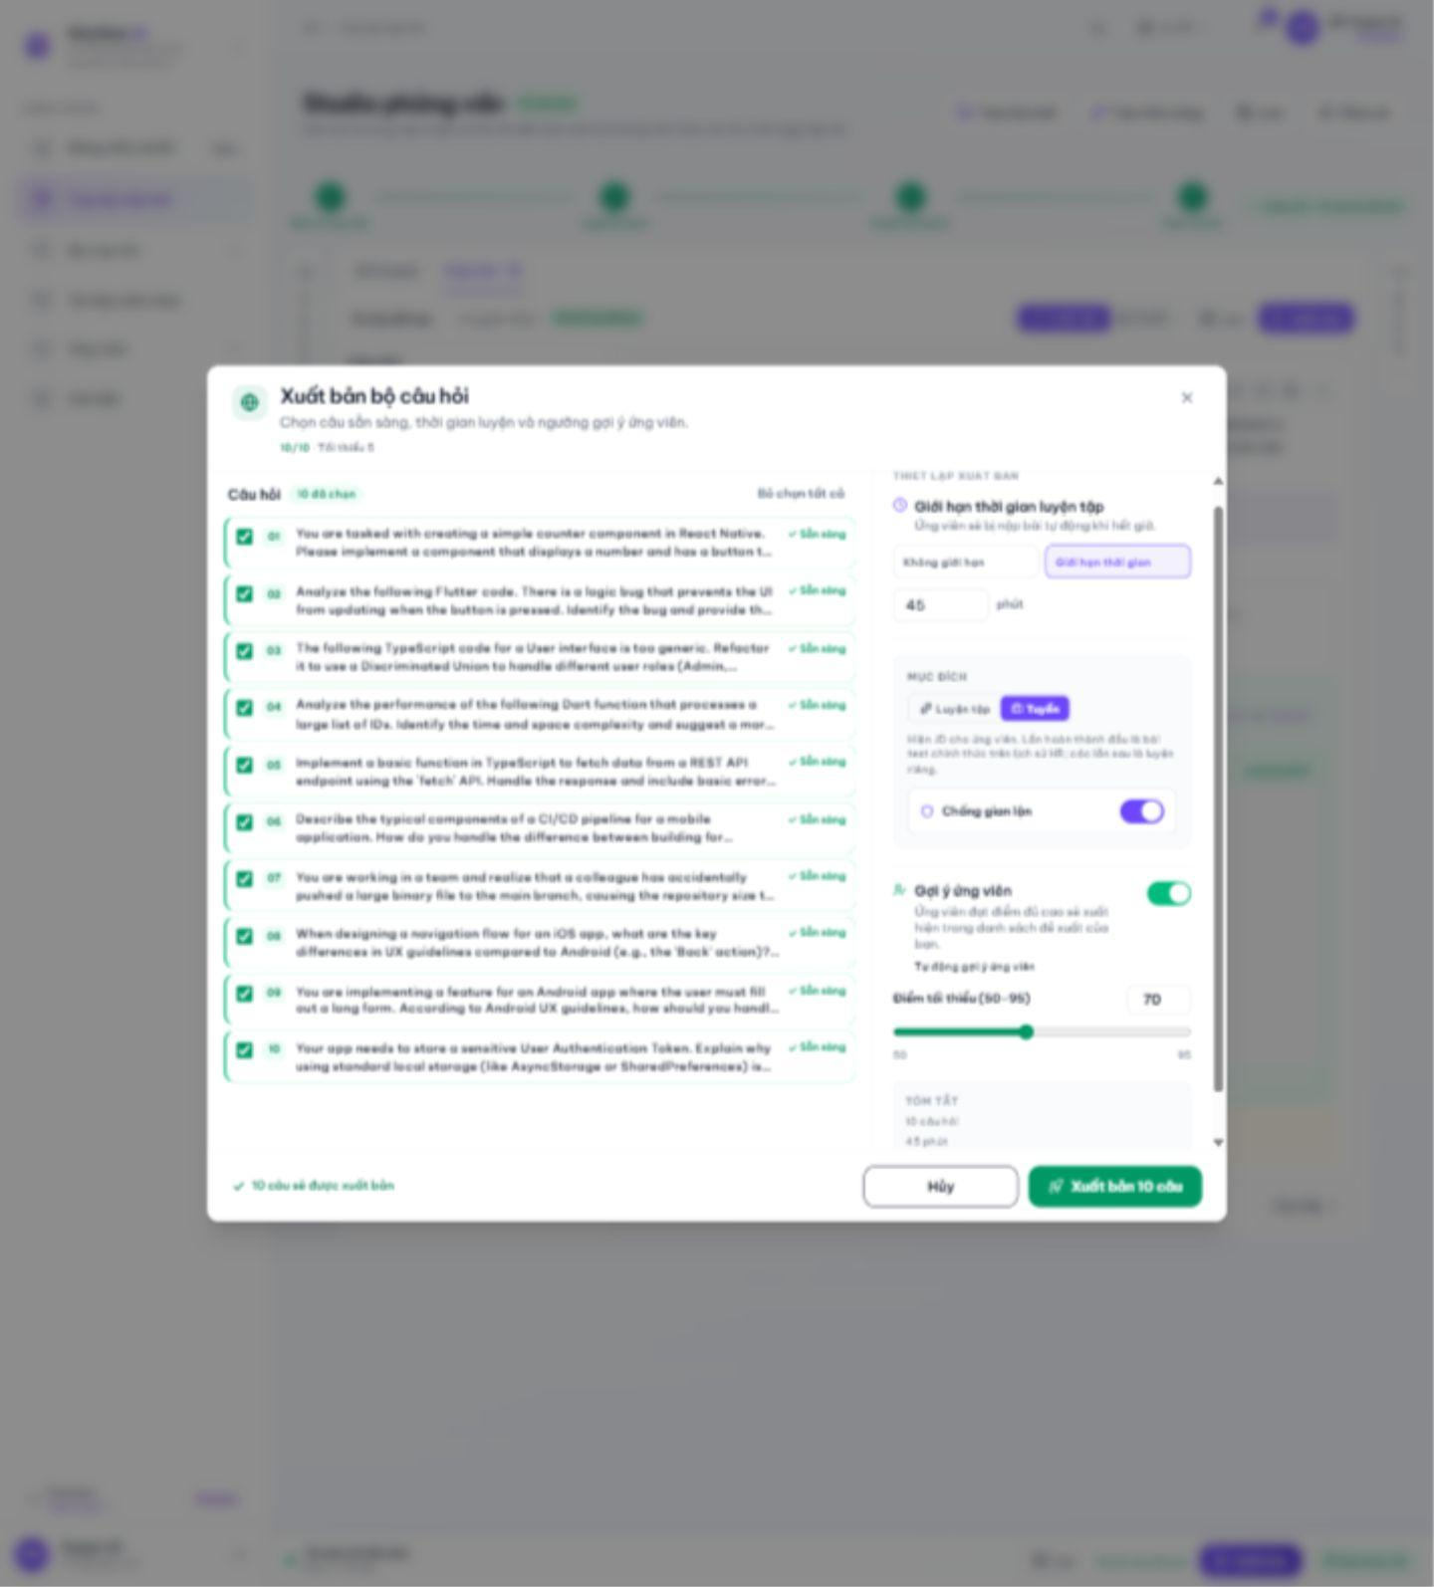
Figure 3.2.16. Hiring anti-cheat options.
3.2.2.7 Question Set History and JD Fit
Route: /hr/history; /hr/history/[id]. History lists owned sets and opens their detail. The JD-fit action evaluates question coverage against the stored JD and returns a verdict, missing topics and suggested changes.
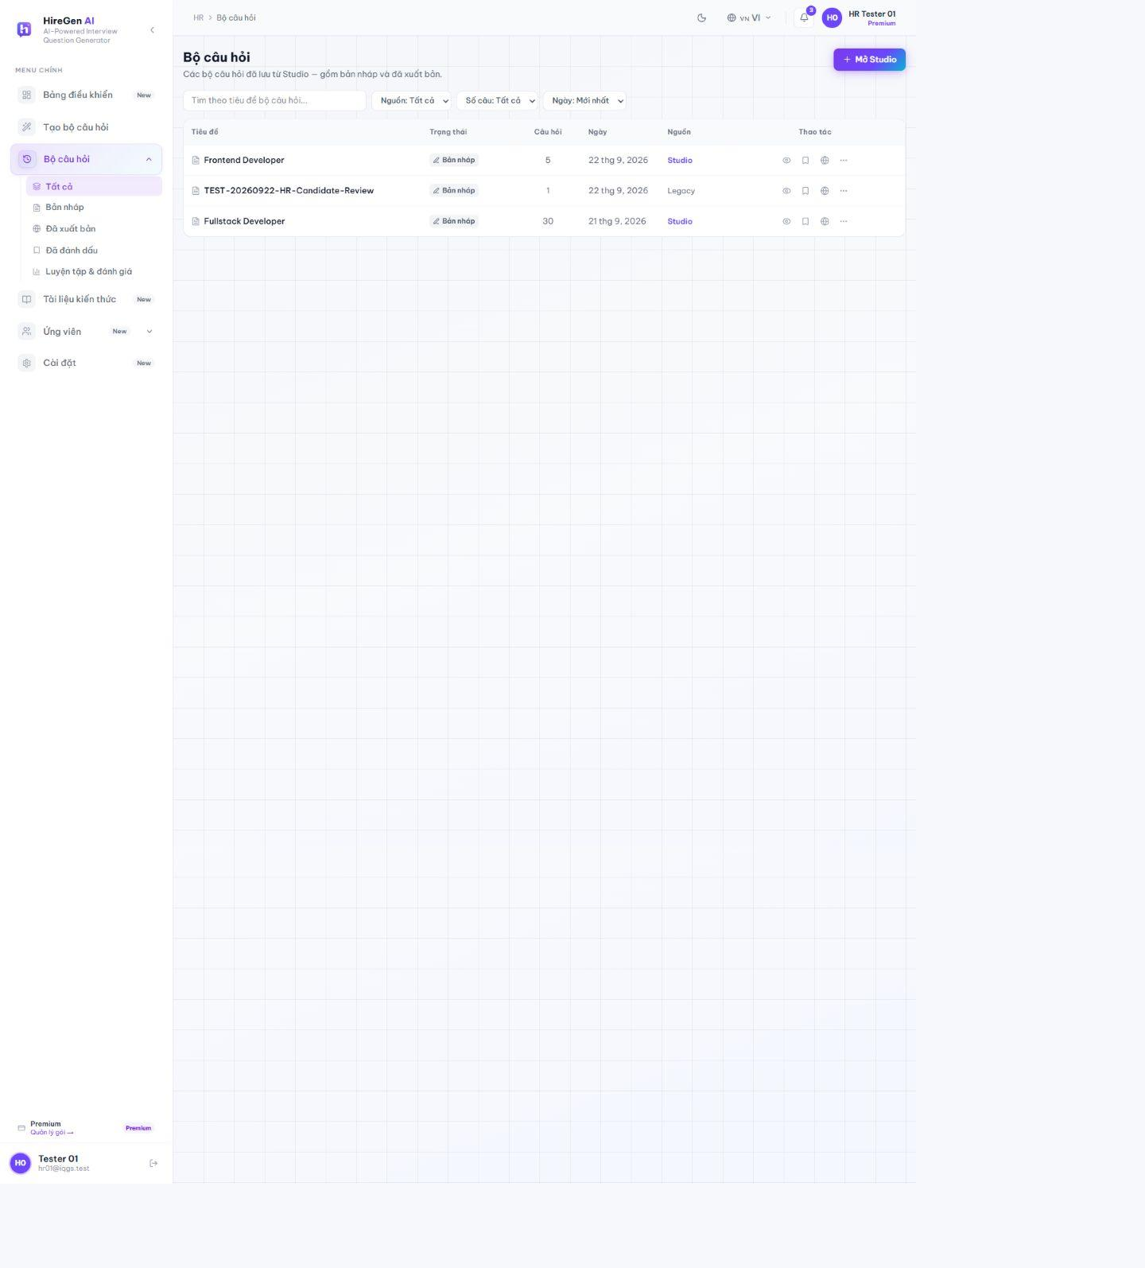
Figure 3.2.17. HR question-set history.
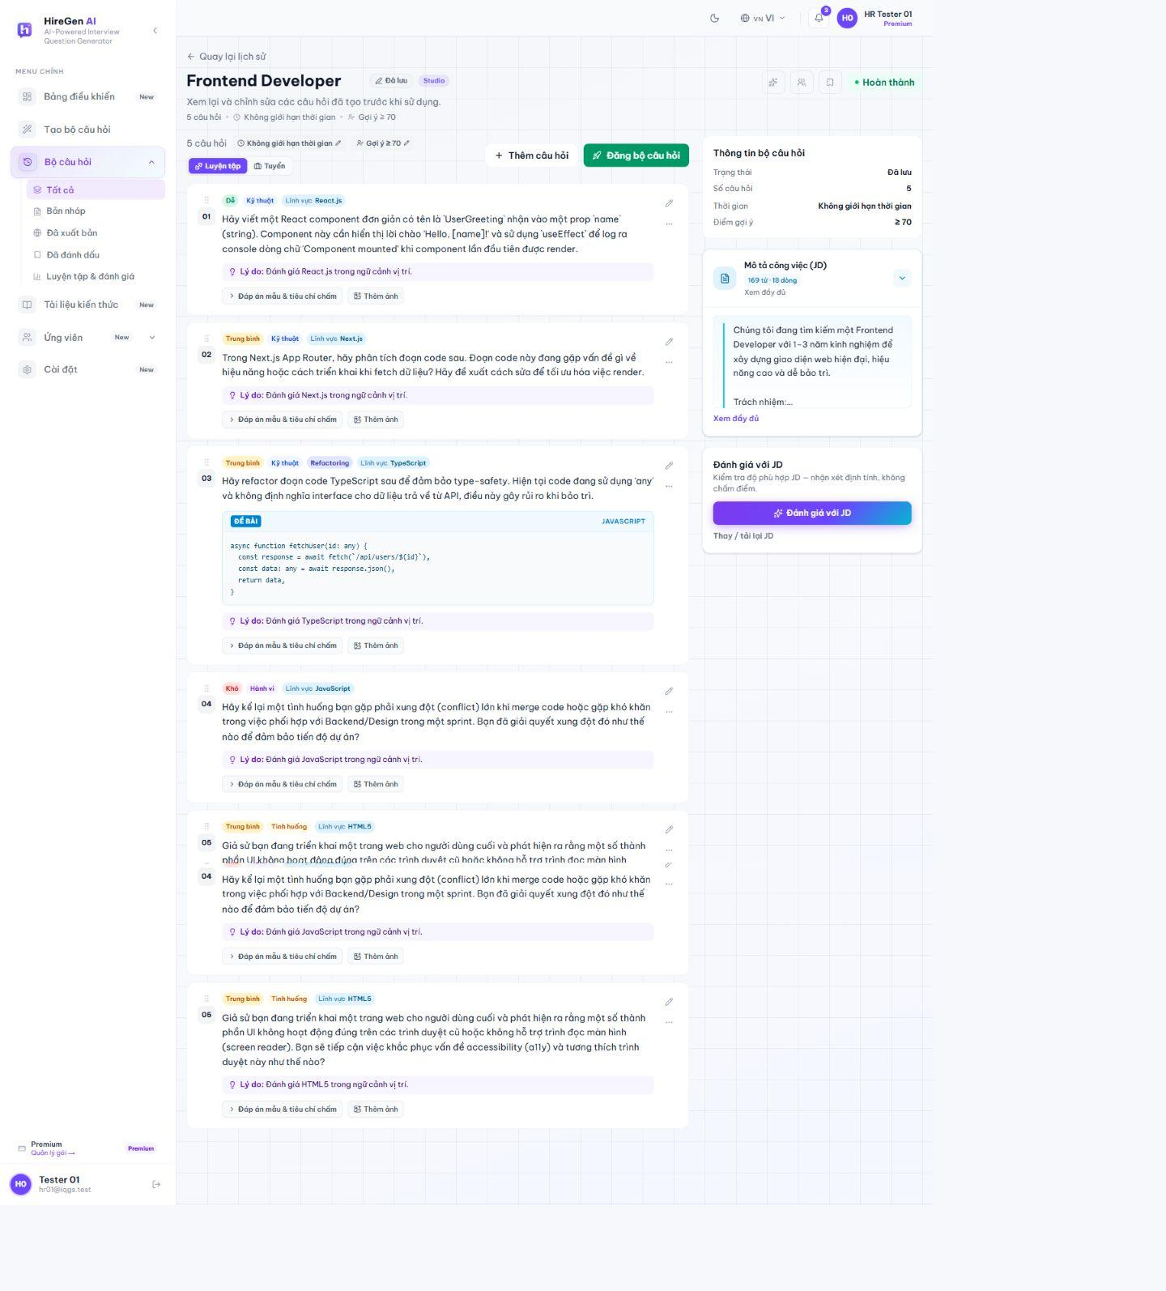
Figure 3.2.18. Question-set detail.
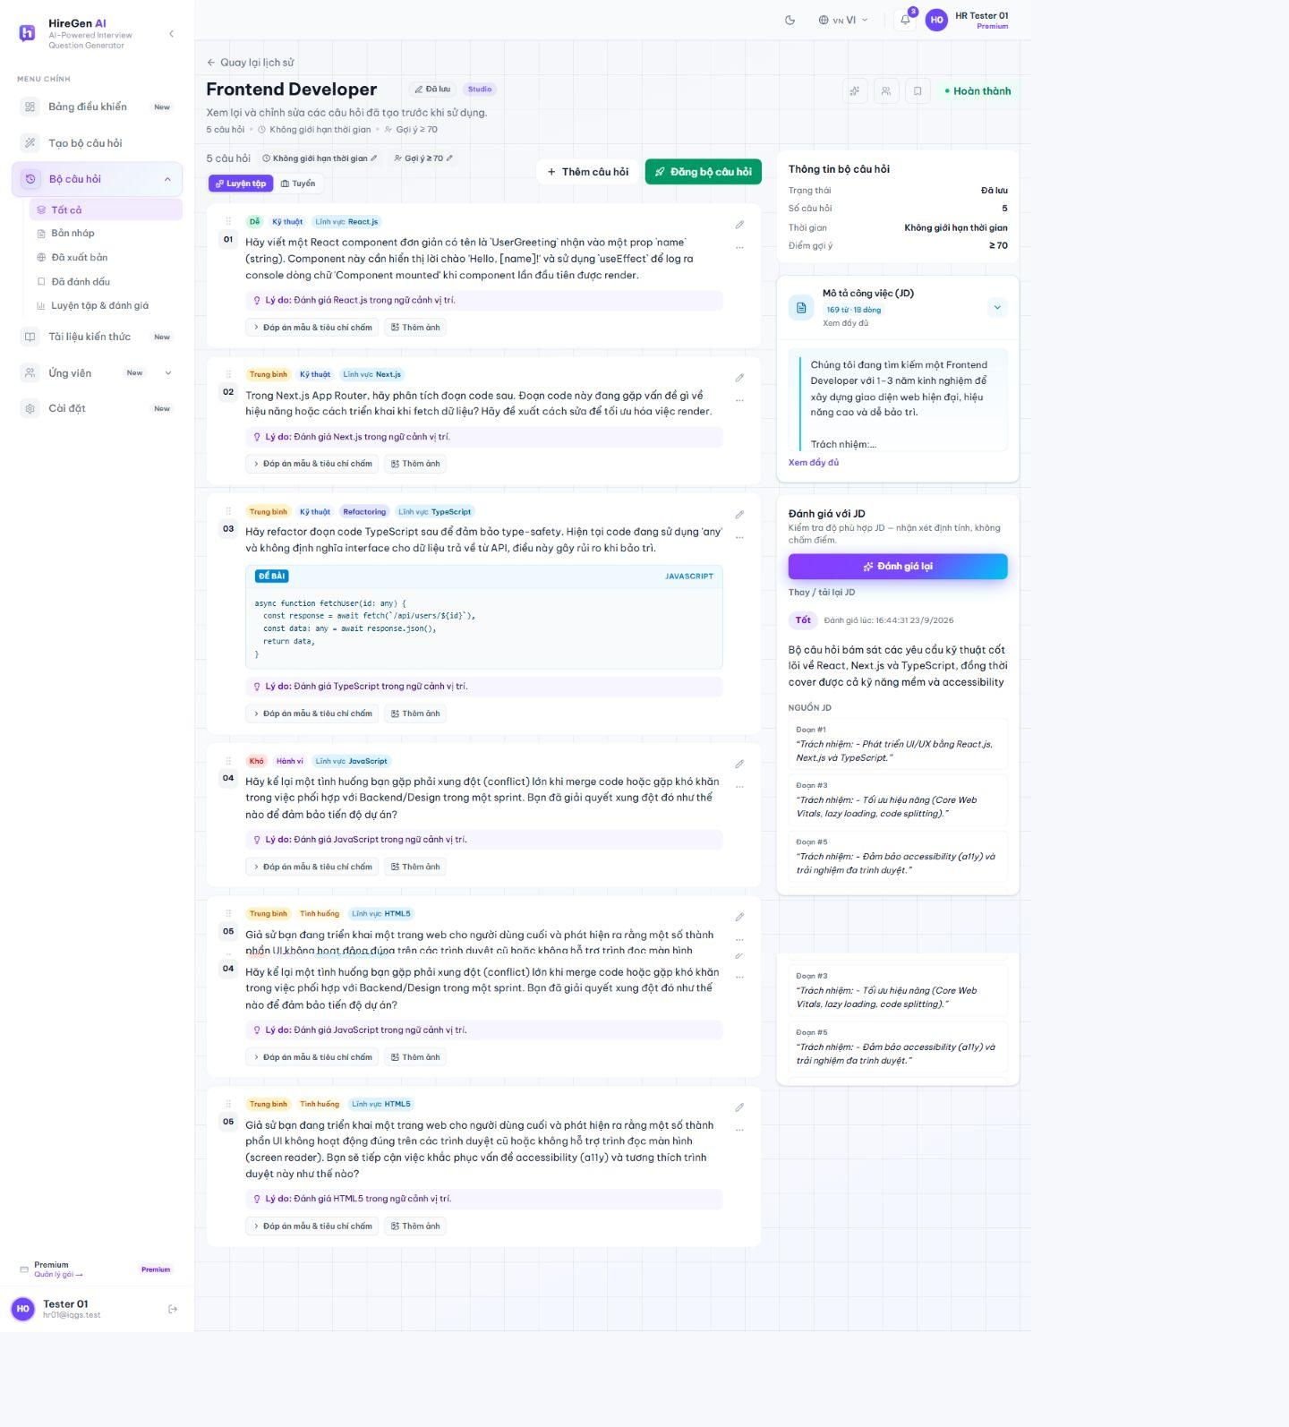
Figure 3.2.19. AI JD-fit review.
3.2.2.8 Published Sets
Route: /hr/published; /hr/published/[id]. The published-set workspace lists HR-owned sets available to candidates. HR01 currently has no published sets, so the actual empty state is shown; detail and practitioner routes require an owned published set.
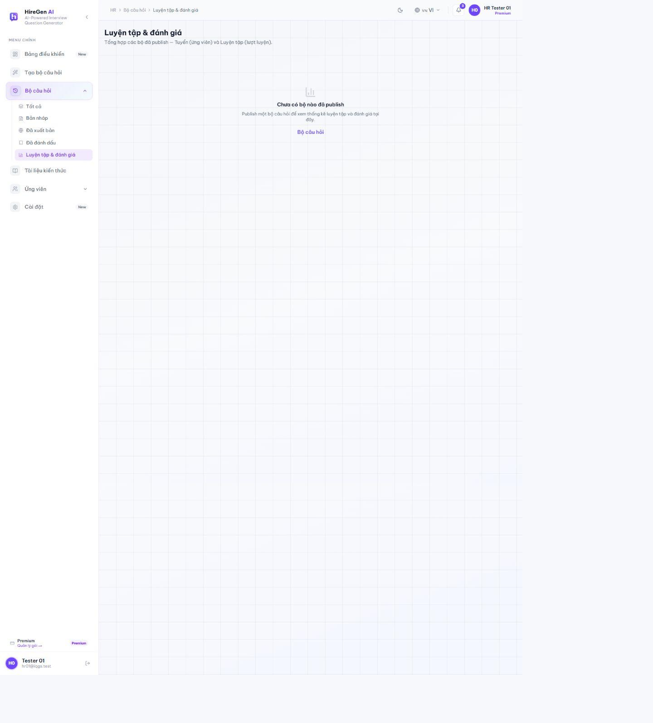
Figure 3.2.20. Published-set empty state for HR01.
3.2.2.9 HR Knowledge Documents
Route: /hr/knowledge. The HR knowledge screen manages the account's document sources for RAG. HR01 currently has no owned documents; this empty state is distinct from the system-wide Admin knowledge library.
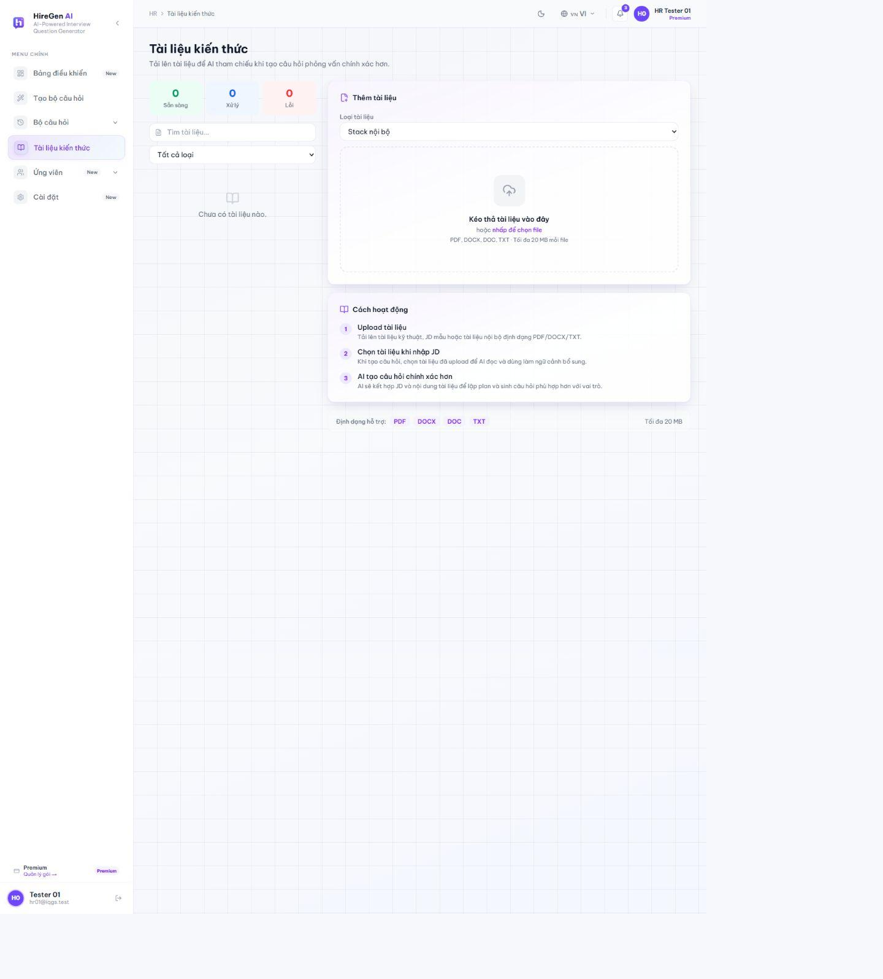
Figure 3.2.21. HR knowledge-library empty state.
3.2.2.10 Candidate Recommendations and Talent
Route: /hr/candidate-recommendations; /hr/talent. Recommendation results depend on matching practice evidence, eligibility and consent. The recommendation view is empty for HR01; the talent view exposes a candidate with prior practice results and drill-down to its profile and session evidence.
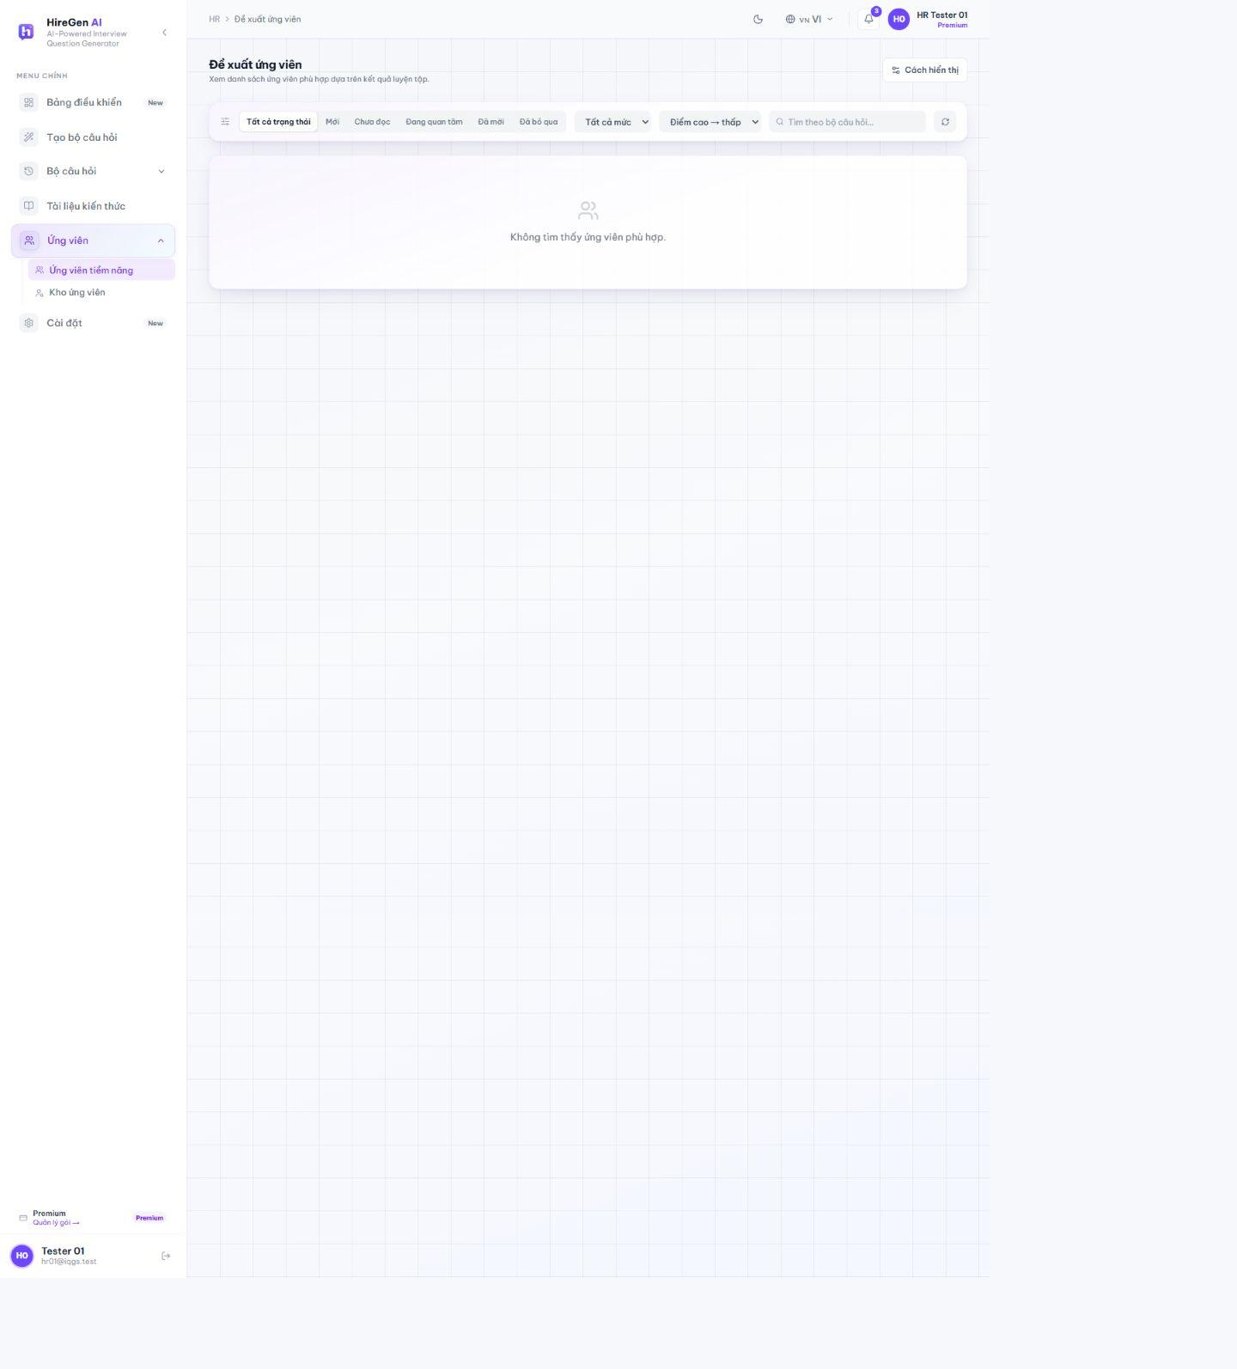
Figure 3.2.22. Candidate recommendation empty state.
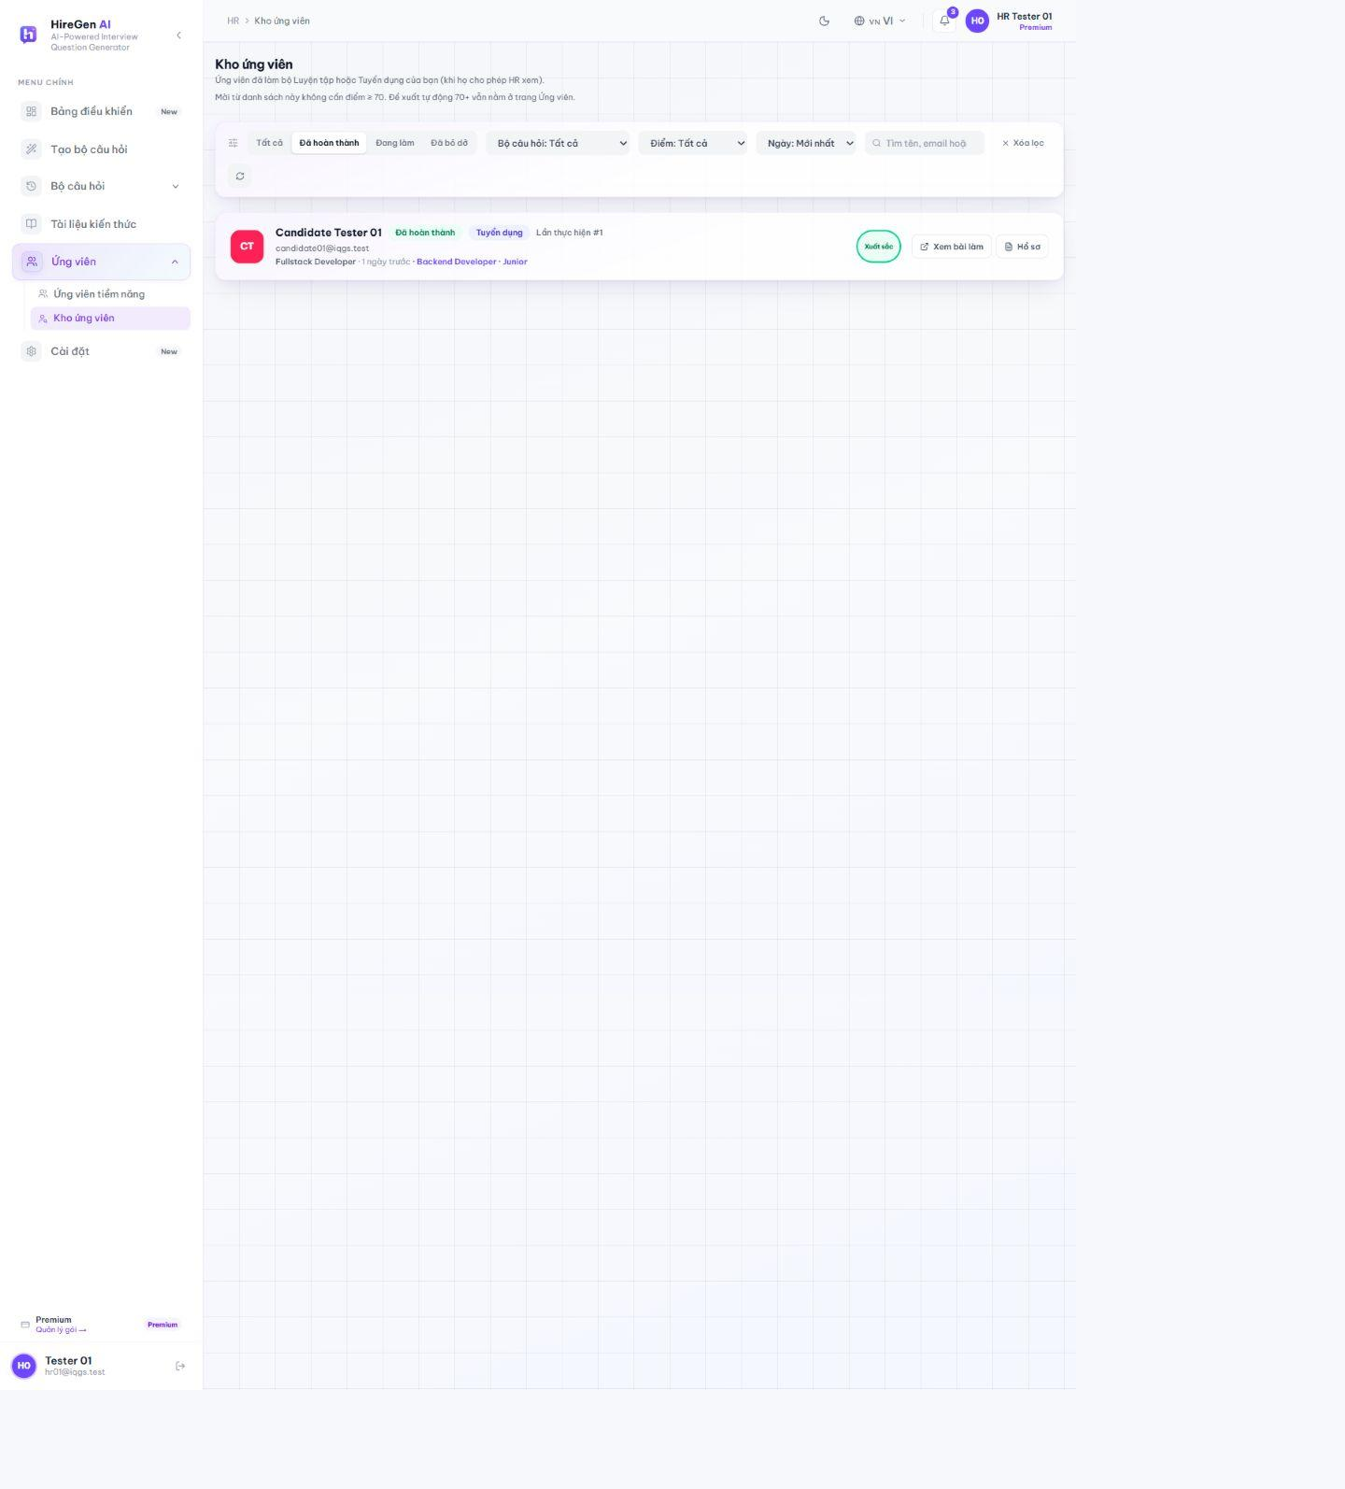
Figure 3.2.23. Talent list with practice evidence.
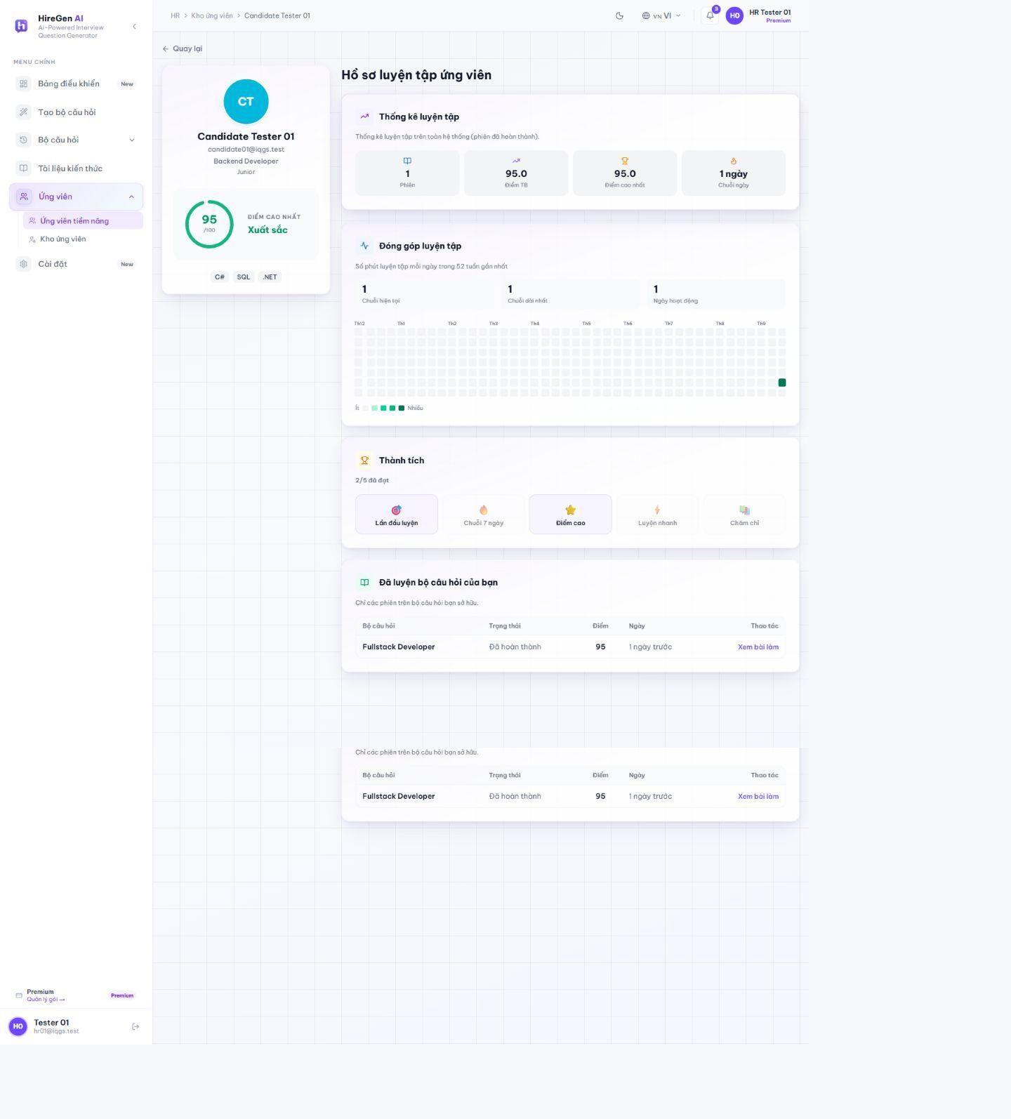
Figure 3.2.24. Candidate practice profile.
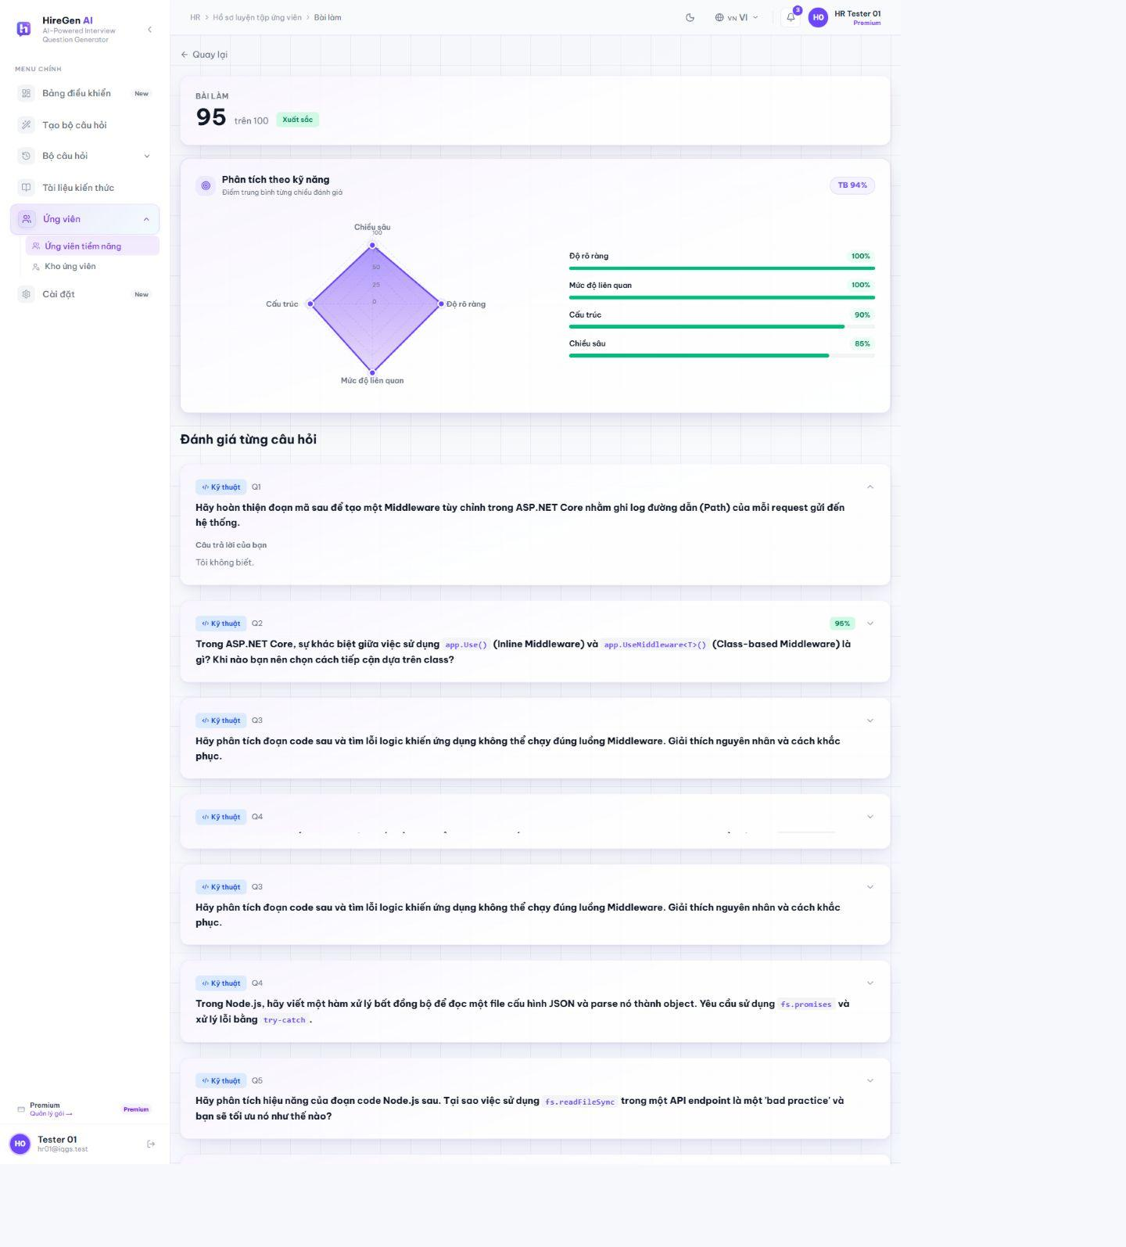
Figure 3.2.25. Candidate session review for HR.
3.2.2.11 HR Settings and Subscription
Route: /hr/settings. The HR settings view provides account profile, preferences, security and billing tabs. Password change is a separate protected action; the documentation capture records the form only.
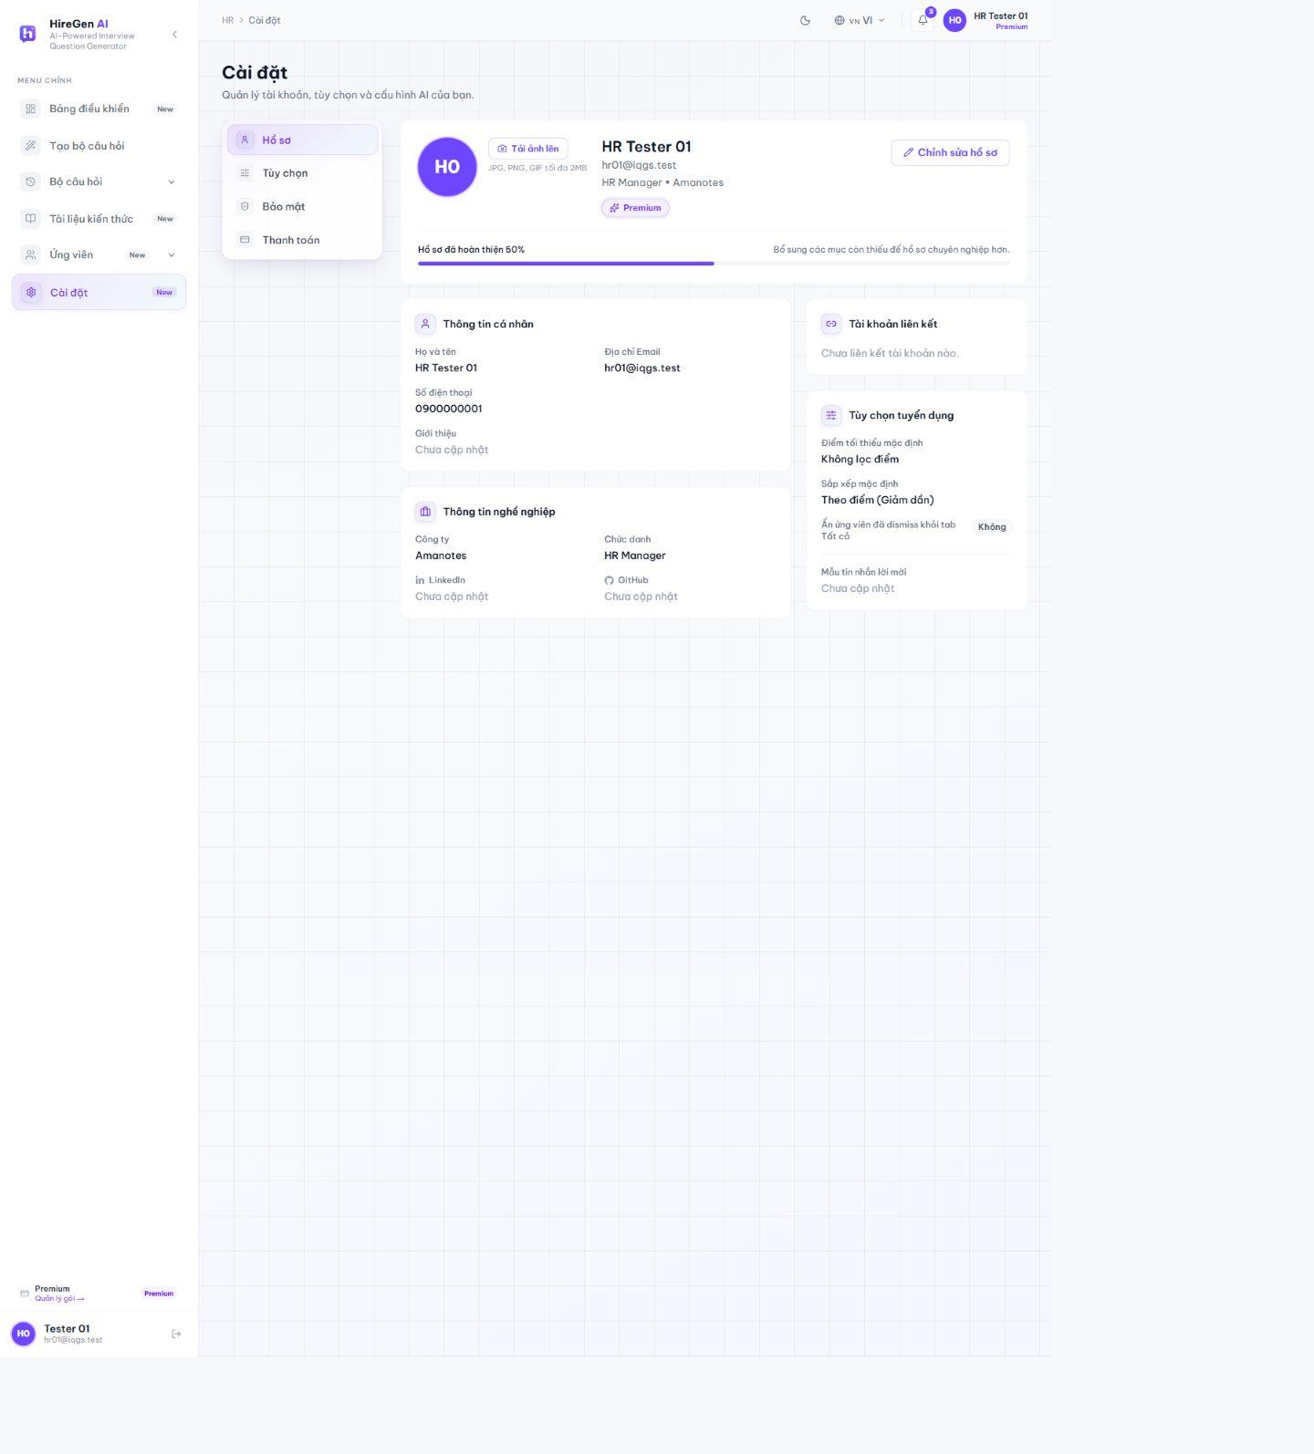
Figure 3.2.26. HR profile settings.
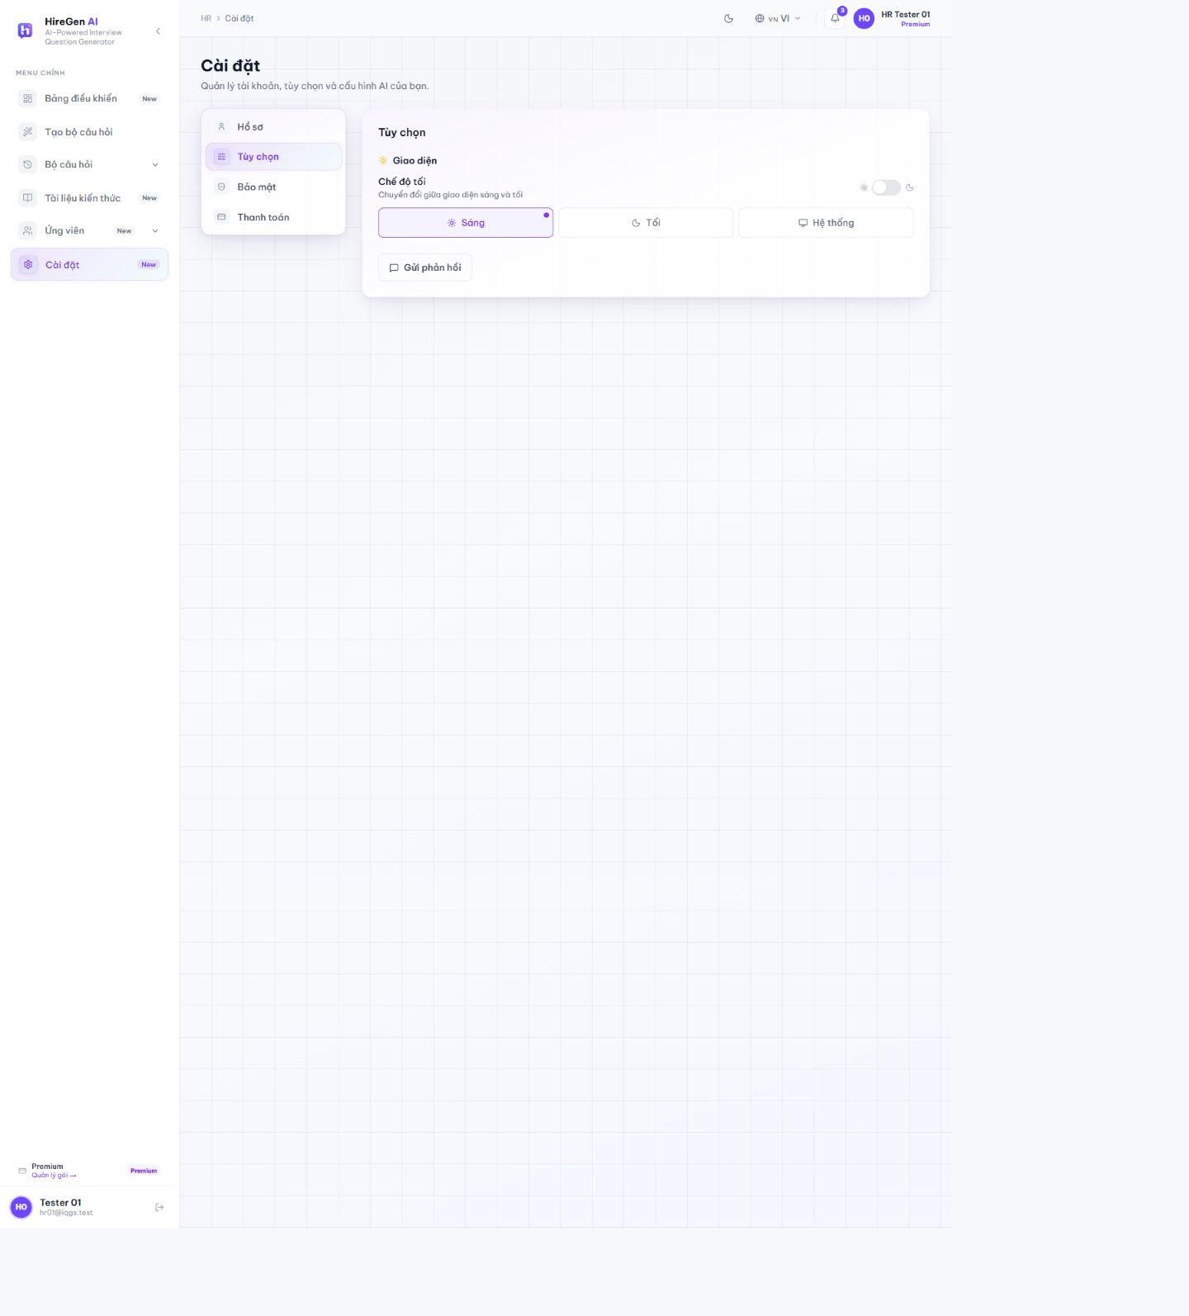
Figure 3.2.27. HR preferences.
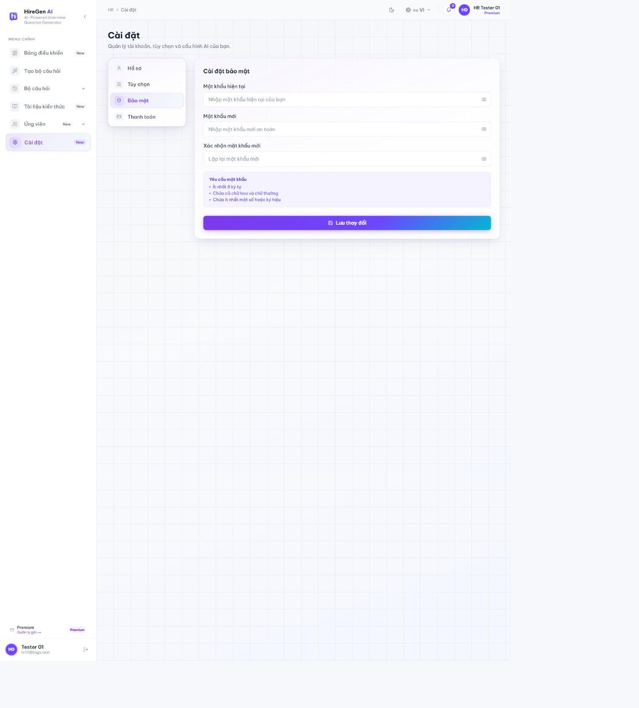
Figure 3.2.28. HR security settings.
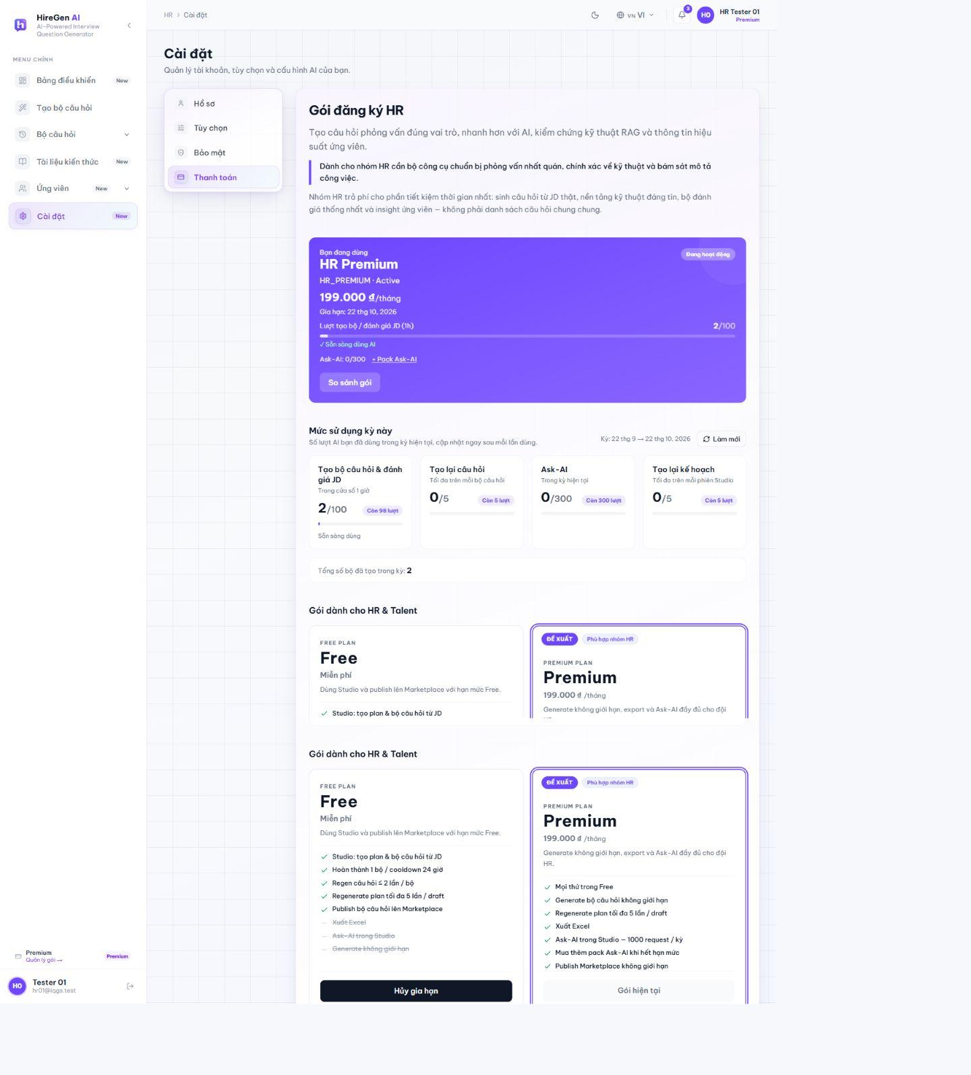
Figure 3.2.29. HR Premium subscription.

3.2.3 Candidate Workspace
3.2.3.1 Dashboard and Marketplace
Route: /candidate/dashboard; /candidate/practice. The dashboard summarizes practice and progress. The marketplace lists published sets with search and filters; it is the entry point for practice.
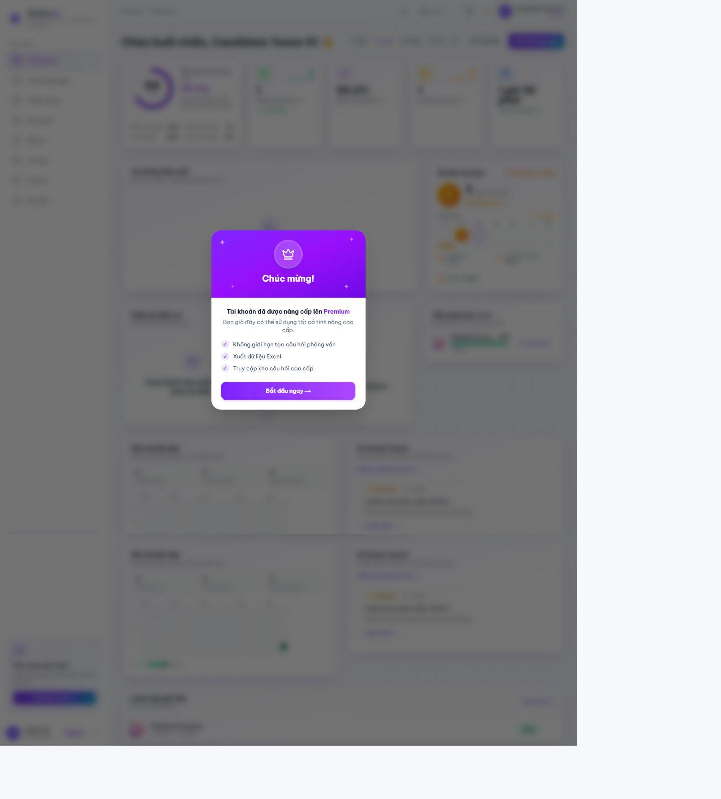
Figure 3.2.30. Candidate dashboard.
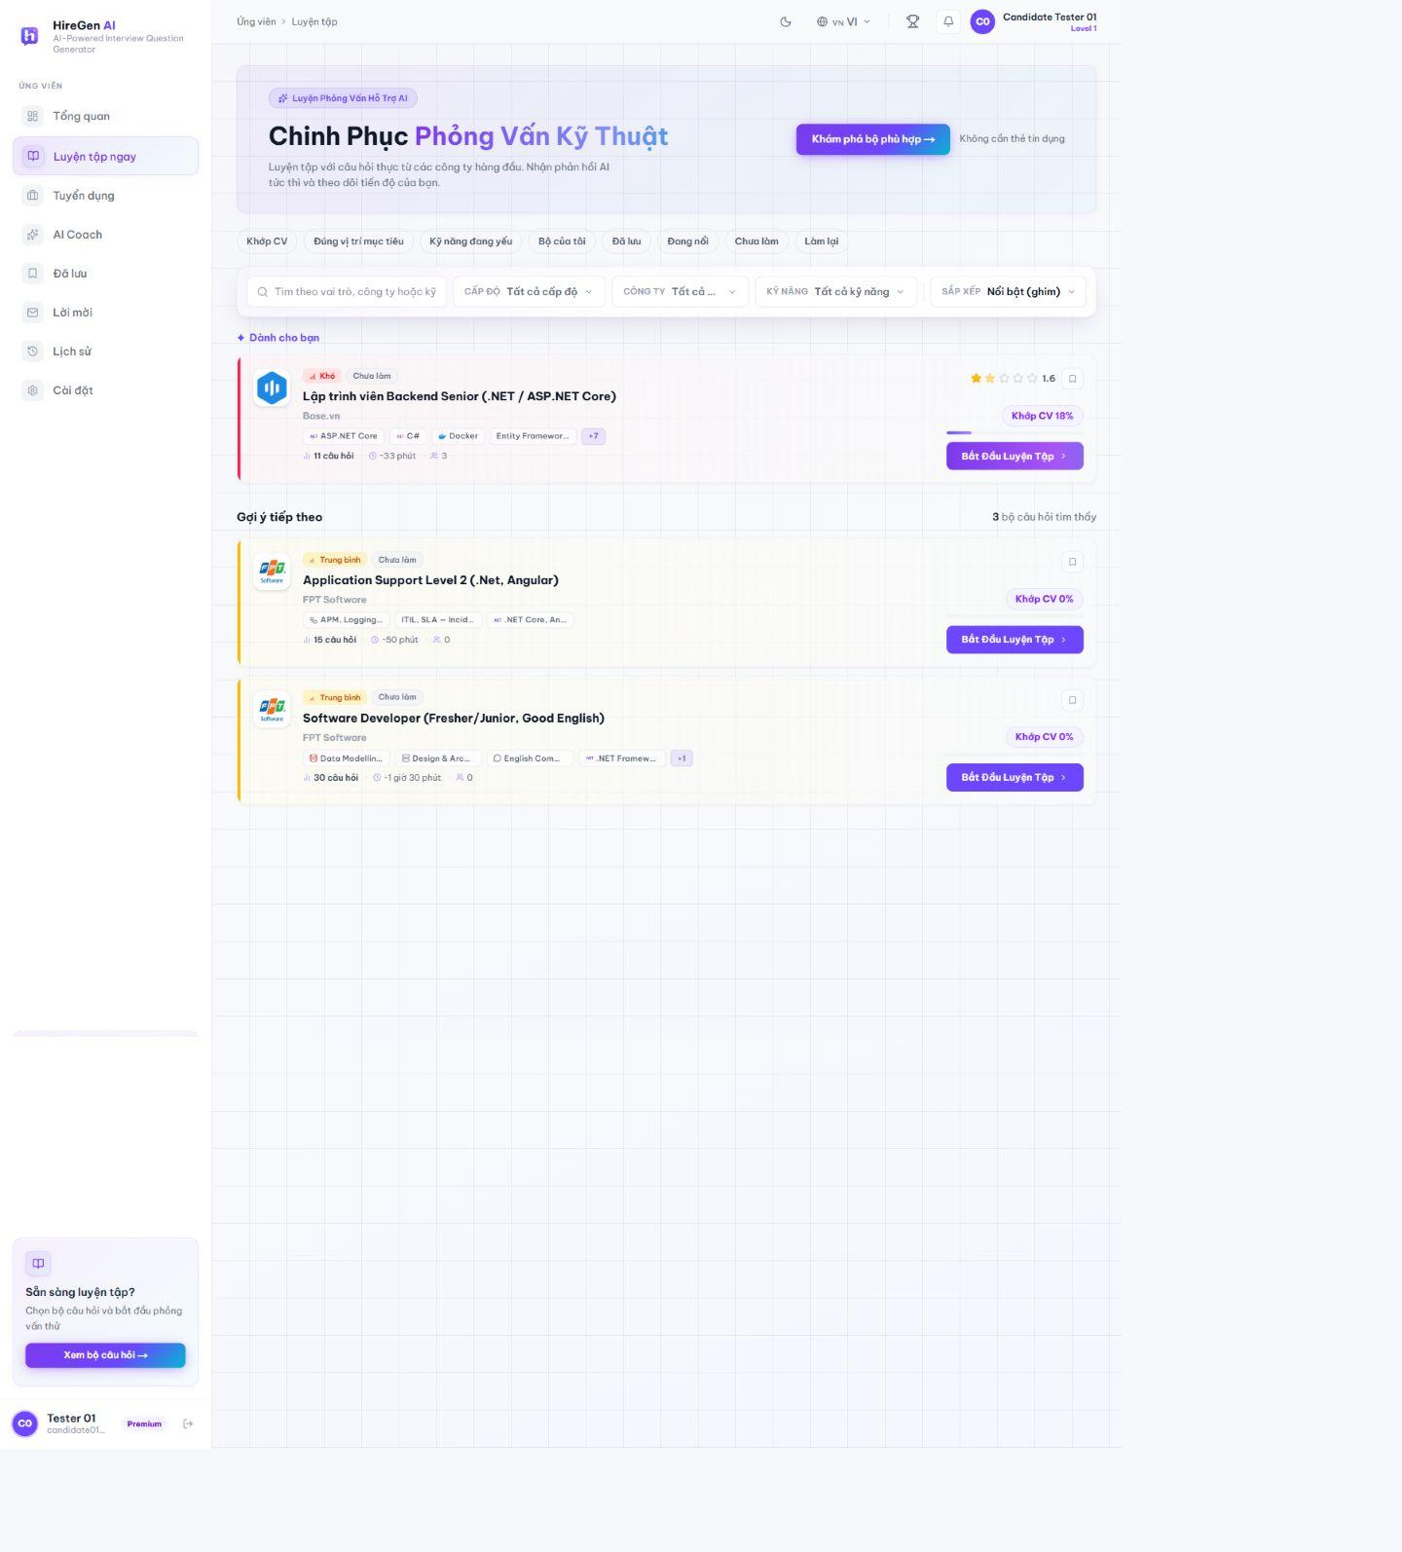
Figure 3.2.31. Question-set marketplace.
3.2.3.2 Question-Set Detail
Route: /candidate/sets/[id]. The detail page shows company, difficulty, question mix, skills, estimated duration and practice action before an attempt begins.
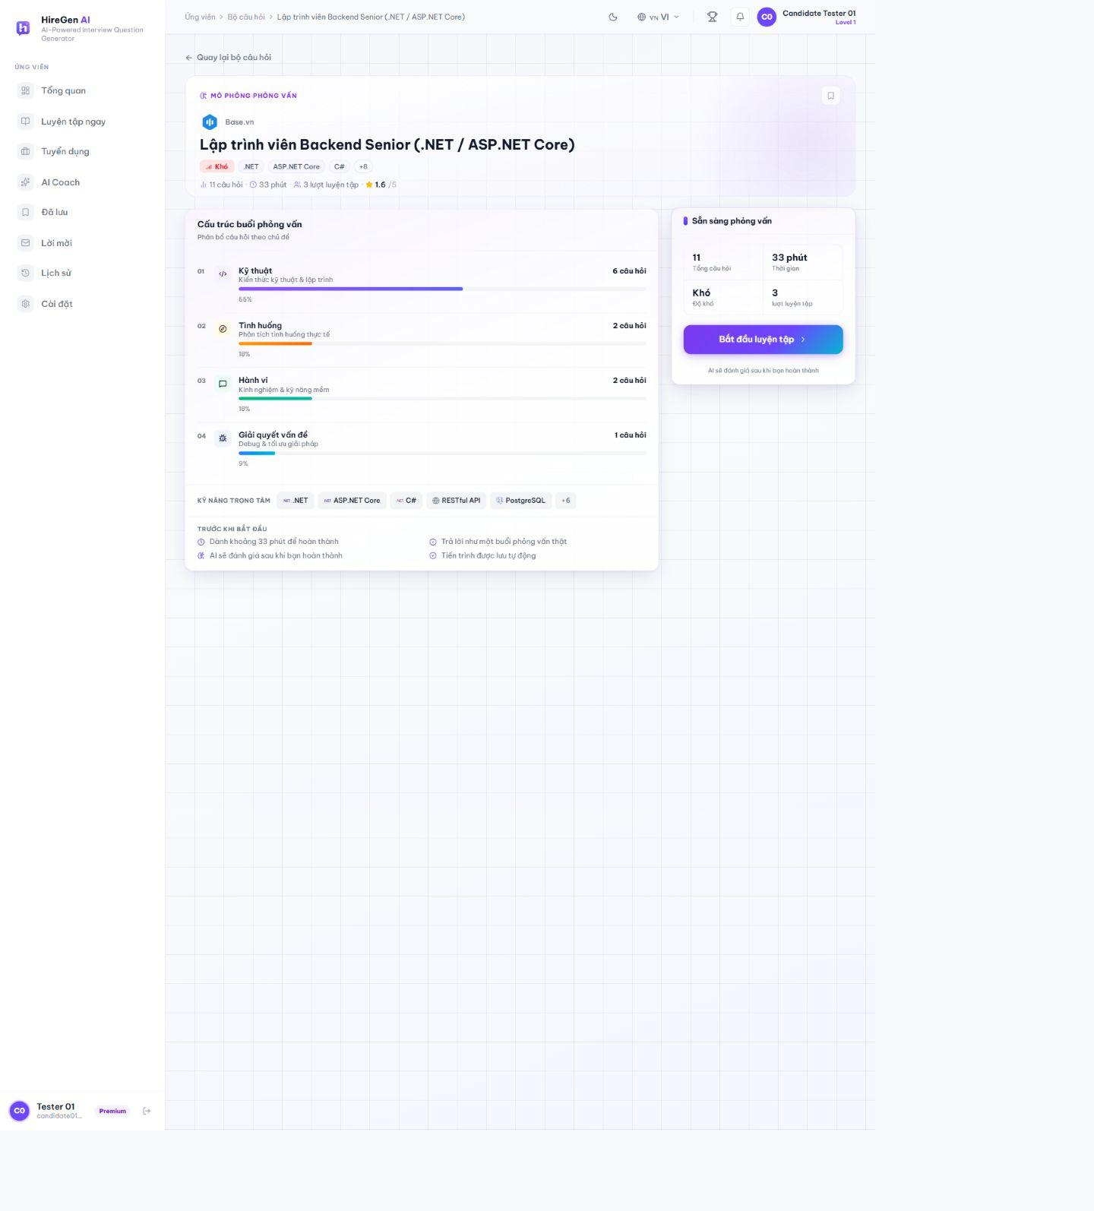
Figure 3.2.32. Published question-set detail.
3.2.3.3 Timed Practice and Submission
Route: /candidate/practice/[id]. A candidate answers text and code questions in a timed session. Answers save during the attempt; completion requires all available questions and a confirmation before AI scoring.
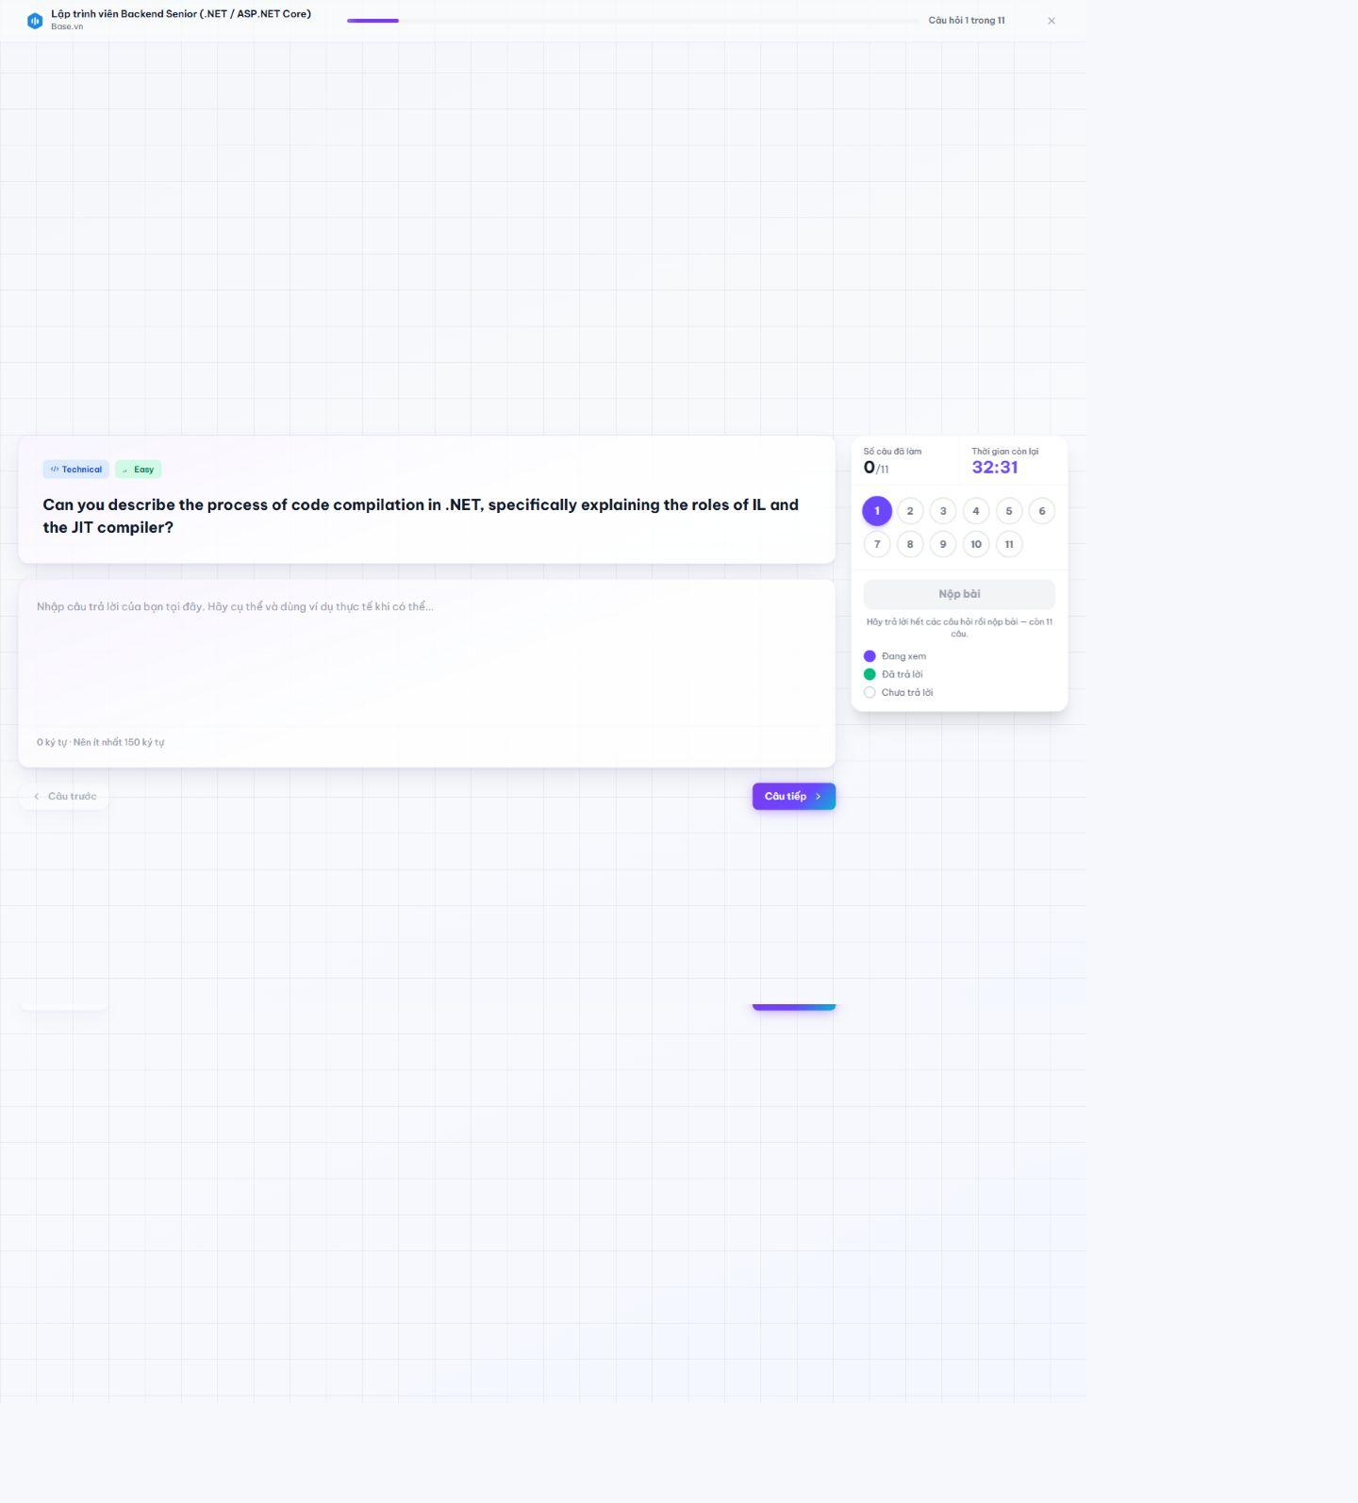
Figure 3.2.33. Text-answer question in an active session.
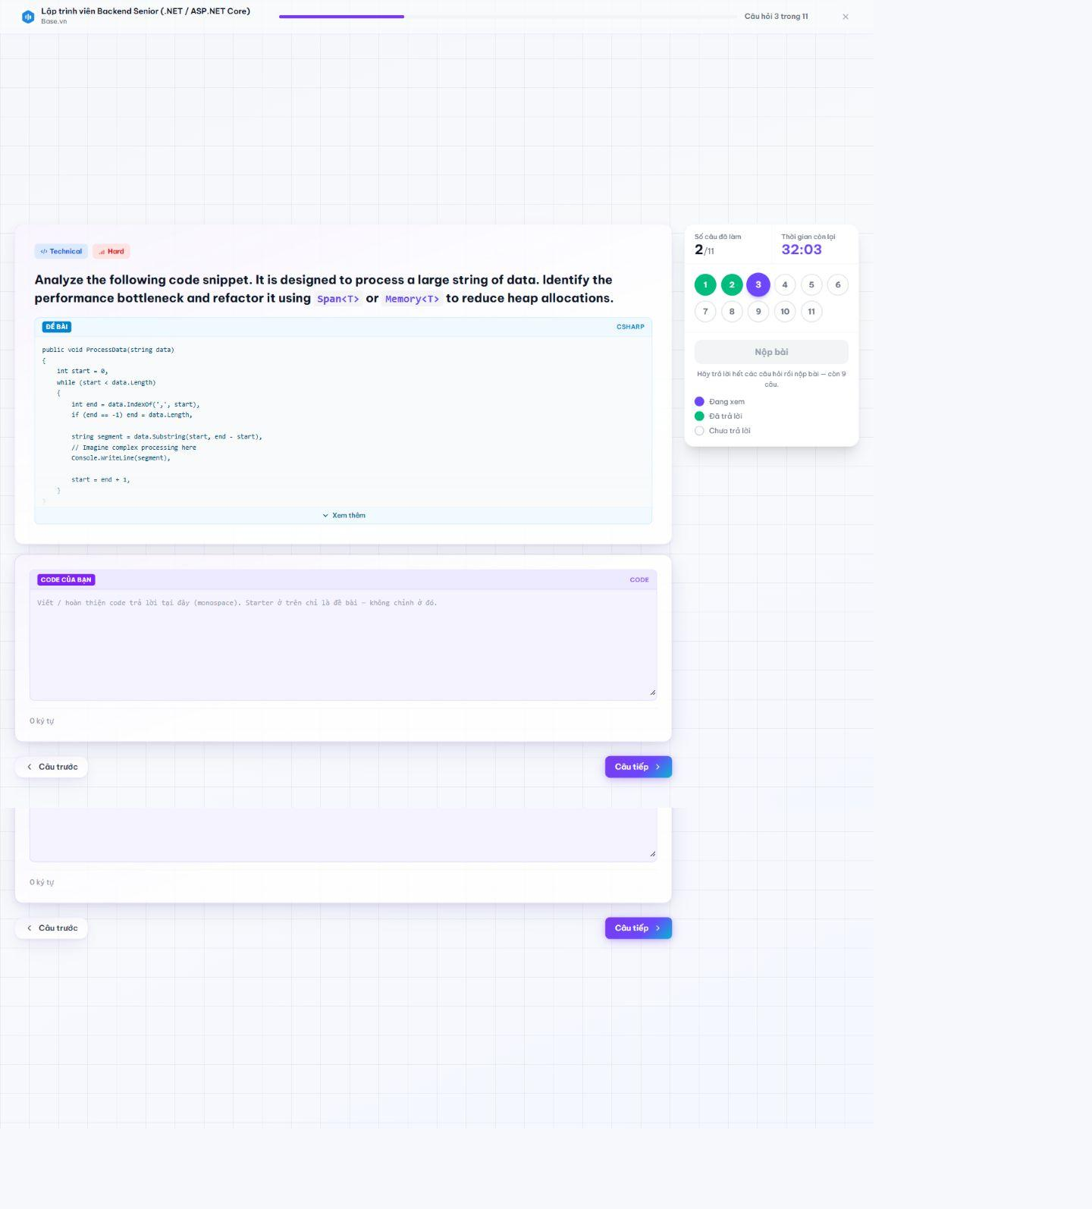
Figure 3.2.34. Code-answer question in an active session.
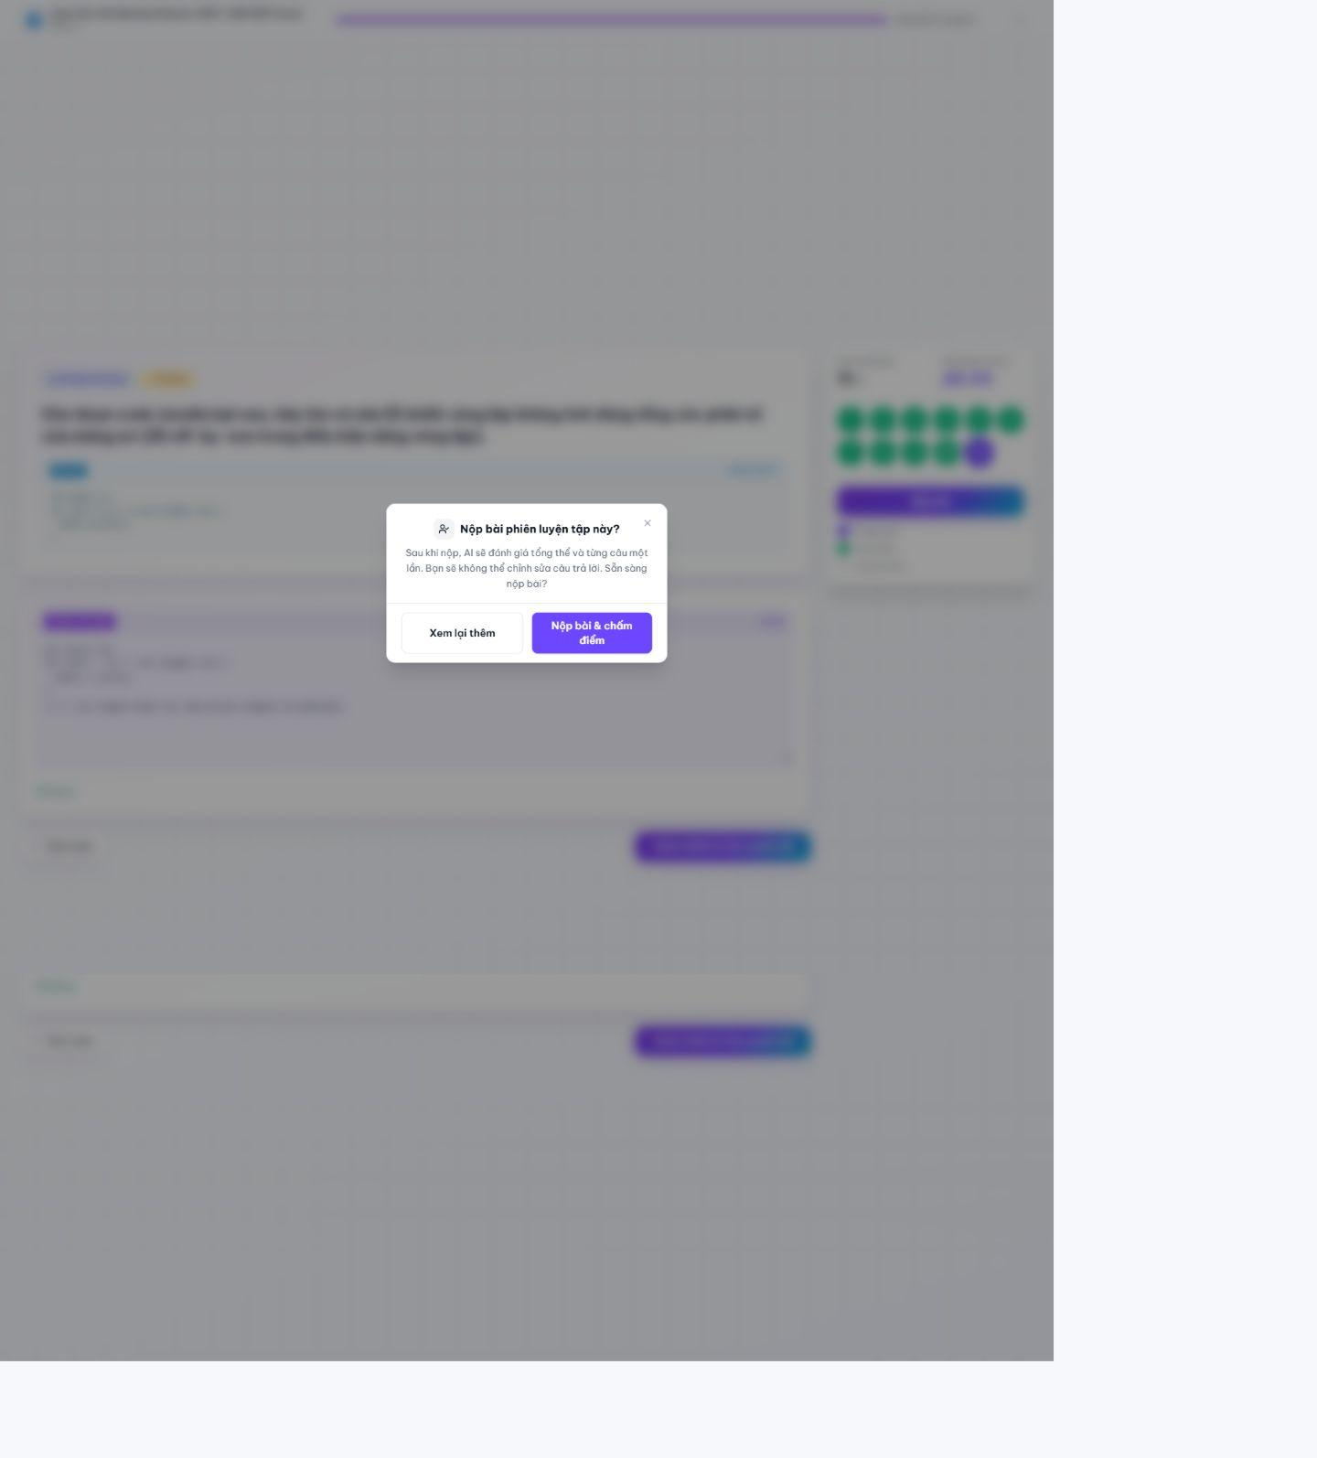
Figure 3.2.35. Submit-session confirmation.
3.2.3.4 AI Result and Practice History
Route: /candidate/practice/[id]/result; /candidate/history. The completed result shows overall score, AI insight, skill dimensions, improvement plan and per-question review. History lists completed and unfinished sessions with links back to results.
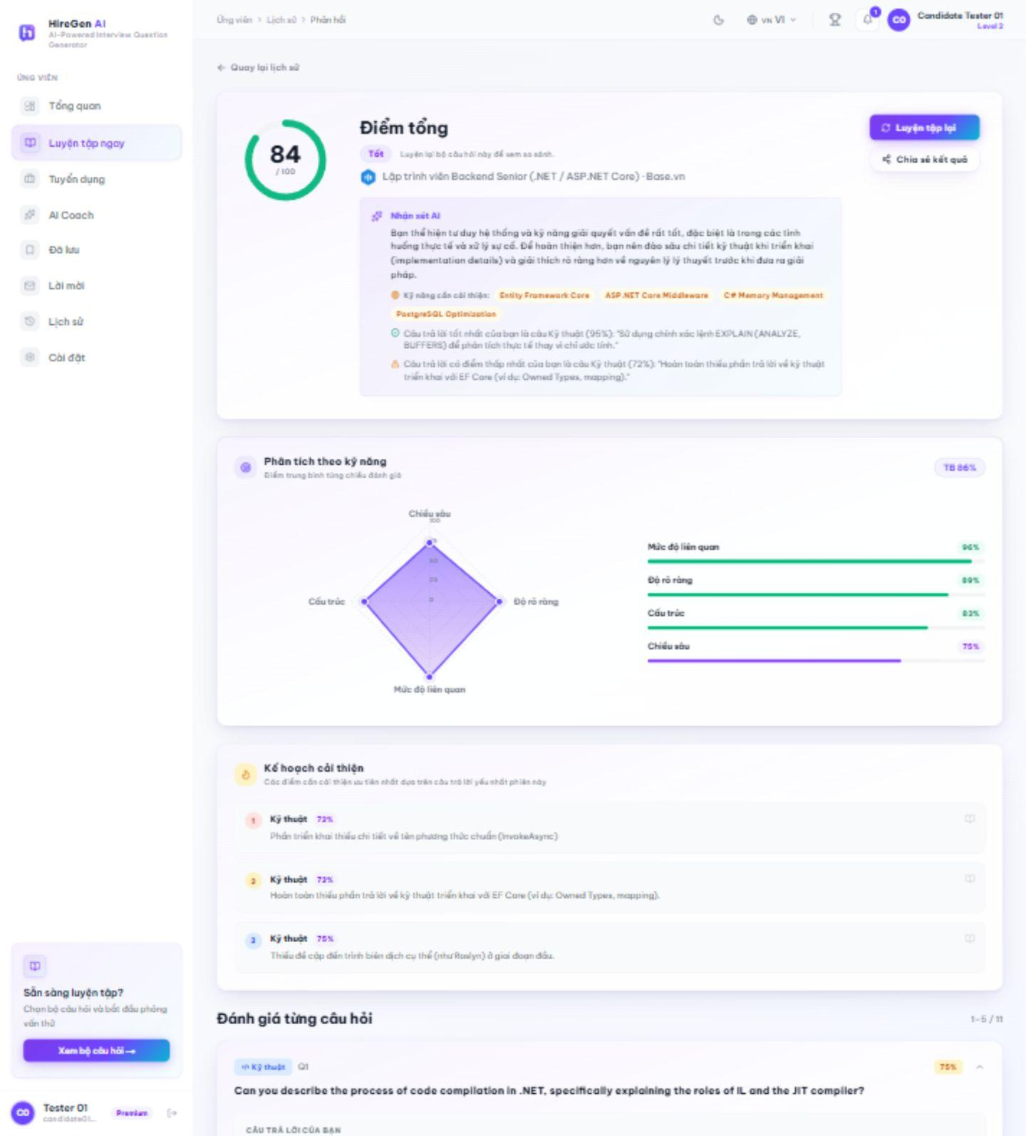
Figure 3.2.36. AI result for a completed live practice session.
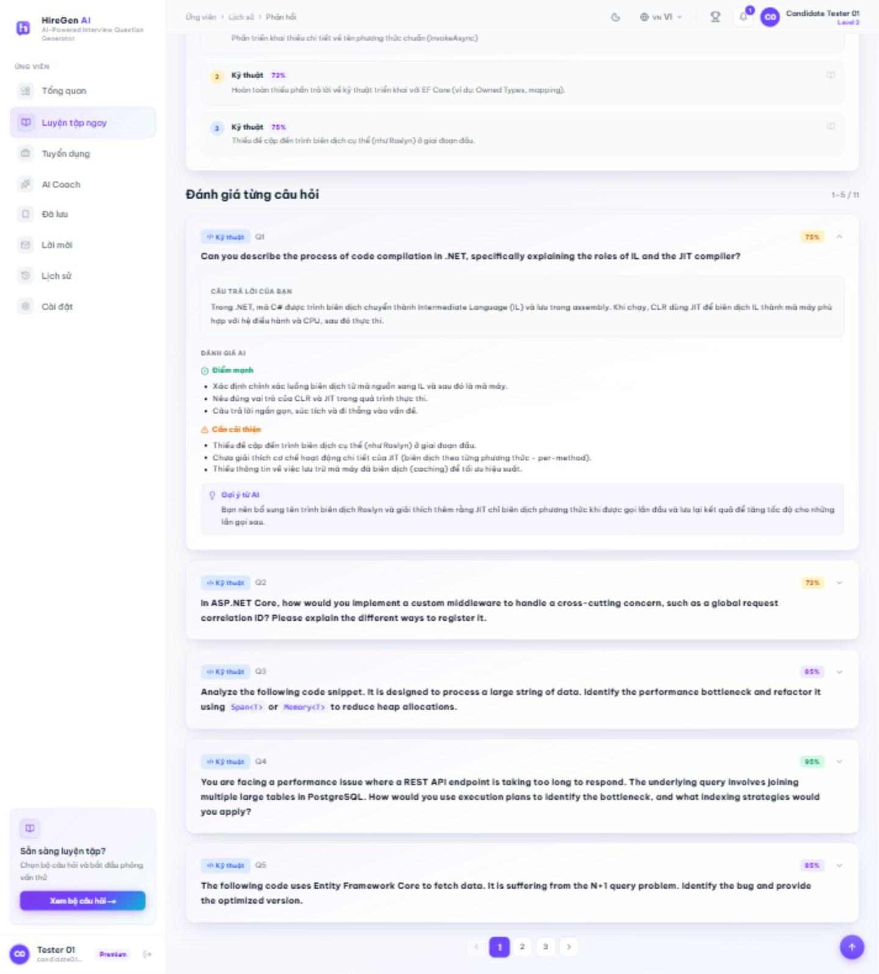
Figure 3.2.37. Per-question AI feedback and improvement advice.
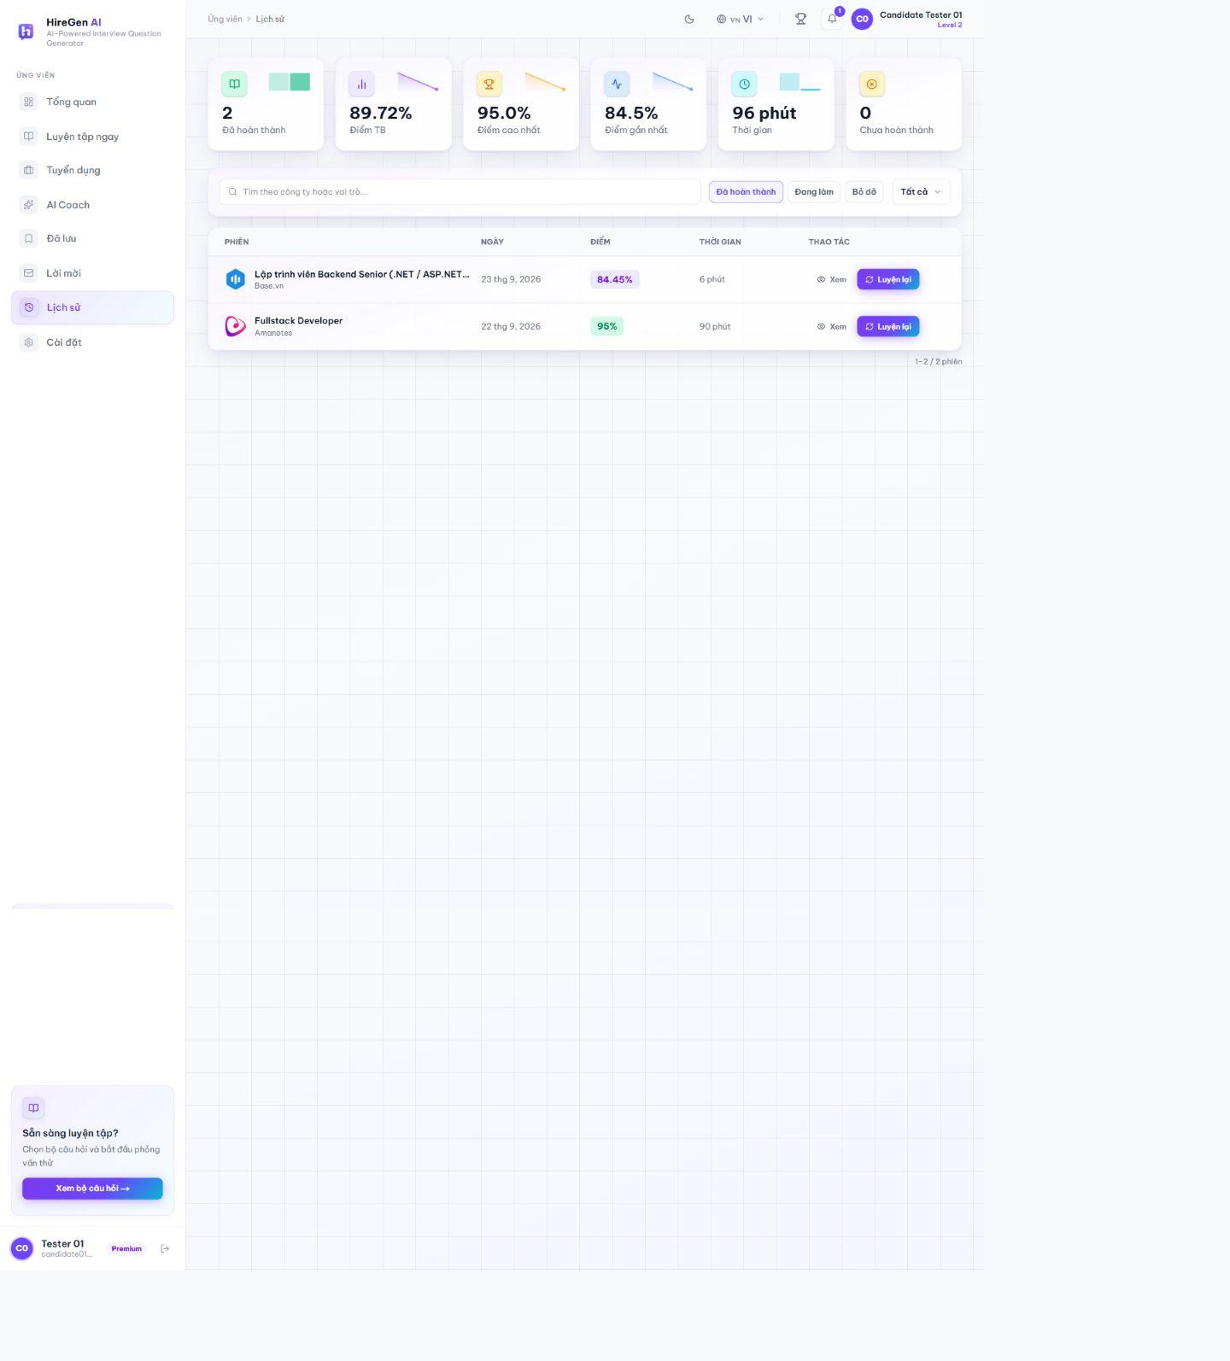
Figure 3.2.38. Practice history with two completed sessions.
3.2.3.5 Recruitment Listings and Detail
Route: /candidate/jobs; /candidate/jobs/[id]. The recruitment view lists live openings and shows a selected role beside the list. The full detail page shows the JD, skills, company information and assessment entry.
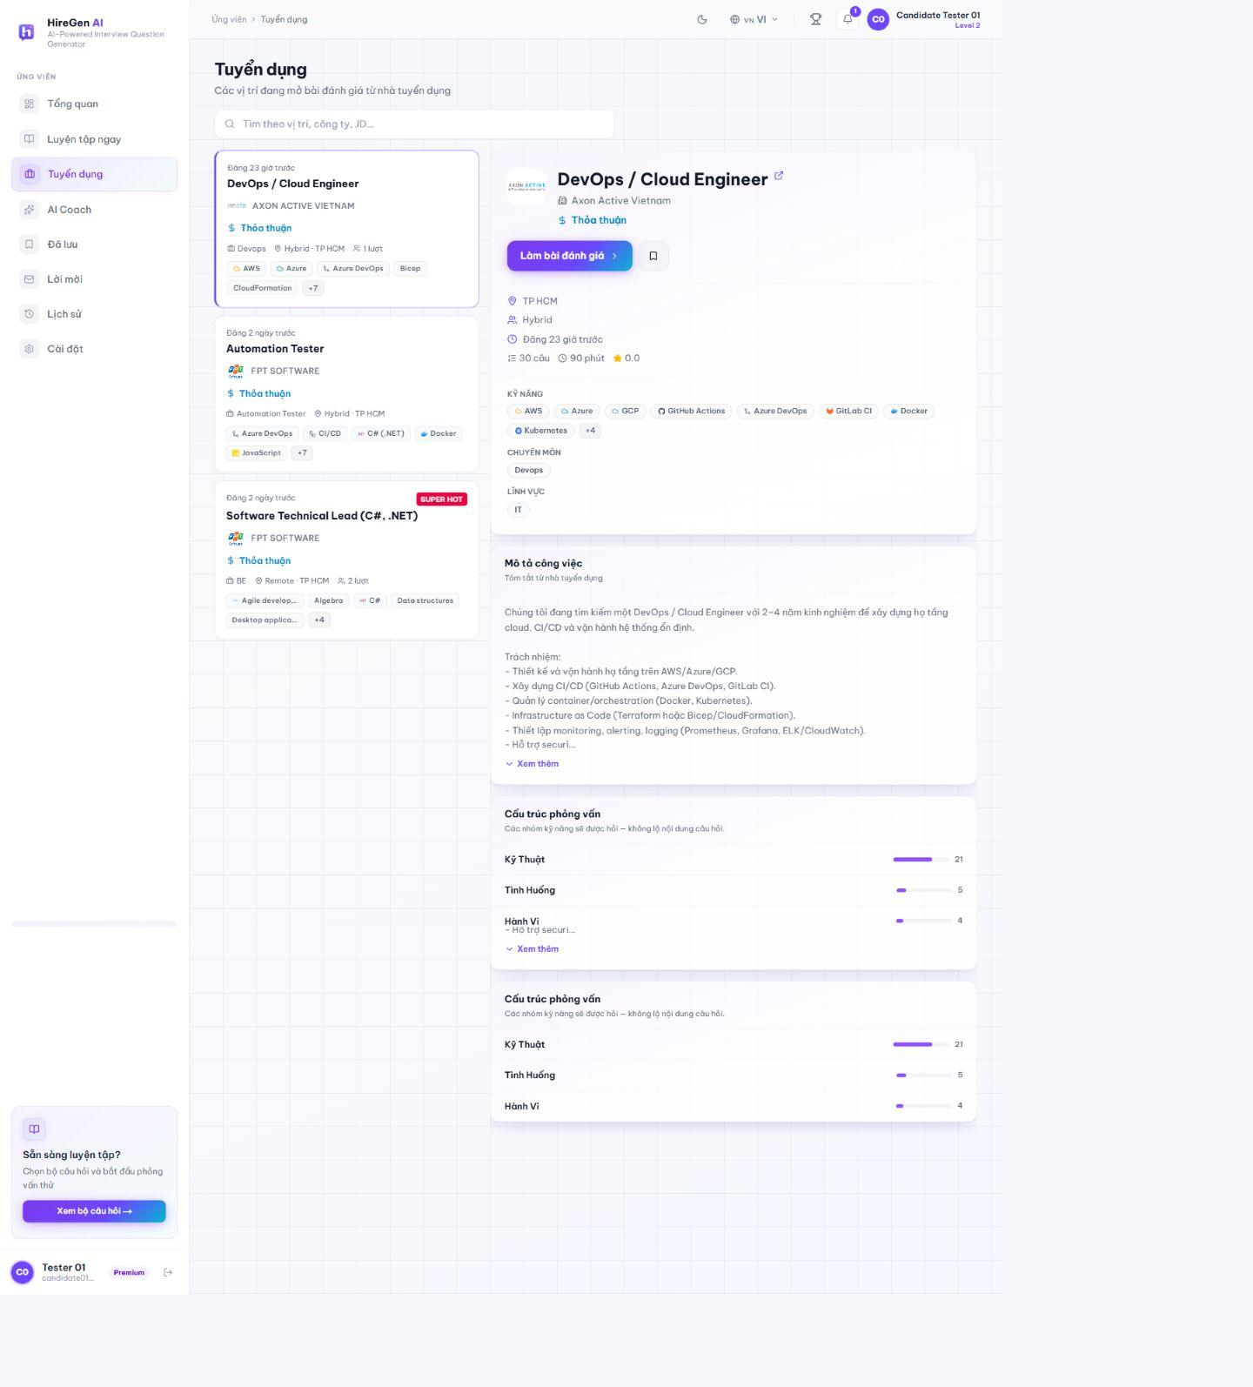
Figure 3.2.39. Recruitment list with selected role.
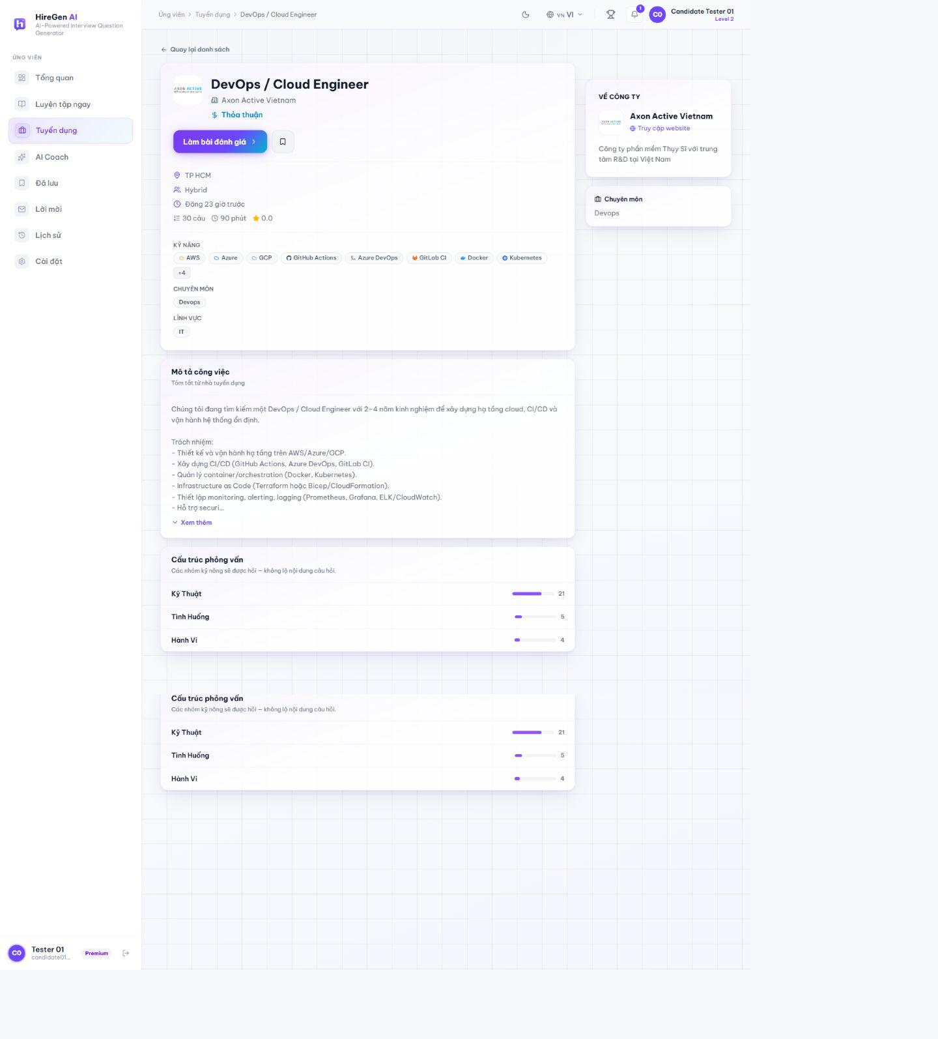
Figure 3.2.40. Full role detail.
3.2.3.6 AI Coach: Skill Profile and Diagnostic
Route: /candidate/coach; /candidate/practice/[id]?mode=coach. AI Coach builds a skill profile from CV or entered technologies, confirms the role and level target, then generates a framework-based diagnostic set. The captured test account used C#, SQL and .NET skills; the UI noted that the diagnostic inferred questions from blueprint/CV because the account's test-candidate system folder had no knowledge documents. The diagnostic has 15 timed questions and does not award XP. The legacy /candidate/roadmap route redirects to Coach.
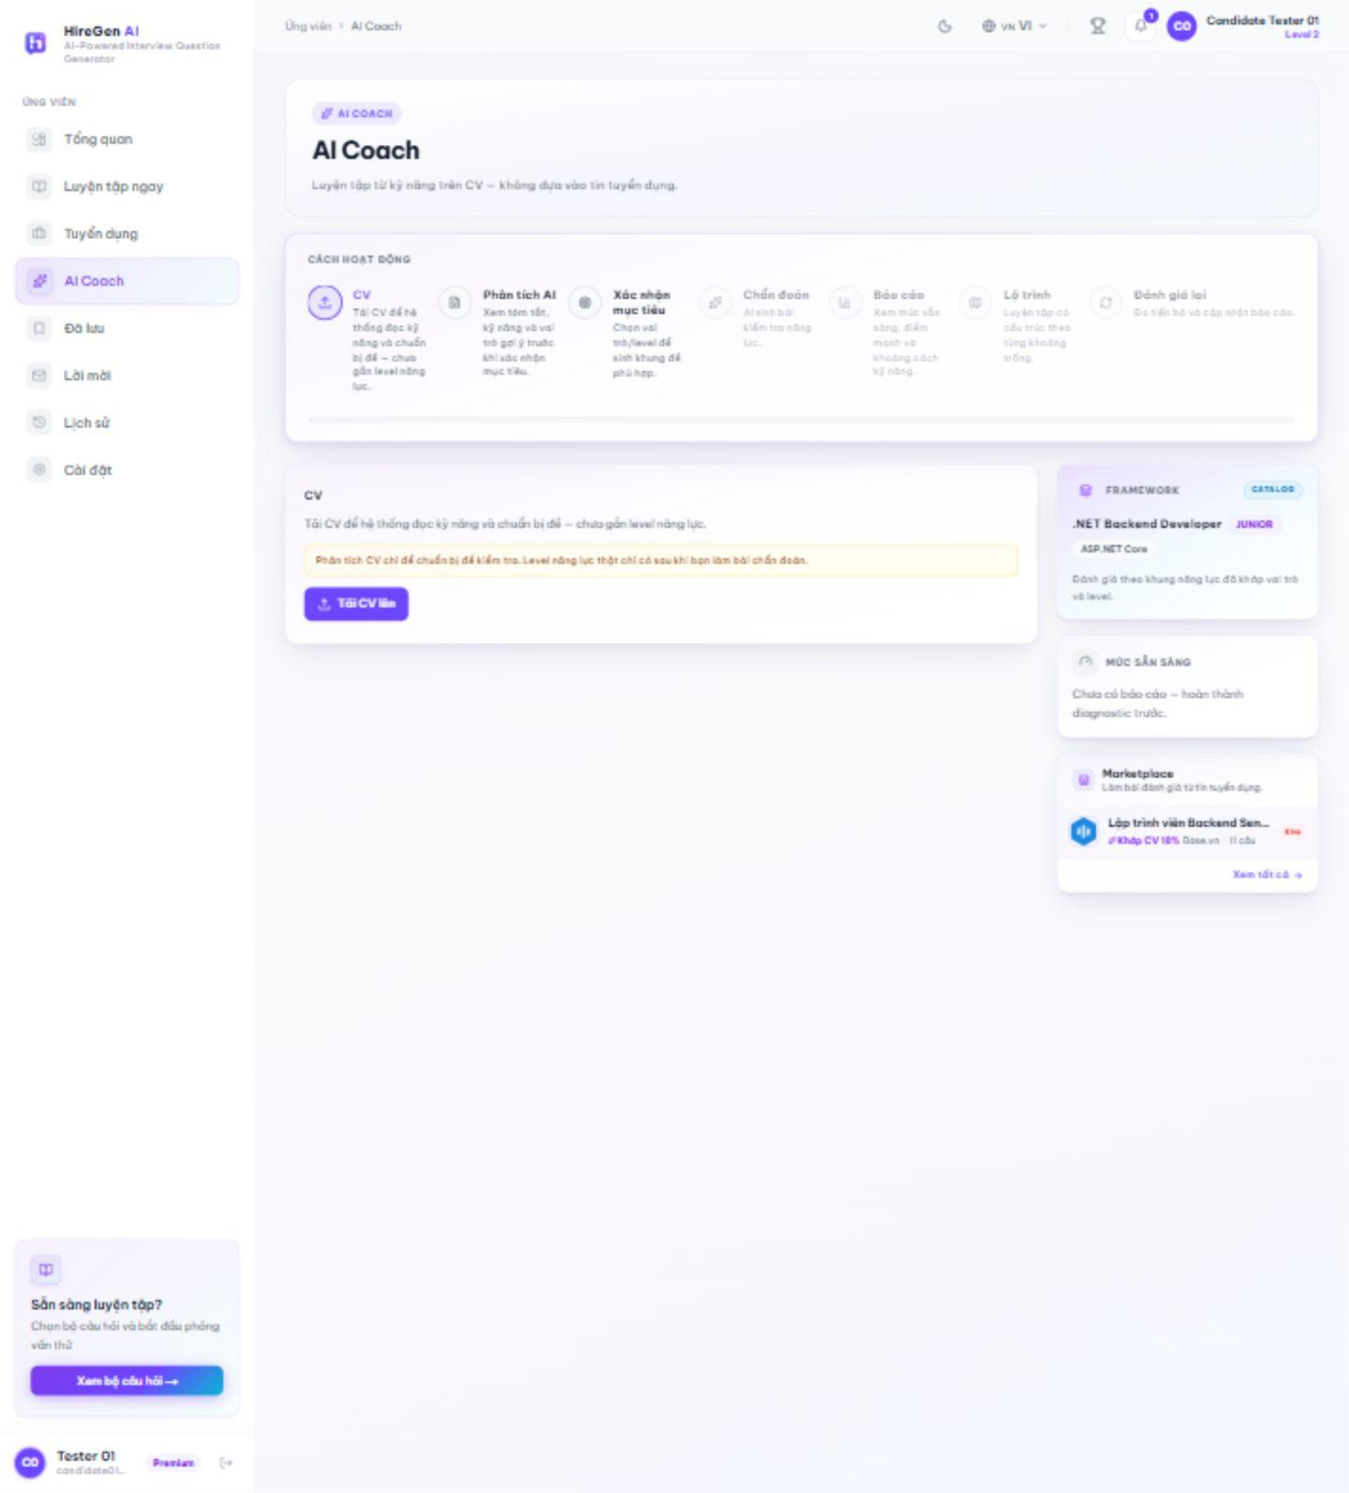
Figure 3.2.41. AI Coach CV entry.
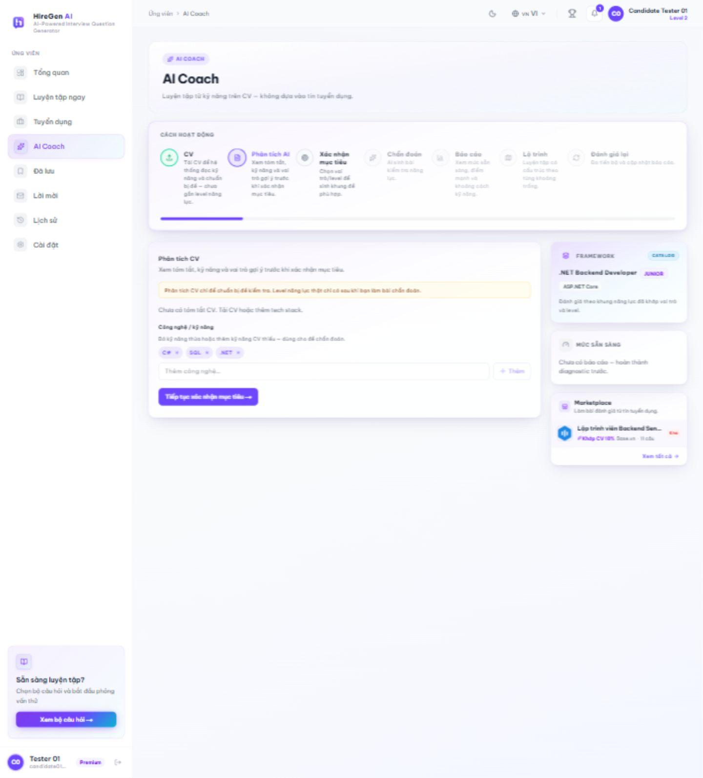
Figure 3.2.42. Analyzed skill profile.
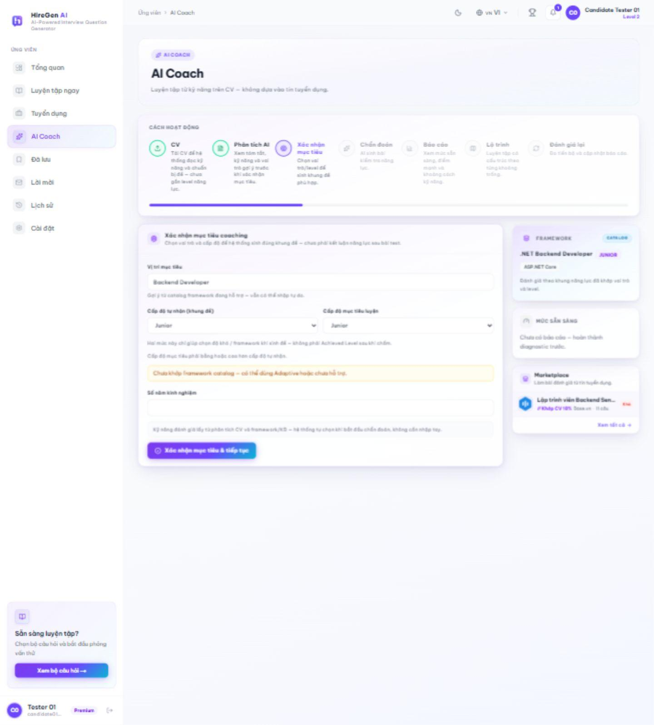
Figure 3.2.43. Role and level confirmation.
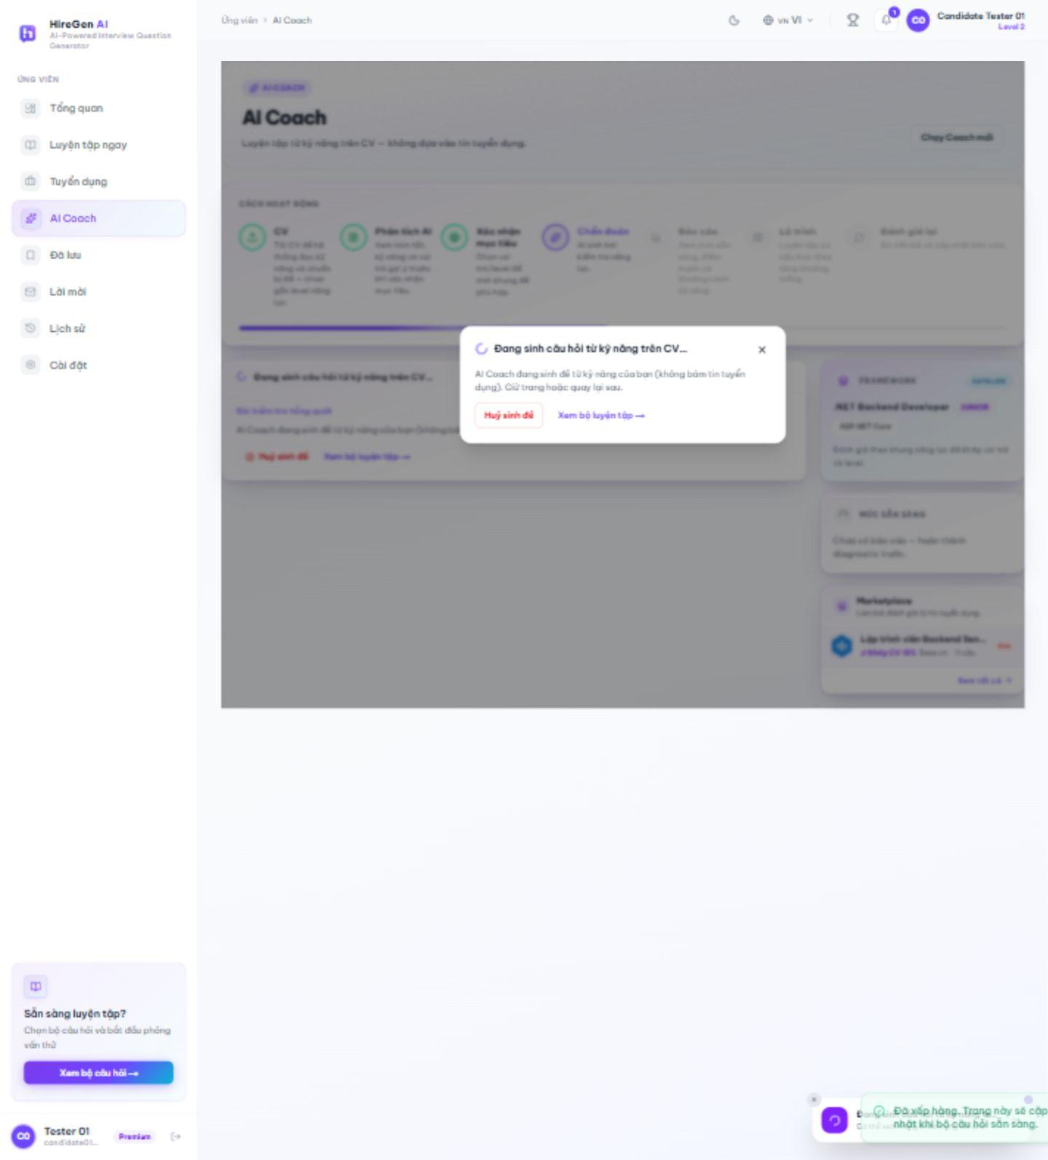
Figure 3.2.44. Diagnostic question generation.
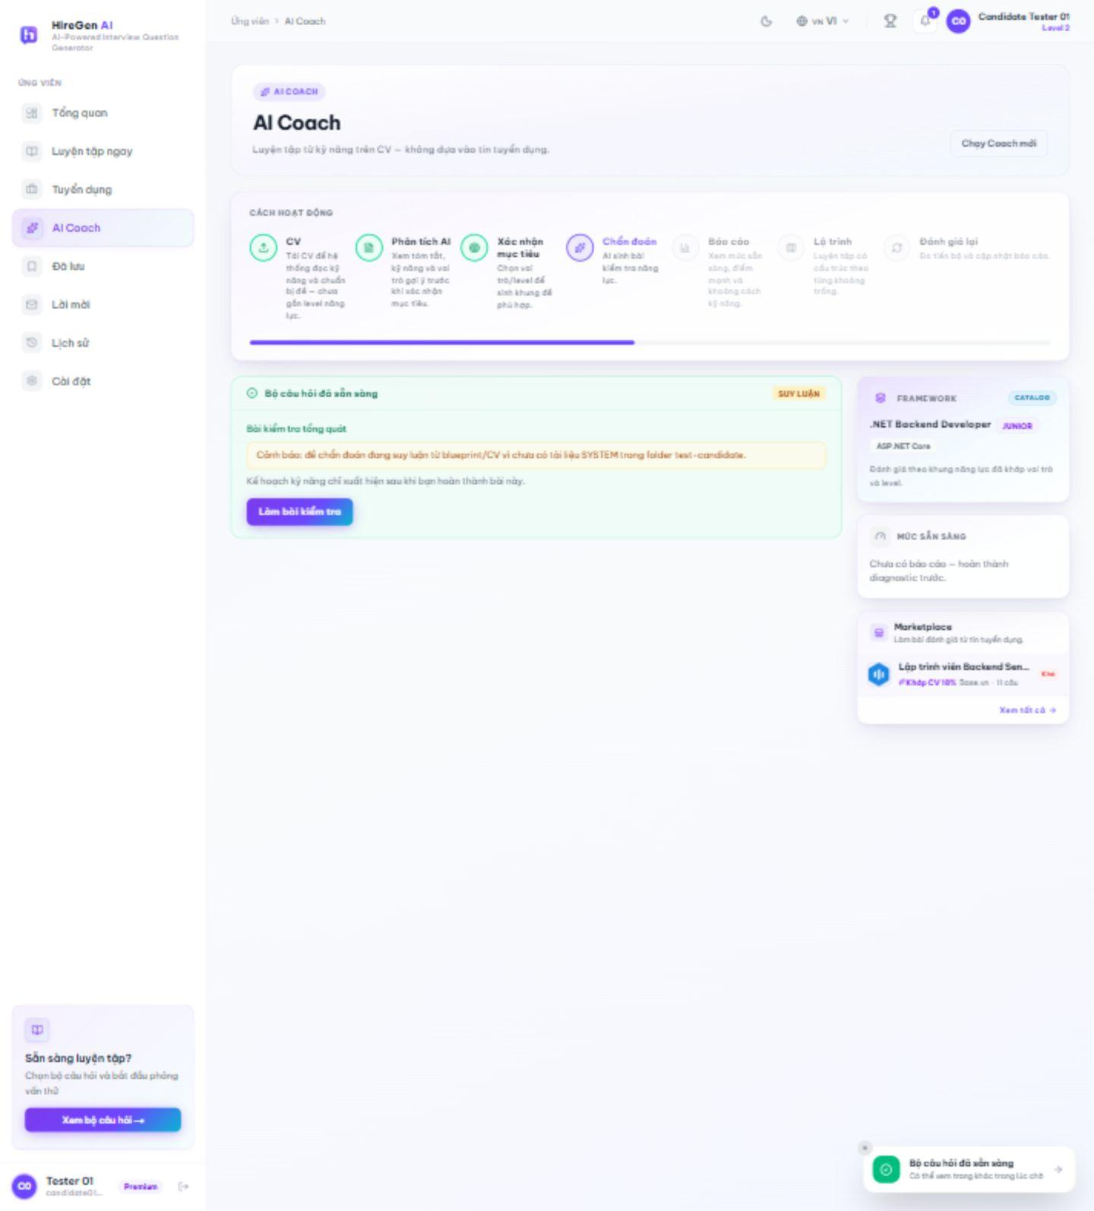
Figure 3.2.45. Framework diagnostic ready.
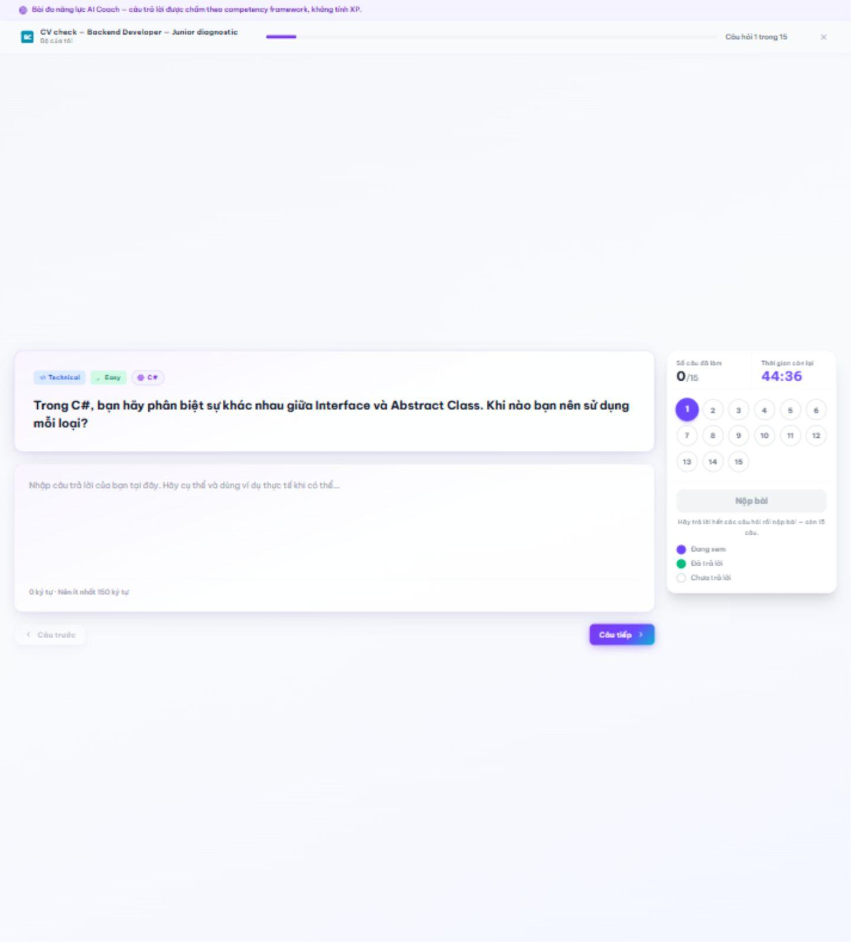
Figure 3.2.46. Coach diagnostic in progress.
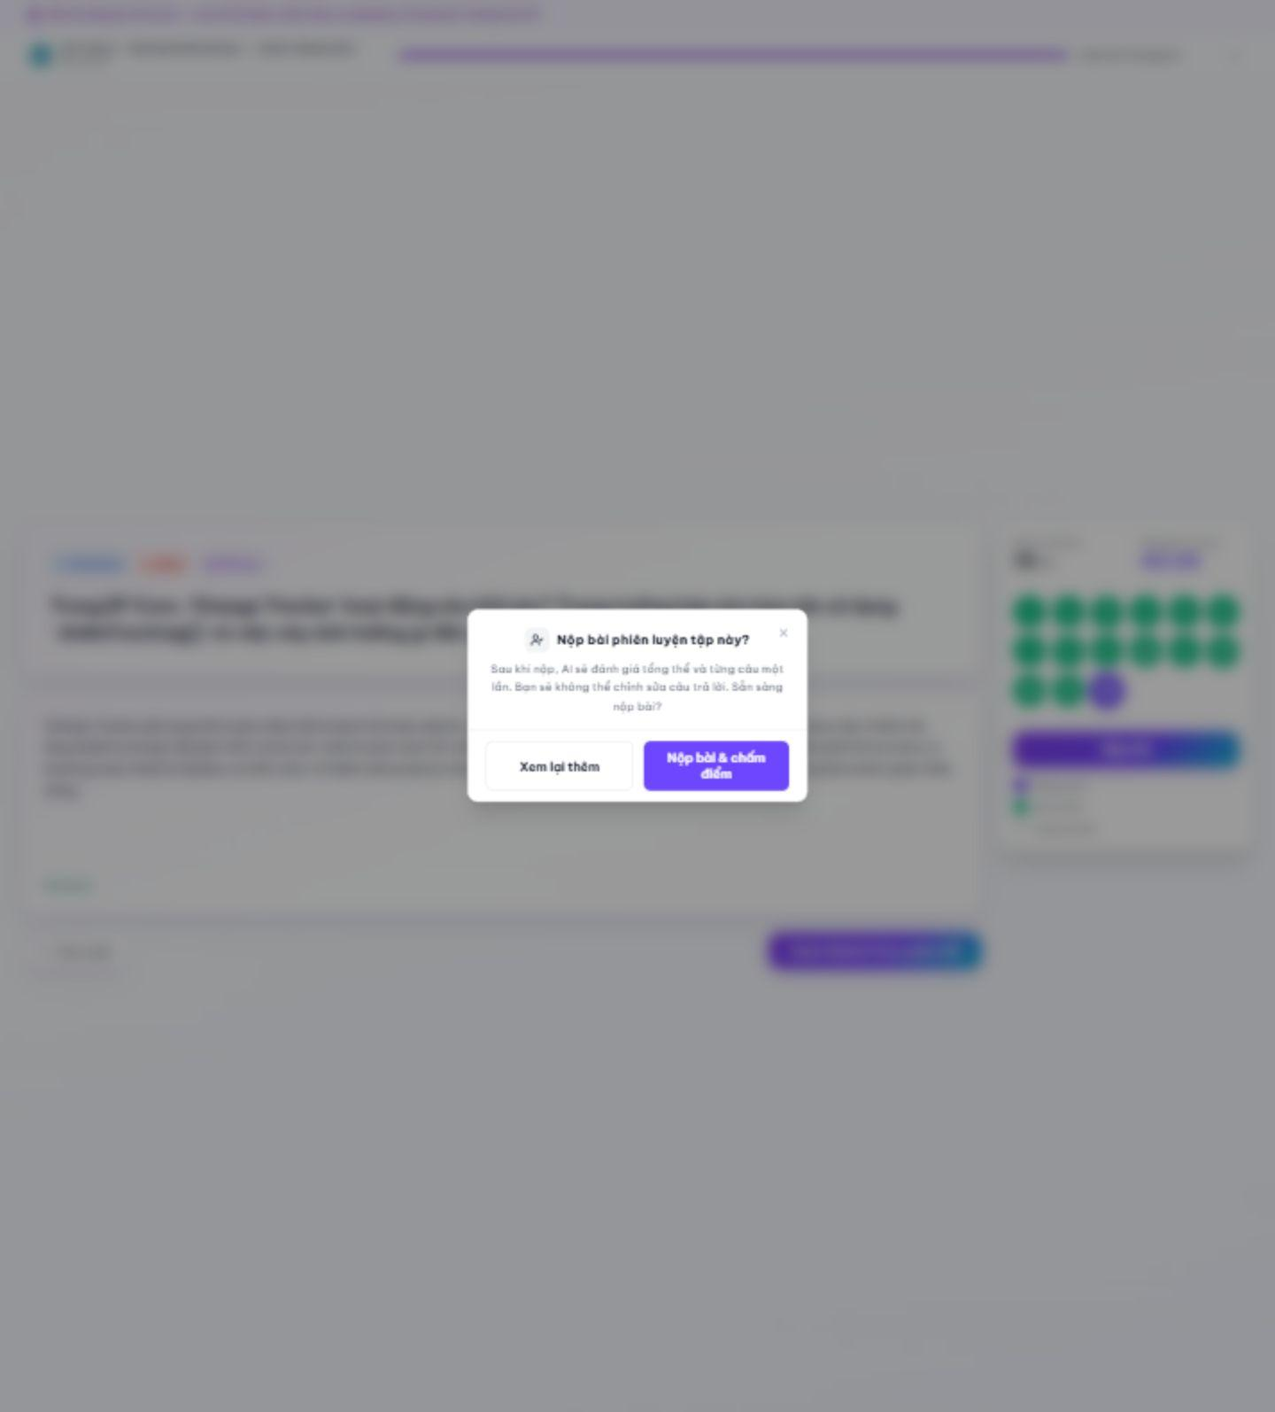
Figure 3.2.47. Diagnostic submission confirmation.
3.2.3.7 AI Coach: Result and Roadmap
Route: /candidate/practice/[id]/result?mode=coach; /candidate/coach?step=6; /candidate/coach/roadmaps/[id]. The completed 15-question diagnostic produced an AI-scored result with per-question feedback. Coach subsequently calculated readiness and suggested a 5-skill, 20-topic roadmap for the selected .NET Backend Developer Junior target. The test account accepted the roadmap, revealing ordered topic drills and a reassessment gate. The application warned that roadmap topics were inferred from the framework because no matching system knowledge was retrieved. Once a roadmap exists, the current frontend locks earlier Coach steps, including its report tab; readiness remains visible in the Coach context panel and the scored diagnostic result remains accessible from practice history.
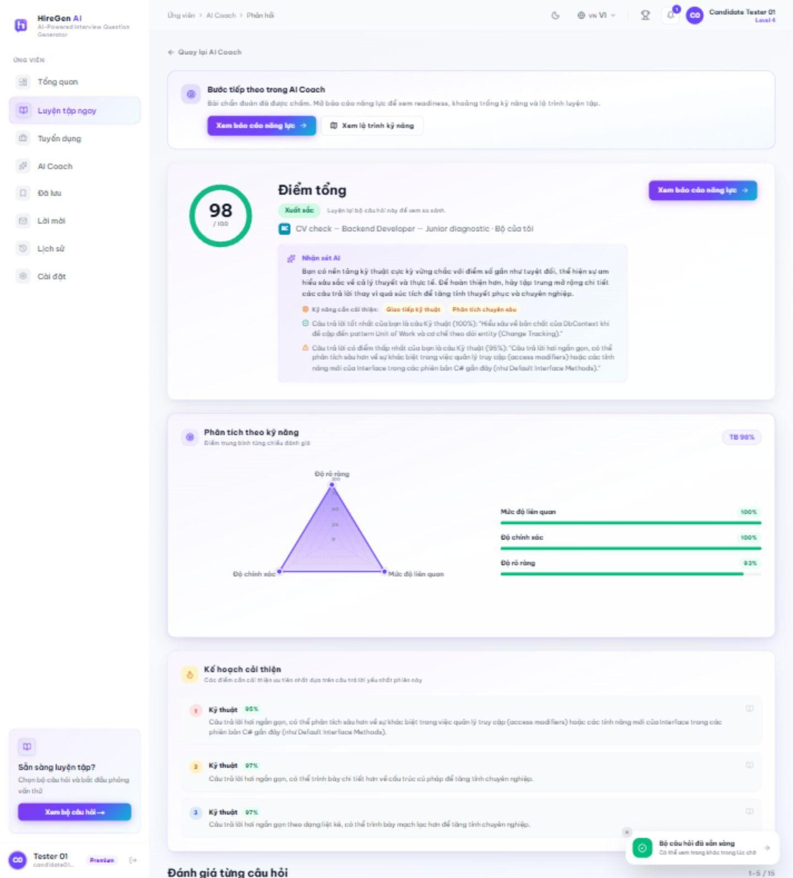
Figure 3.2.48. AI Coach diagnostic score and feedback.
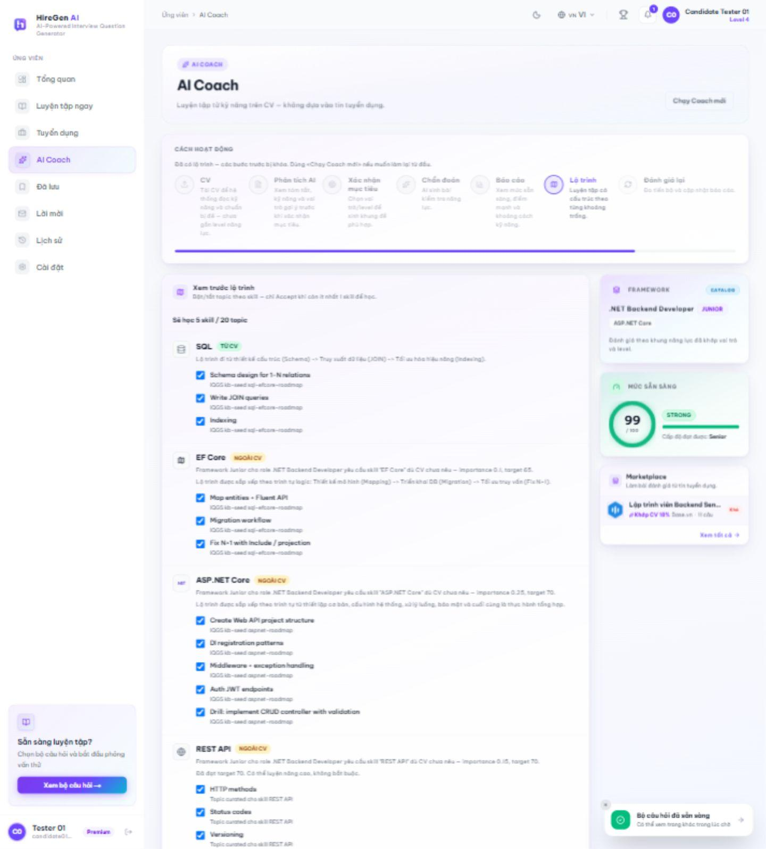
Figure 3.2.49. Suggested skill roadmap before acceptance.
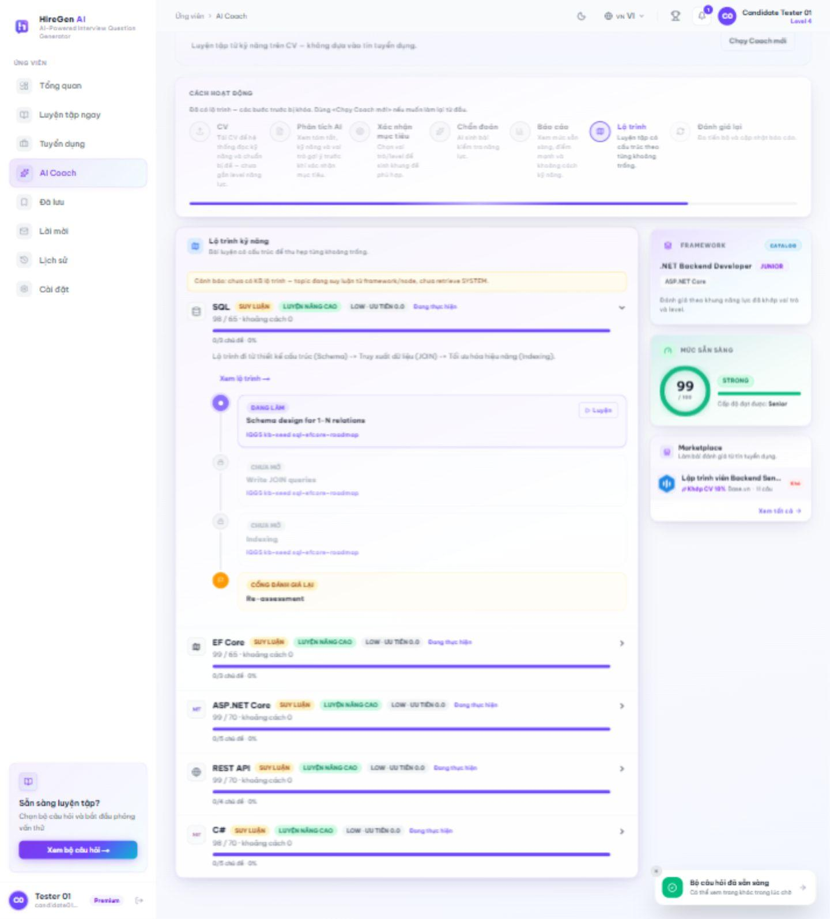
Figure 3.2.50. Accepted skill roadmap and topic progress.
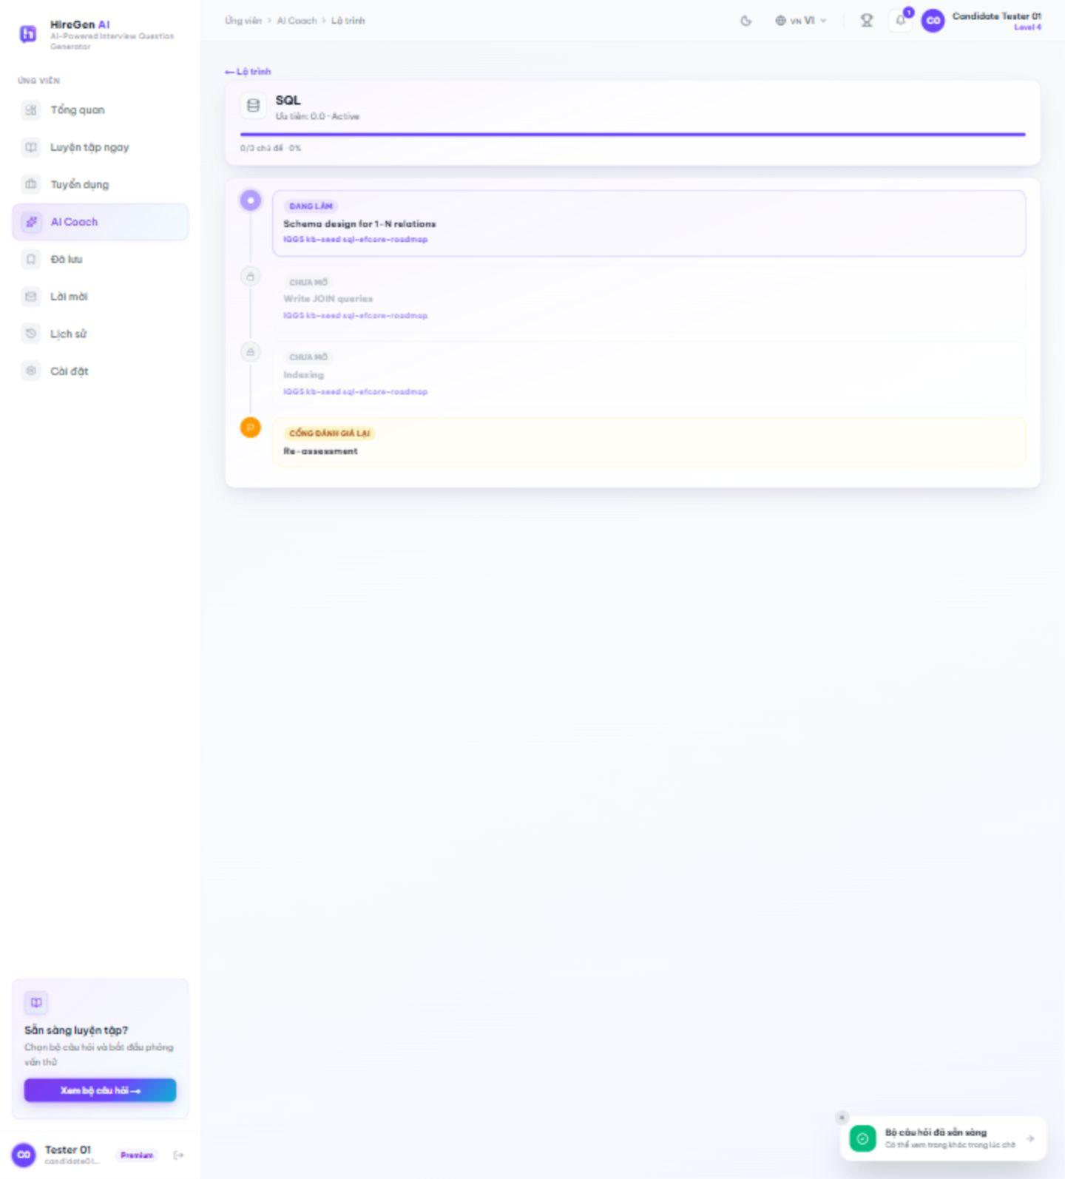
Figure 3.2.51. Skill roadmap detail and reassessment gate.
3.2.3.8 Saved Sets and Invitations
Route: /candidate/saved; /candidate/invitations. Candidates bookmark published sets for later practice and review interview invitations. The saved-set view was captured after saving a live set; this account has no current invitations.
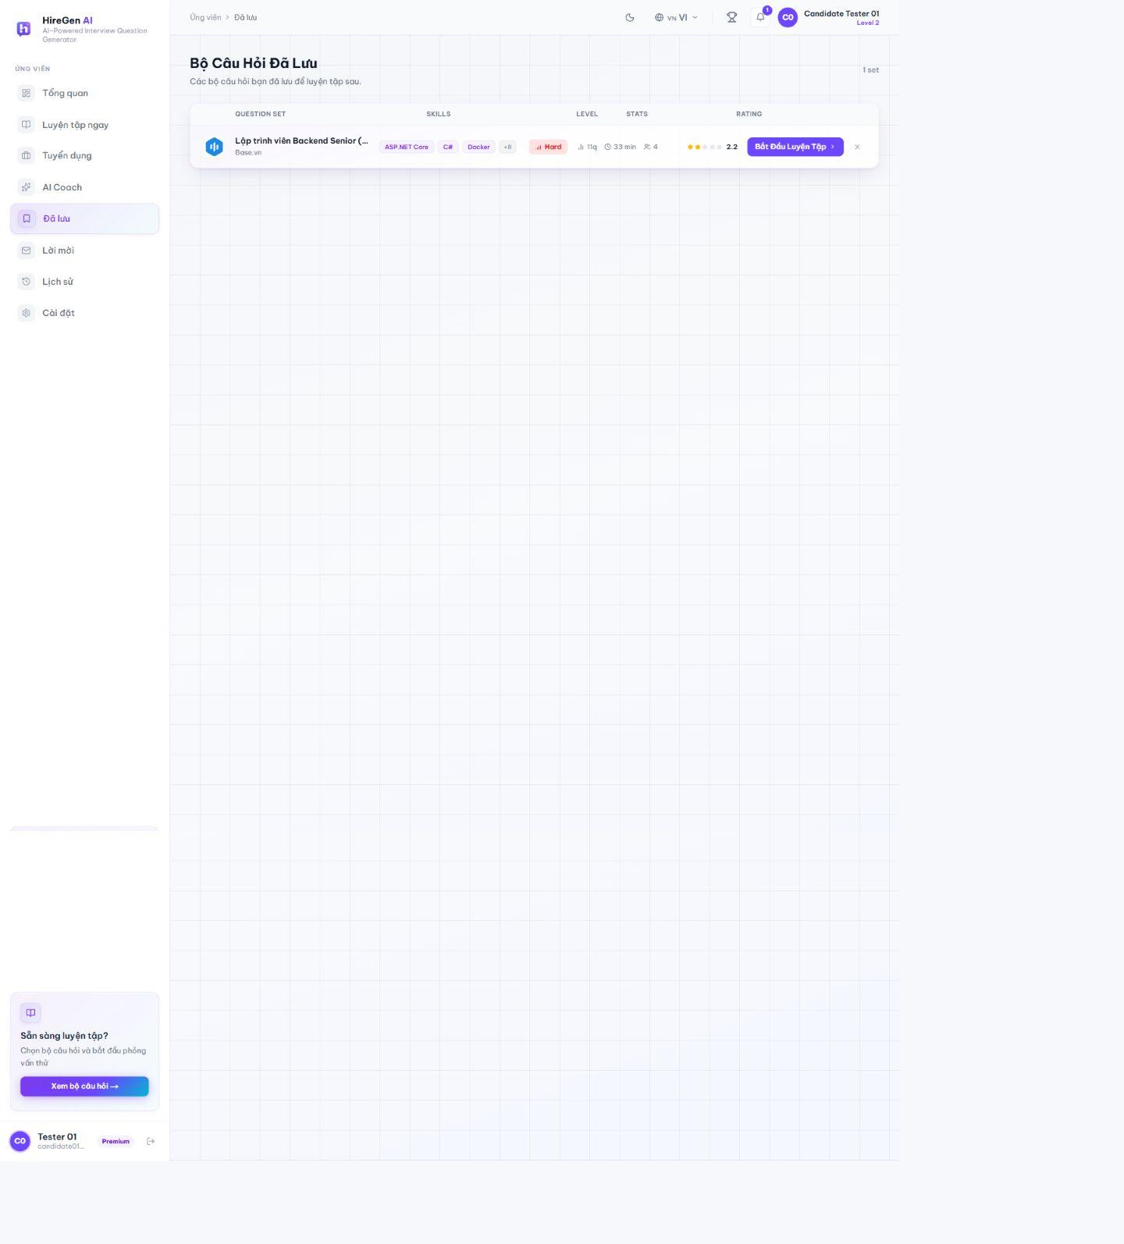
Figure 3.2.52. Saved question set.
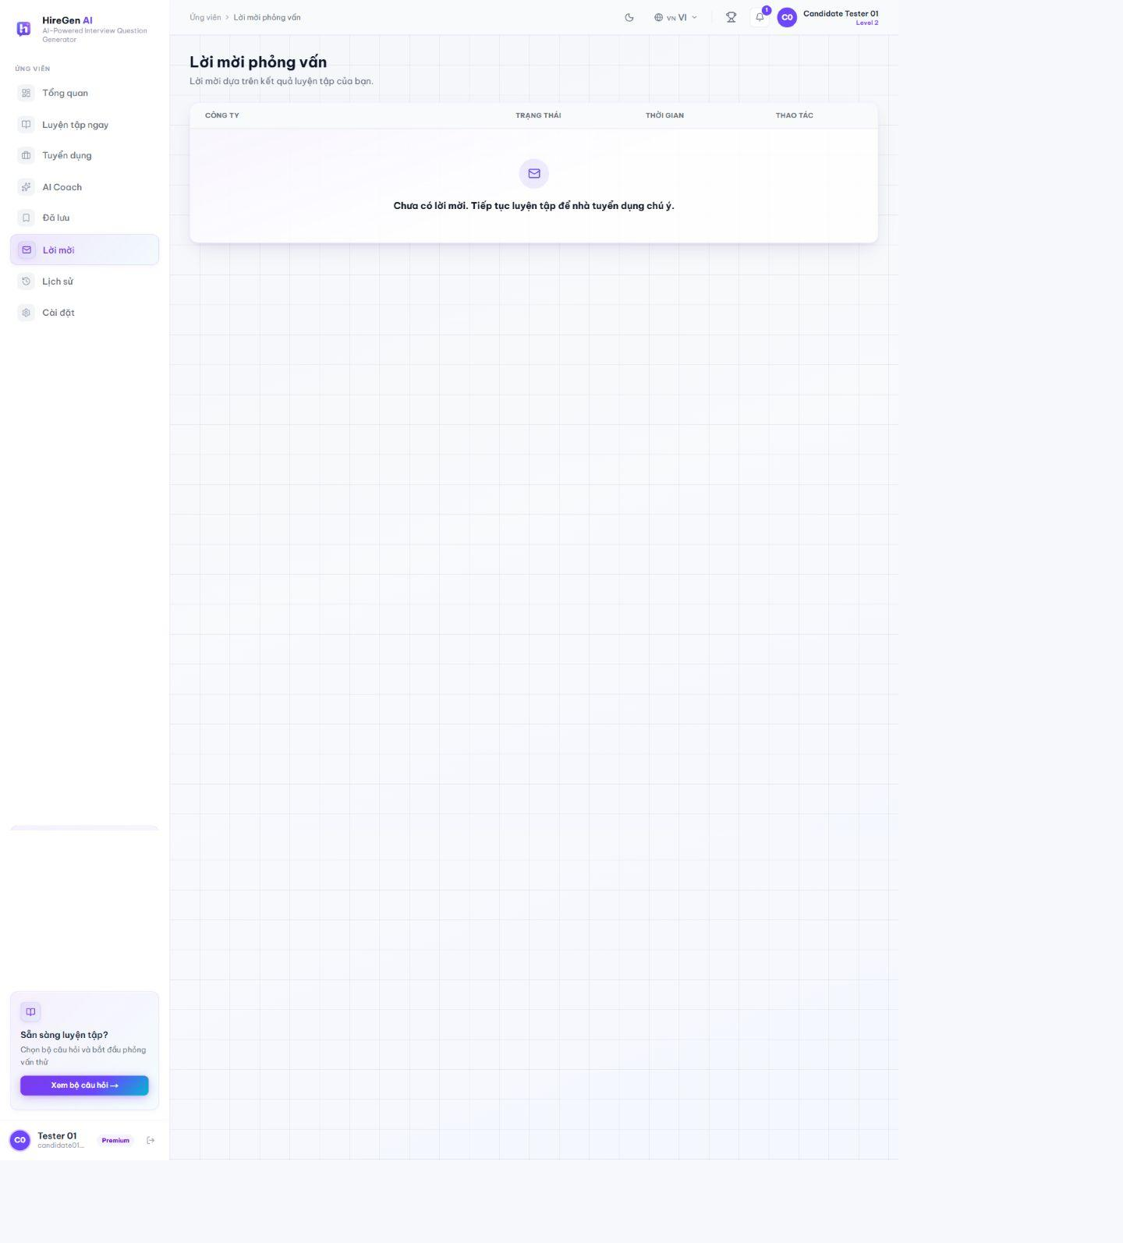
Figure 3.2.53. Invitation empty state.
3.2.3.9 Leaderboard and Profile
Route: /candidate/leaderboard; /candidate/profile. The leaderboard ranks candidate XP and streaks. Profile displays practice statistics, XP progress, achievements and editable personal details.
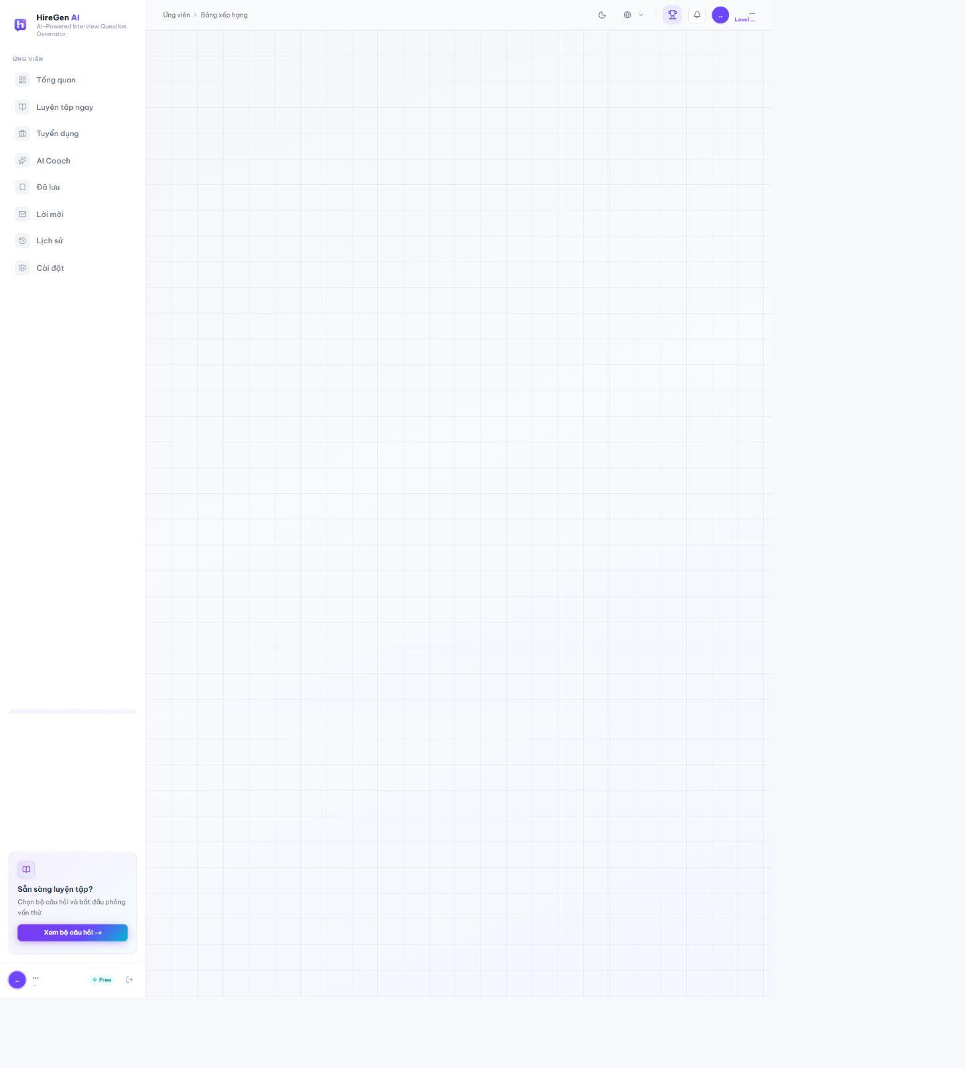
Figure 3.2.54. Candidate leaderboard.
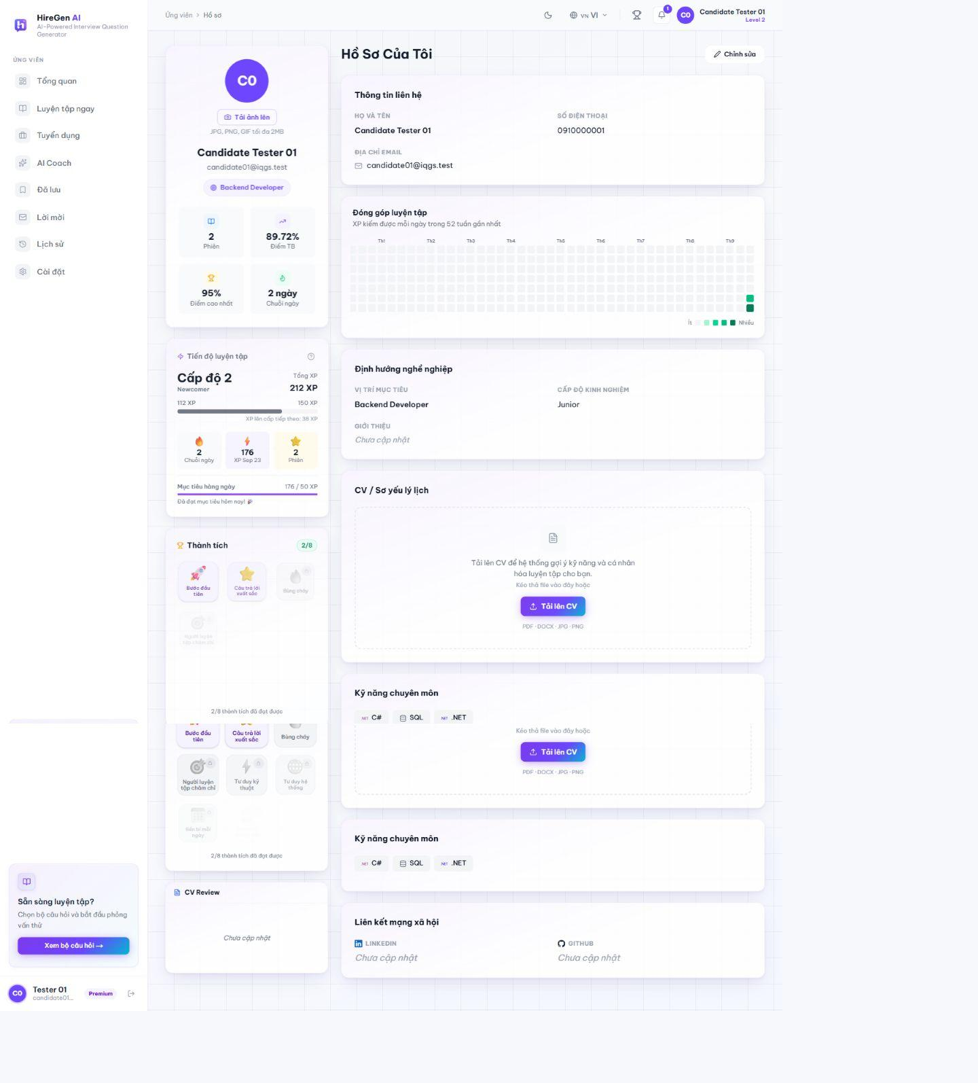
Figure 3.2.55. Candidate profile and progress.
3.2.3.10 Candidate Settings
Route: /candidate/settings. Settings include profile, general preferences, password security, recruiter recommendation consent, XP history and subscription billing. The captured account has Candidate Premium; no payment or cancellation was made.
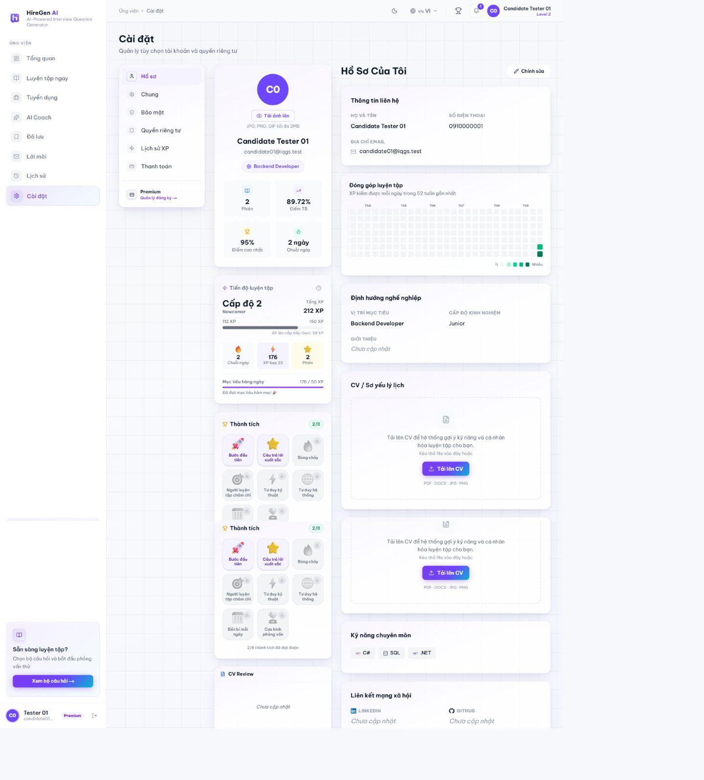
Figure 3.2.56. Profile tab.
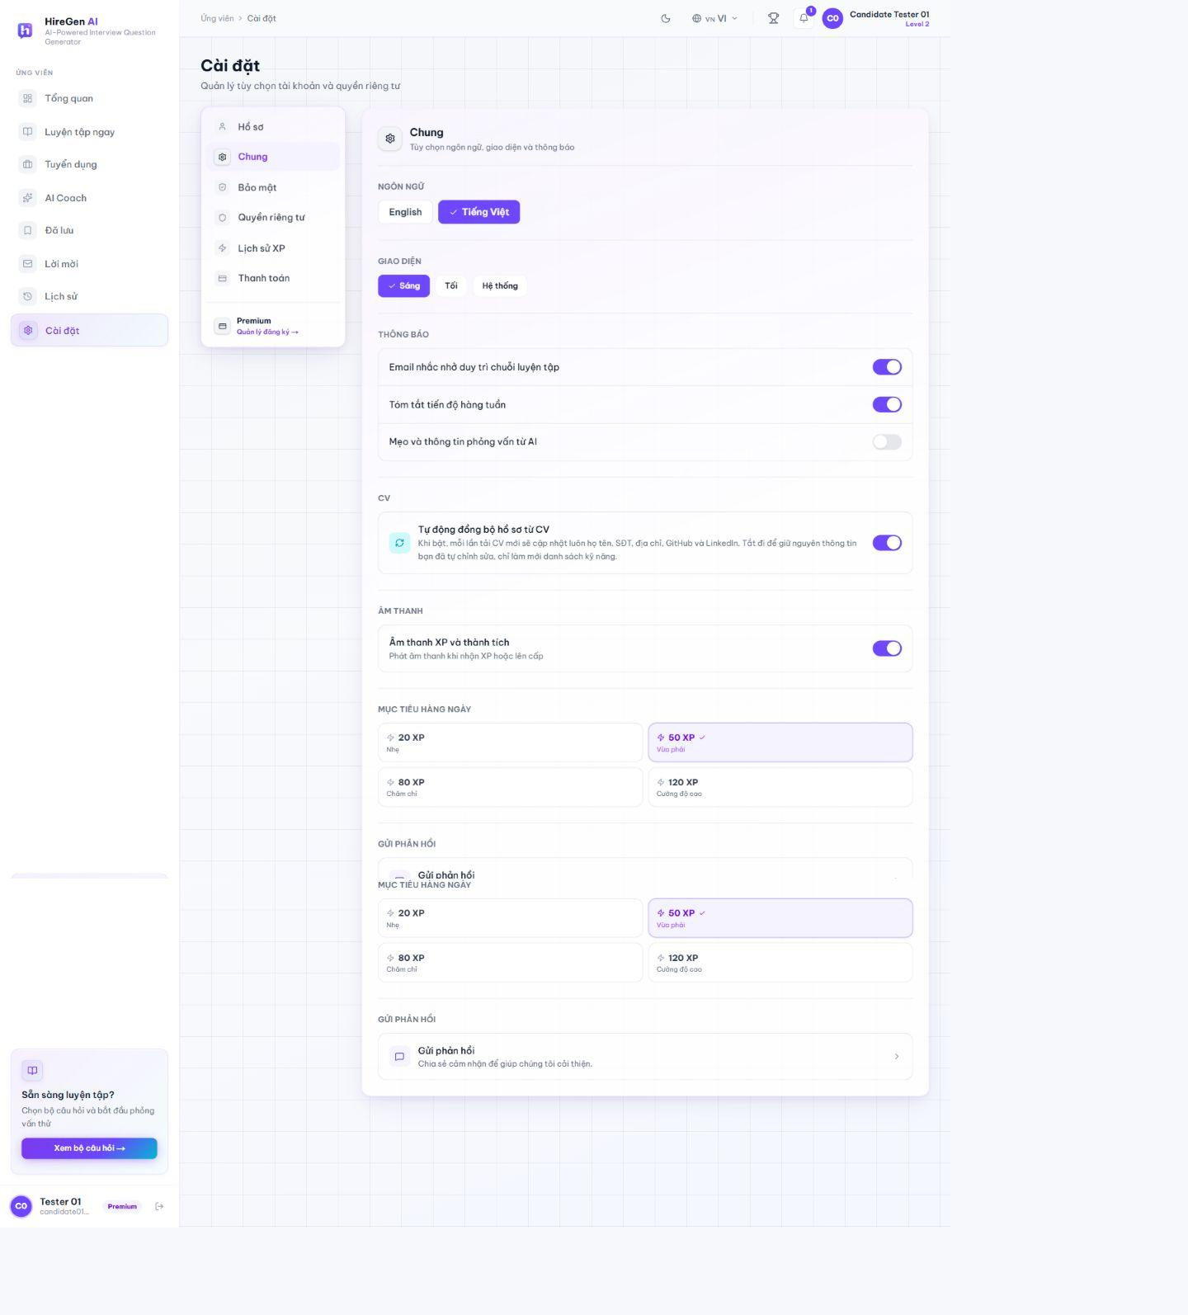
Figure 3.2.57. General preferences.
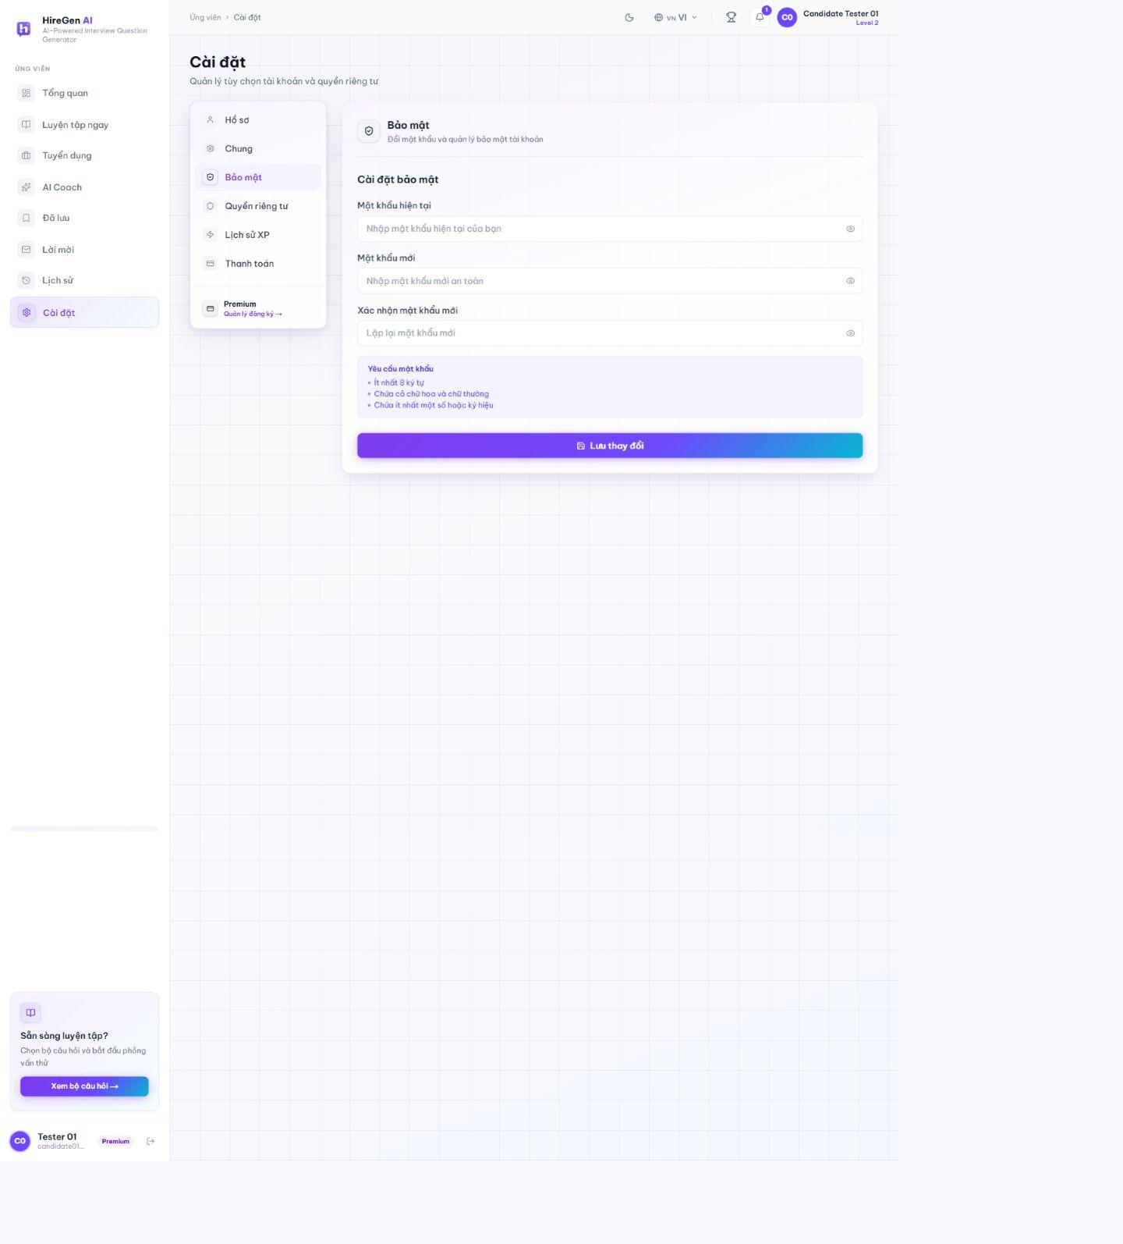
Figure 3.2.58. Security tab.
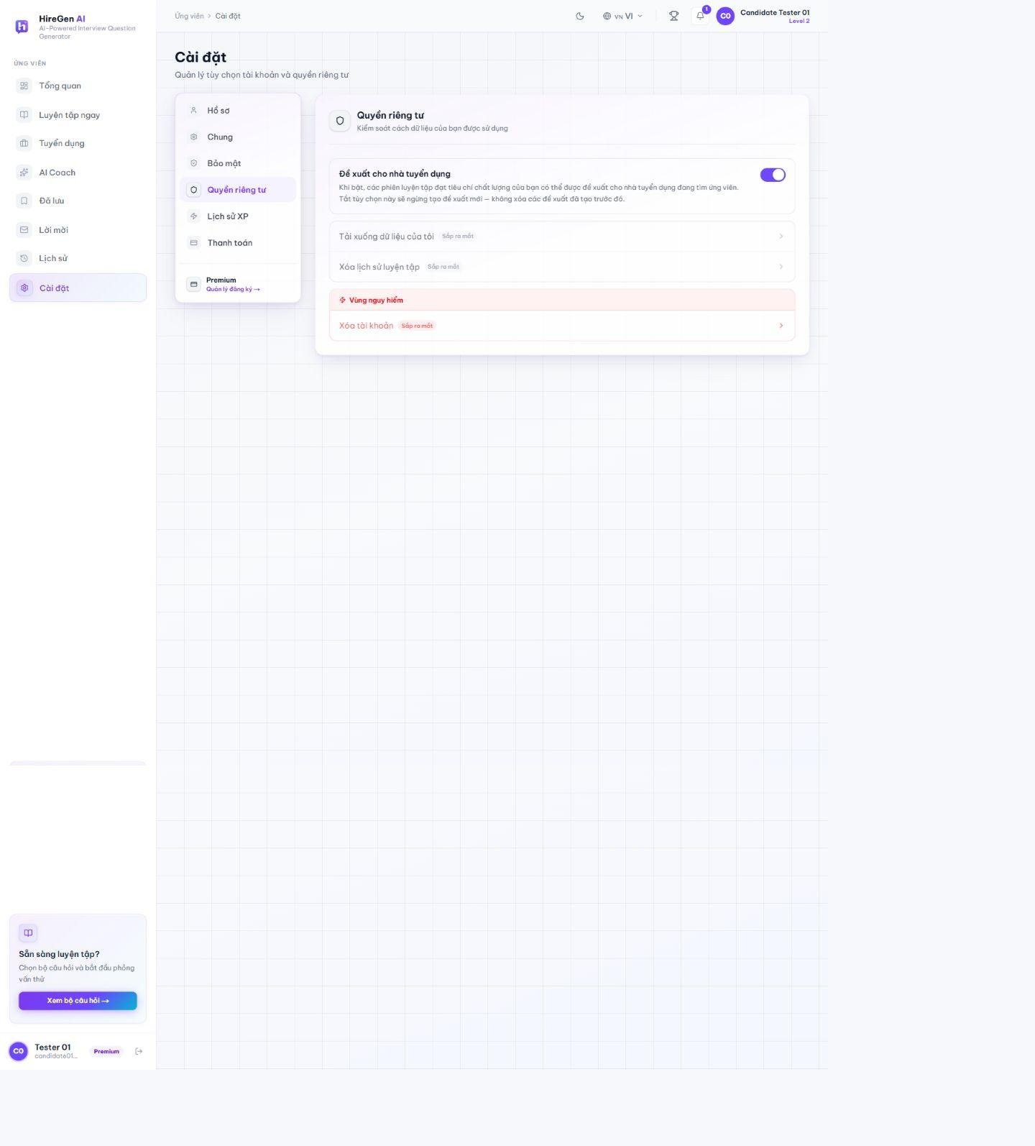
Figure 3.2.59. Privacy and recruiter-consent tab.
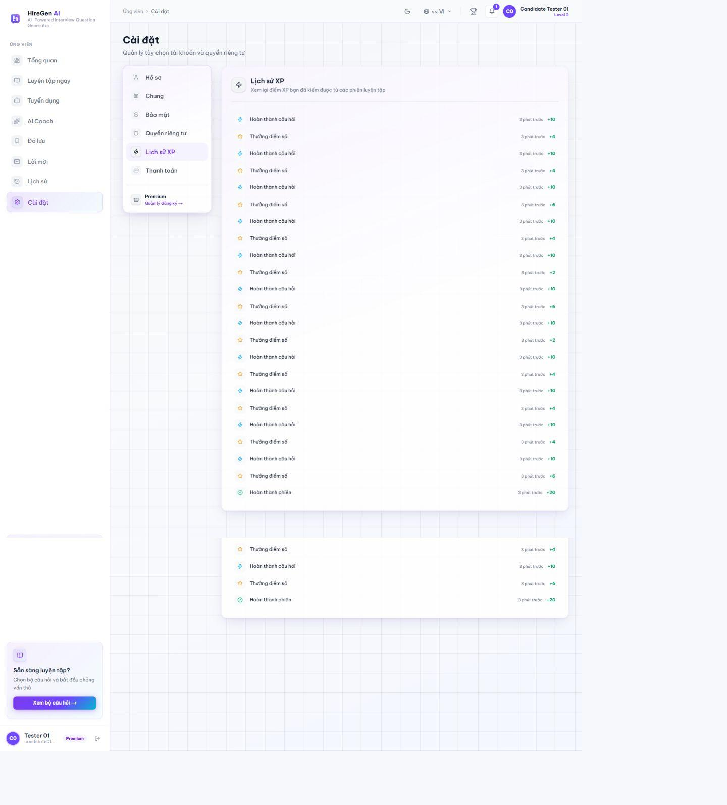
Figure 3.2.60. XP transaction history.
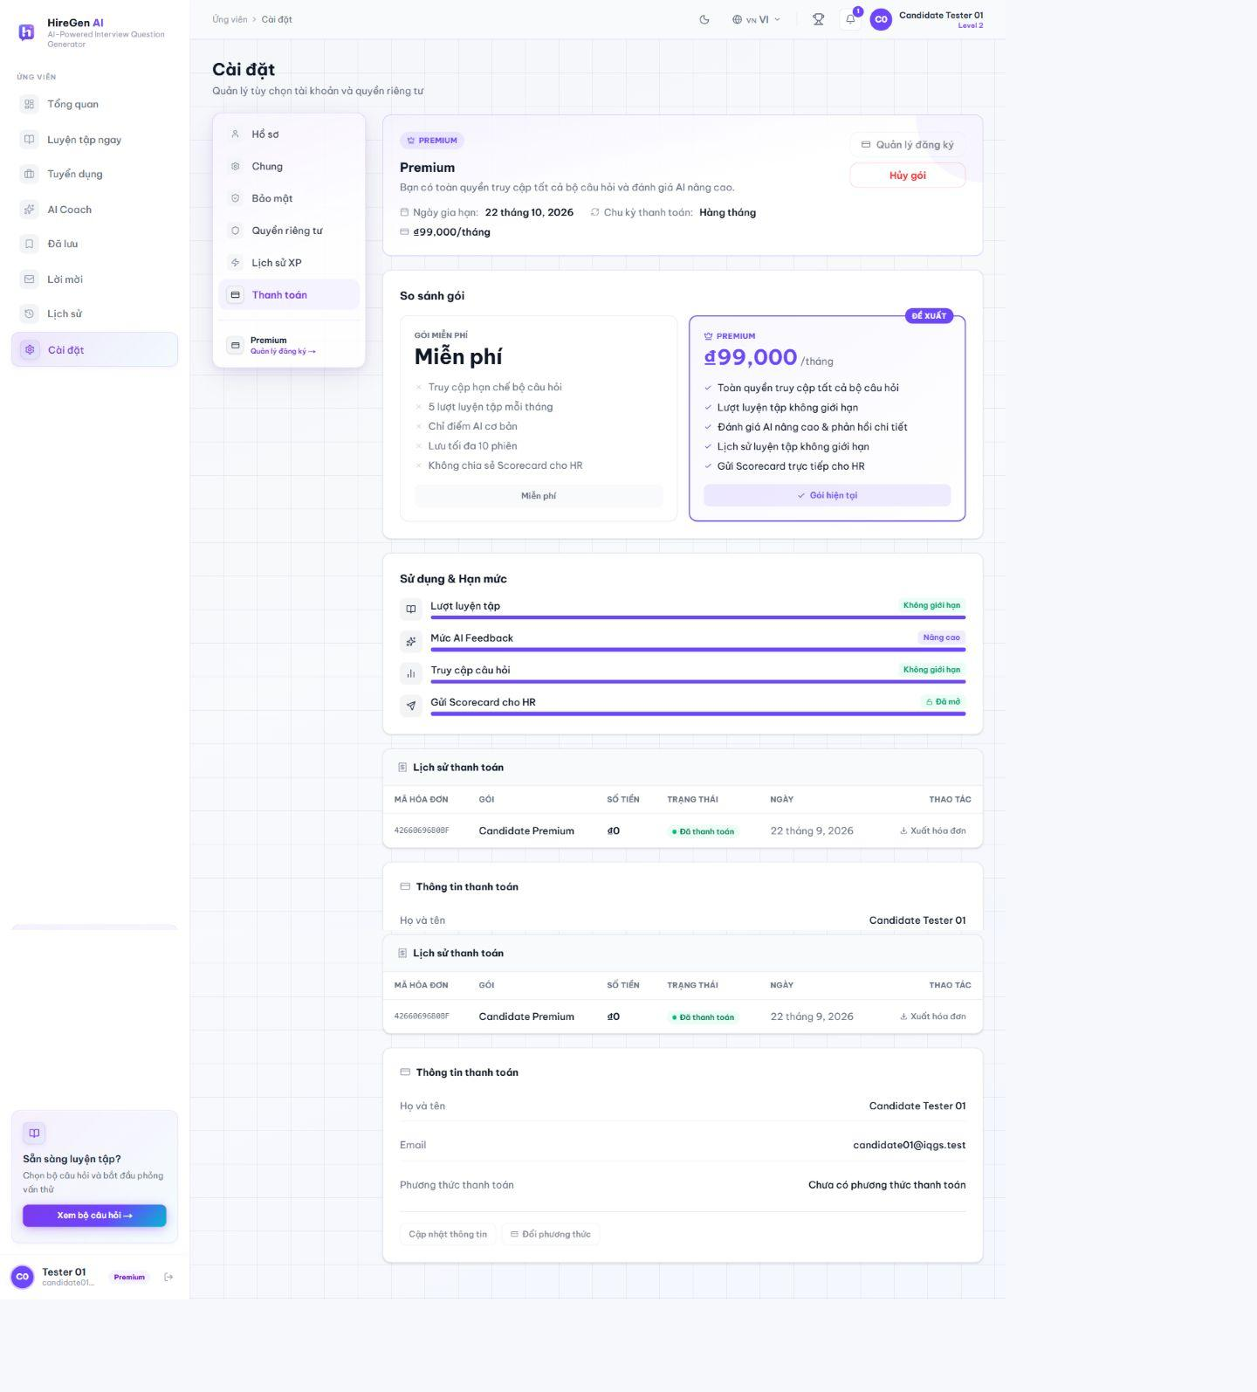
Figure 3.2.61. Candidate Premium billing view.
3.2.1.1 Sign In
Route: /login. Guest enters an existing account and is routed to the workspace for its role. The API authenticates the account; the frontend redirects after login.
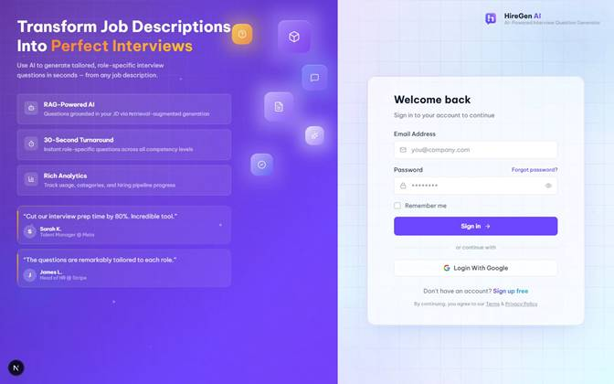
Figure 3.2.1. Sign-in form for Candidate, HR Manager and Administrator.
3.2.1.2 Candidate and HR Registration
Route: /register/jobseeker; /register. The two registration pages collect role-specific account information. Email verification and HR approval determine when an account can use protected workflows.
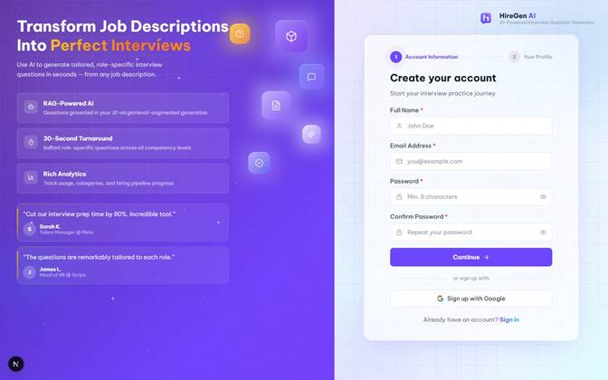
Figure 3.2.2. Candidate registration form.
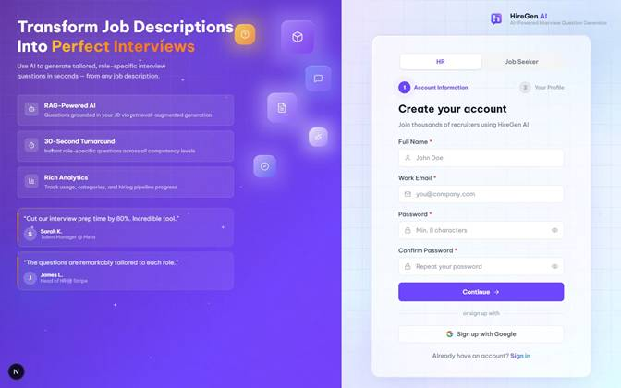
Figure 3.2.3. HR registration form.
3.2.1.3 Password Recovery
Route: /forgot-password; /reset-password. The recovery page accepts an email address and starts the reset process. The reset page is usable only with a valid reset token; no password was changed for this documentation capture.
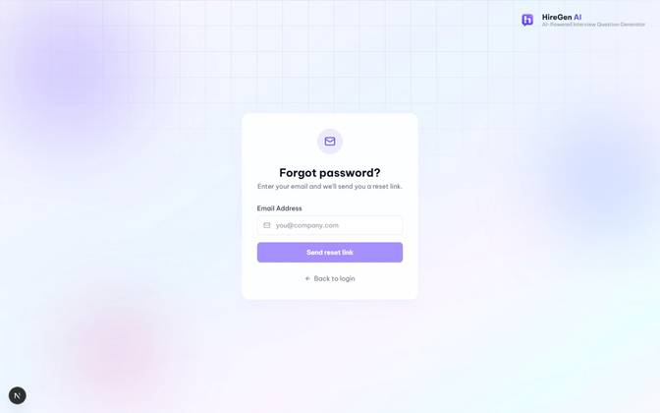
Figure 3.2.4. Forgot-password form.

3.2.2 HR Manager Workspace
3.2.2.1 Dashboard
Route: /hr/dashboard. Shows the HR recruitment funnel and question-generation activity, with links into Studio, question sets, talent and settings. The captured account has Premium access.
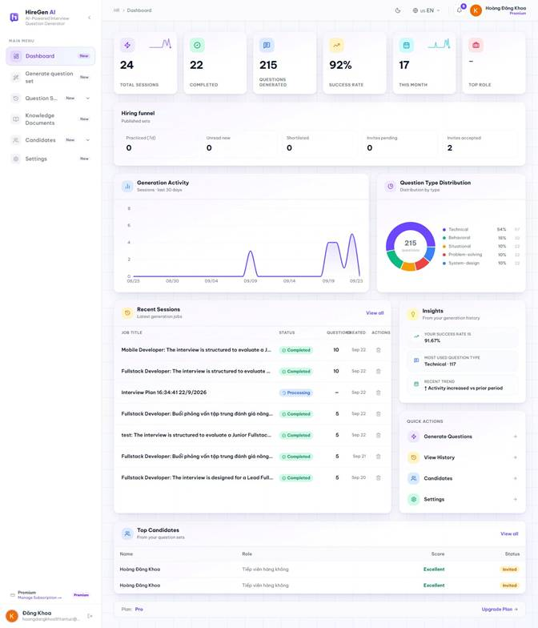
Figure 3.2.5. HR dashboard with activity and recruitment funnel.
3.2.2.2 Project Studio: Job Description and Knowledge
Route: /hr/generate-question. HR creates a Studio project, enters a job description and may select owned knowledge documents. The captured completed project shows the stored JD and detected skills. HR01 has no owned knowledge documents, as shown in the HR knowledge-library state below.
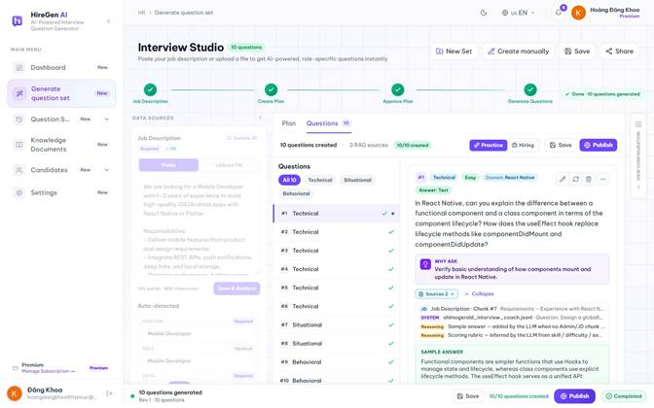
Figure 3.2.6. Stored job description and detected skills.
3.2.2.3 Project Studio: Plan and Approval
Route: /hr/generate-question. Studio generates an interview plan from the JD, displays sections and focus areas, and requires approval before generating questions. The captured plan is approved and contains ten question slots and RAG-derived focus areas.
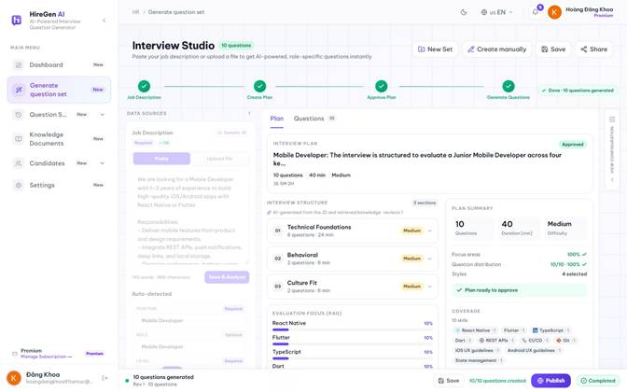
Figure 3.2.7. Approved interview plan and skill coverage.
3.2.2.4 Project Studio: Generate and Review Questions
Route: /hr/generate-question. After approval, Studio runs question generation asynchronously. HR reviews the generated questions and their RAG references, then edits or regenerates an individual question before publishing.
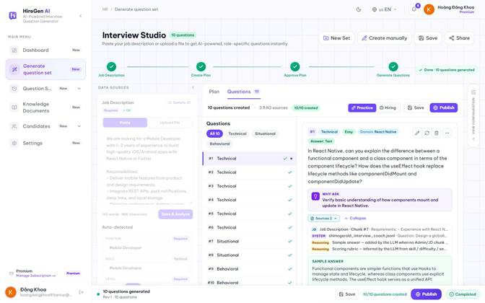
Figure 3.2.8. Generated questions and source references.
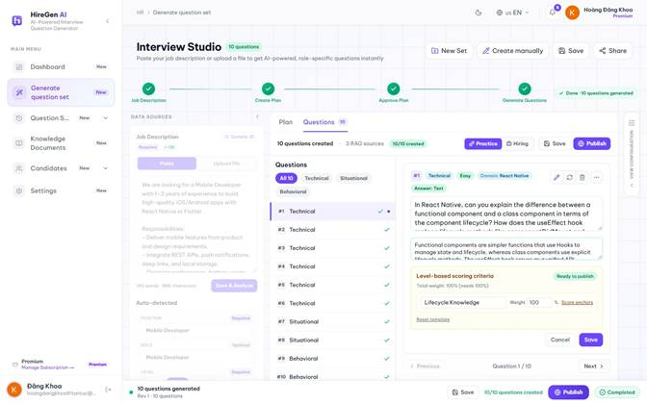
Figure 3.2.9. Edit a generated question.
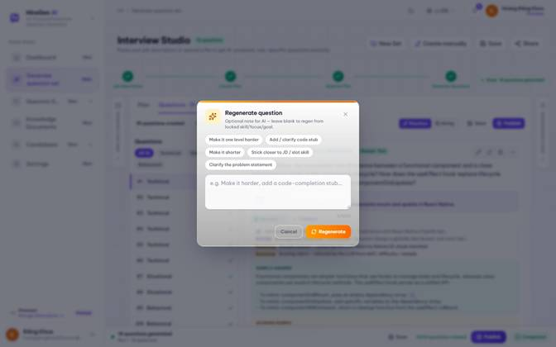
Figure 3.2.10. Regenerate a question.
3.2.2.5 Manual Question Builder
Route: /hr/generate-question/manual. The manual builder creates or selects a draft set, chooses question type and difficulty, and provides content, answer, rubric and optional classification fields. It does not invoke Studio generation.
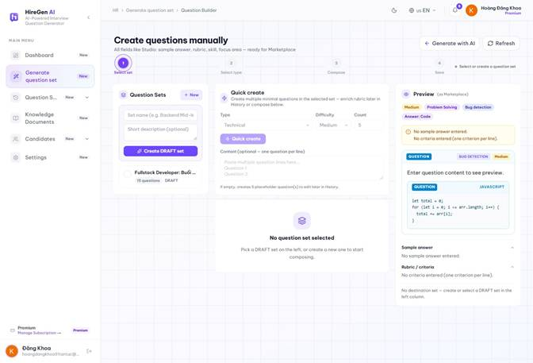
Figure 3.2.11. Manual builder before selecting a draft.
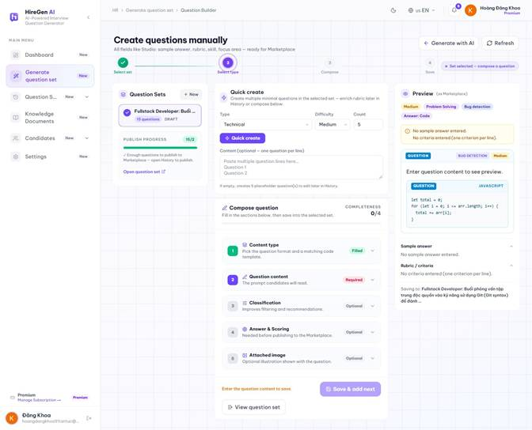
Figure 3.2.12. Manual builder with an existing draft selected.
3.2.2.6 Publish Practice or Hiring Set
Route: /hr/generate-question. The publish dialog separates practice and hiring use. Hiring publication exposes assessment duration and anti-cheat controls. The capture records the dialogs without publishing a new set.
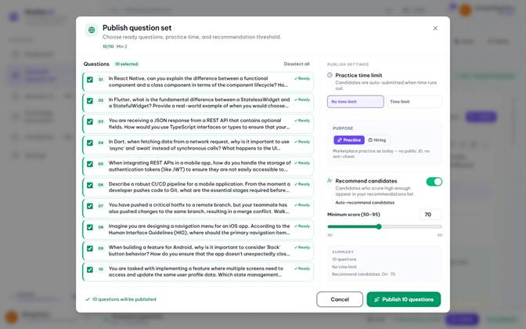
Figure 3.2.13. Practice publication settings.
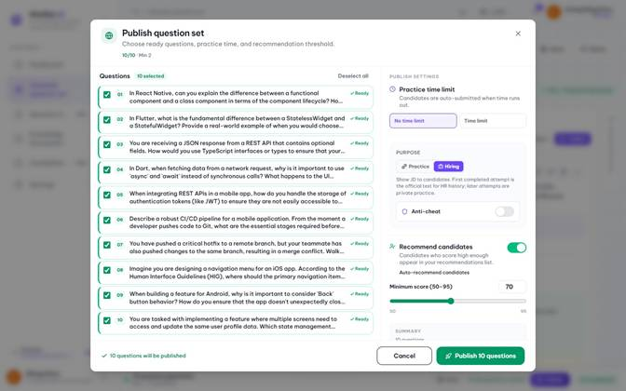
Figure 3.2.14. Hiring publication settings.
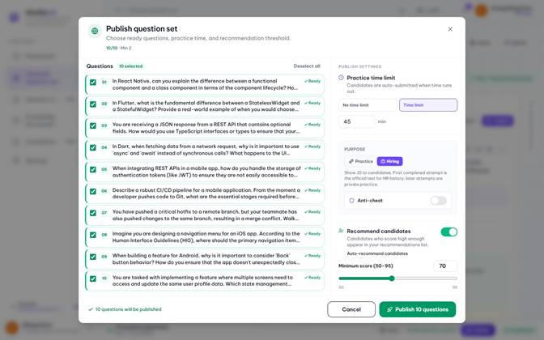
Figure 3.2.15. Hiring time-limit options.
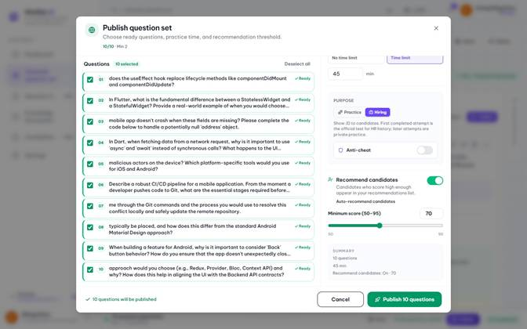
Figure 3.2.16. Hiring anti-cheat options.
3.2.2.7 Question Set History and JD Fit
Route: /hr/history; /hr/history/[id]. History lists owned sets and opens their detail. The JD-fit action evaluates question coverage against the stored JD and returns a verdict, missing topics and suggested changes.
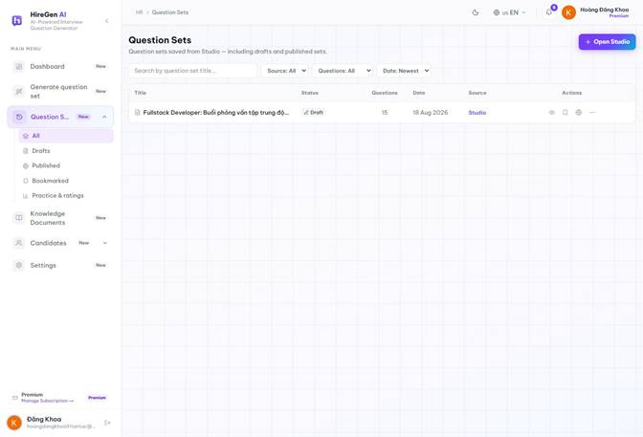
Figure 3.2.17. HR question-set history.
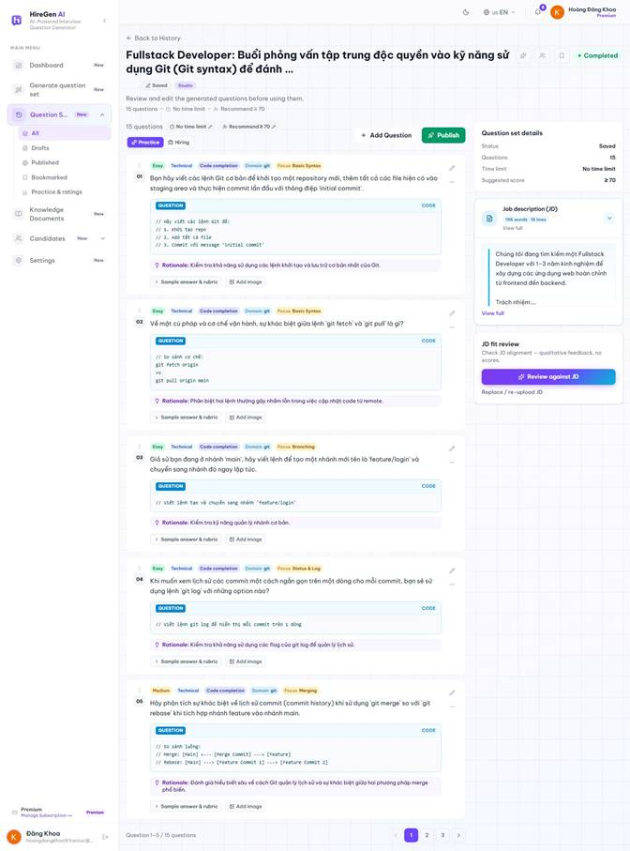
Figure 3.2.18. Question-set detail.
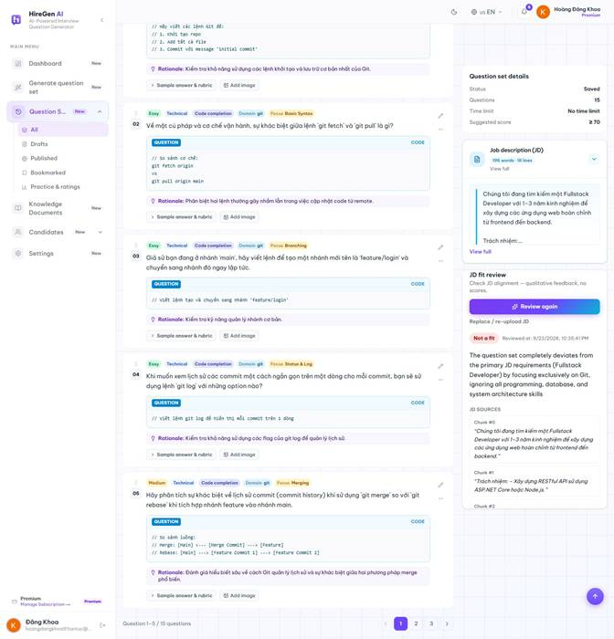
Figure 3.2.19. AI JD-fit review.
3.2.2.8 Published Sets
Route: /hr/published; /hr/published/[id]. The published-set workspace lists HR-owned sets available to candidates. HR01 currently has no published sets, so the actual empty state is shown; detail and practitioner routes require an owned published set.
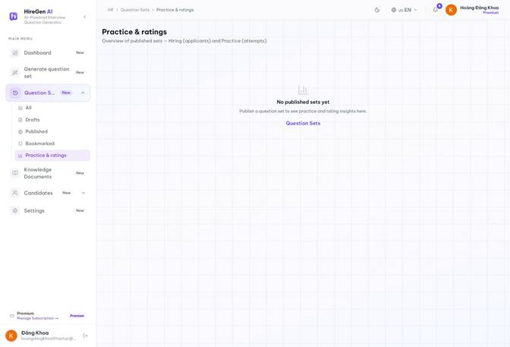
Figure 3.2.20. Published-set empty state for HR01.
3.2.2.9 HR Knowledge Documents
Route: /hr/knowledge. The HR knowledge screen manages the account's document sources for RAG. HR01 currently has no owned documents; this empty state is distinct from the system-wide Admin knowledge library.
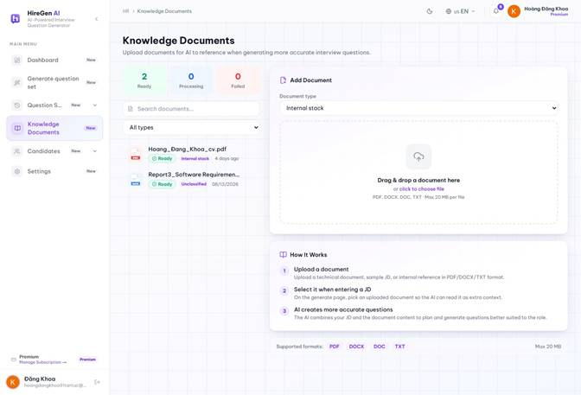
Figure 3.2.21. HR knowledge-library empty state.
3.2.2.10 Candidate Recommendations and Talent
Route: /hr/candidate-recommendations; /hr/talent. Recommendation results depend on matching practice evidence, eligibility and consent. The recommendation view is empty for HR01; the talent view exposes a candidate with prior practice results and drill-down to its profile and session evidence.
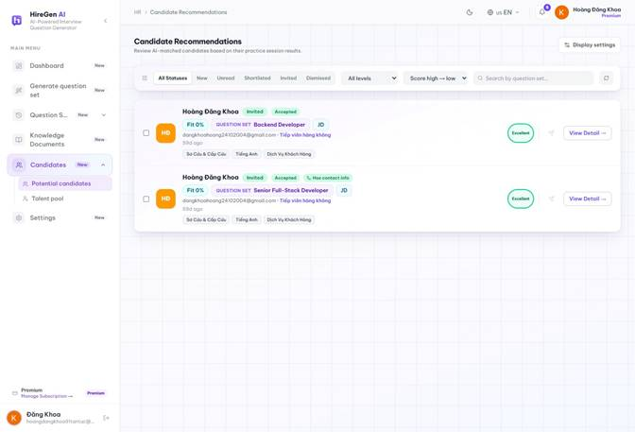
Figure 3.2.22. Candidate recommendation empty state.
Figure 3.2.23. Talent list with practice evidence.
Figure 3.2.24. Candidate practice profile.
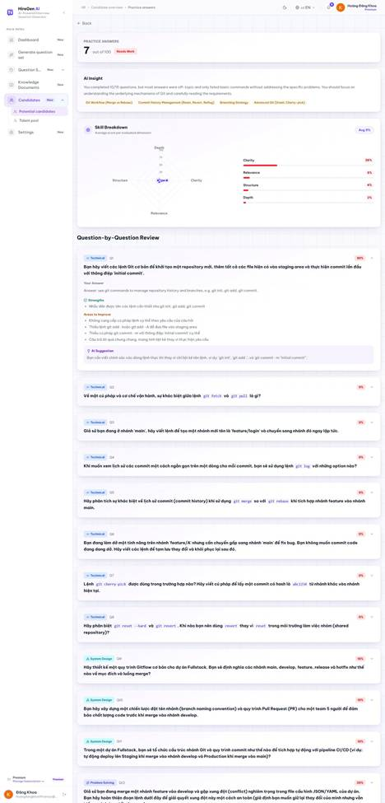
Figure 3.2.25. Candidate session review for HR.
3.2.2.11 HR Settings and Subscription
Route: /hr/settings. The HR settings view provides account profile, preferences, security and billing tabs. Password change is a separate protected action; the documentation capture records the form only.
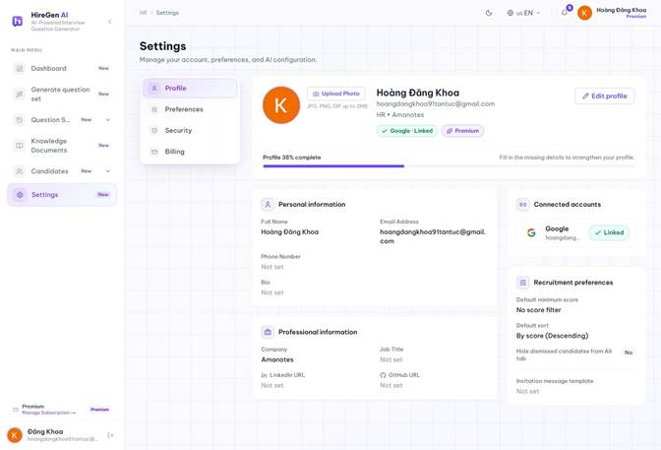
Figure 3.2.26. HR profile settings.
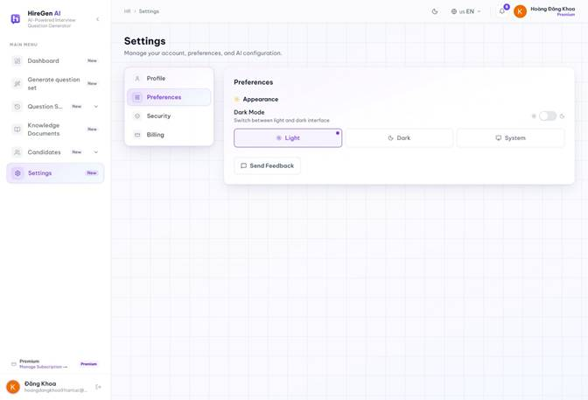
Figure 3.2.27. HR preferences.
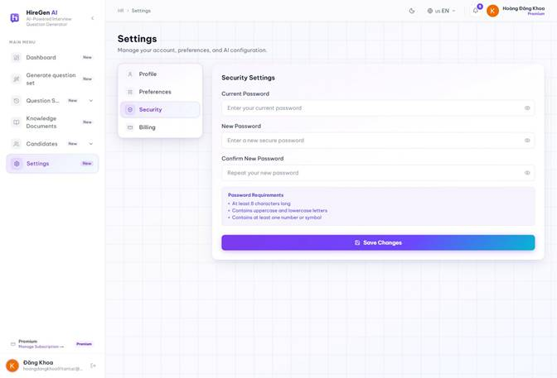
Figure 3.2.28. HR security settings.
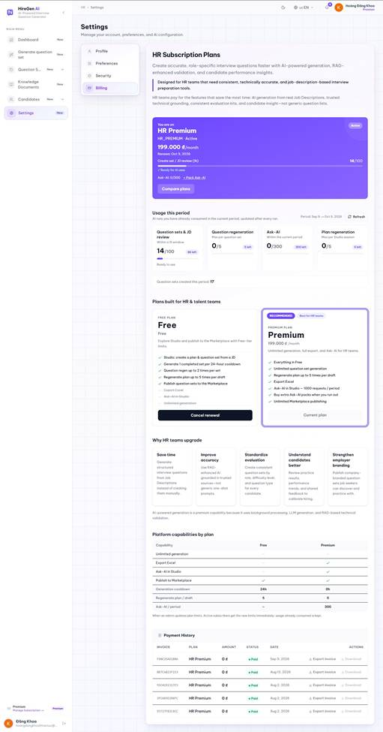
Figure 3.2.29. HR Premium subscription.

3.2.3 Candidate Workspace
3.2.3.1 Dashboard and Marketplace
Route: /candidate/dashboard; /candidate/practice. The dashboard summarizes practice and progress. The marketplace lists published sets with search and filters; it is the entry point for practice.
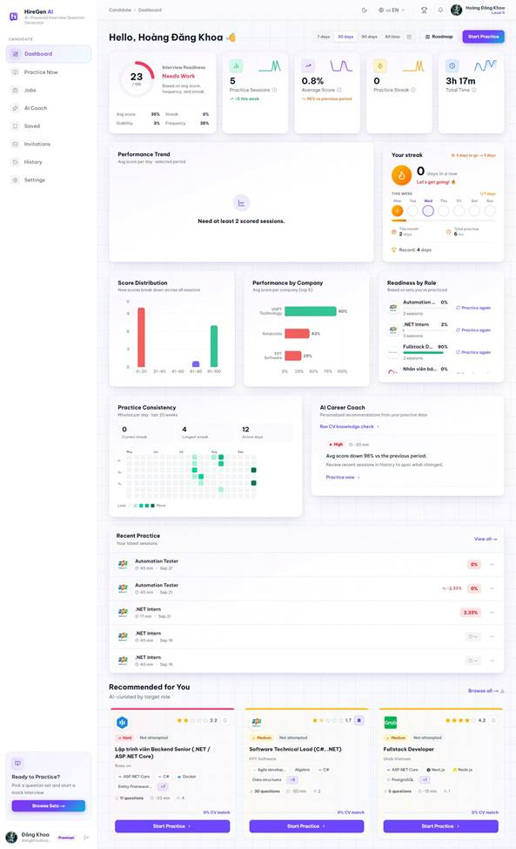
Figure 3.2.30. Candidate dashboard.
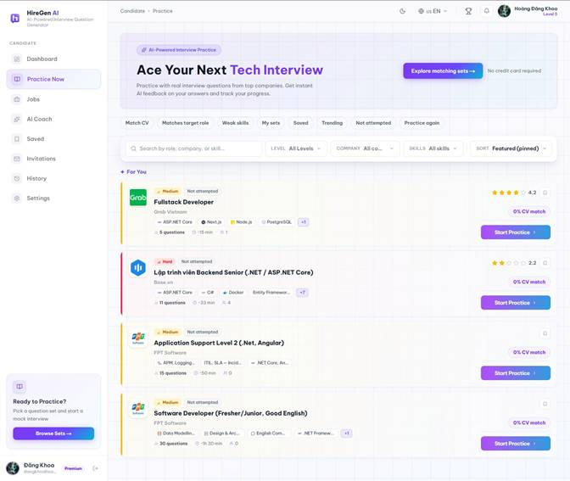
Figure 3.2.31. Question-set marketplace.
3.2.3.2 Question-Set Detail
Route: /candidate/sets/[id]. The detail page shows company, difficulty, question mix, skills, estimated duration and practice action before an attempt begins.
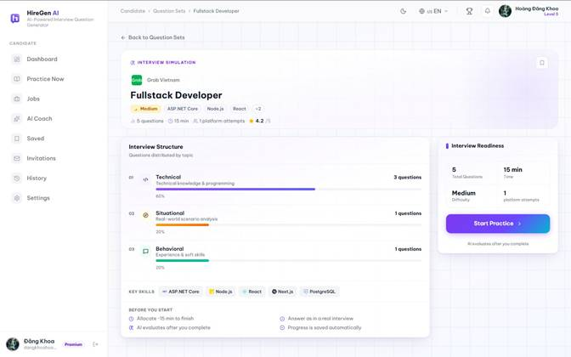
Figure 3.2.32. Published question-set detail.
3.2.3.3 Timed Practice and Submission
Route: /candidate/practice/[id]. A candidate answers text and code questions in a timed session. Answers save during the attempt; completion requires all available questions and a confirmation before AI scoring.
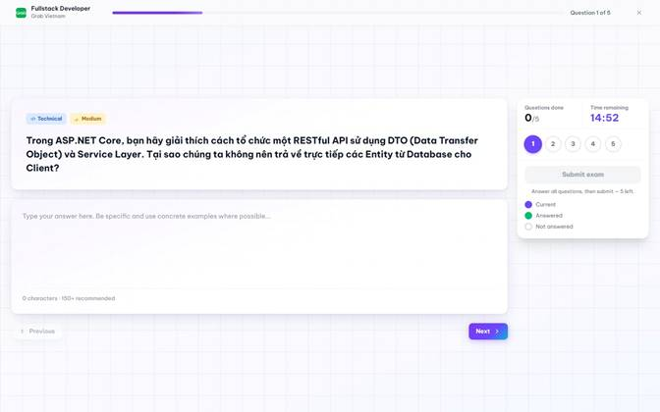
Figure 3.2.33. Text-answer question in an active session.
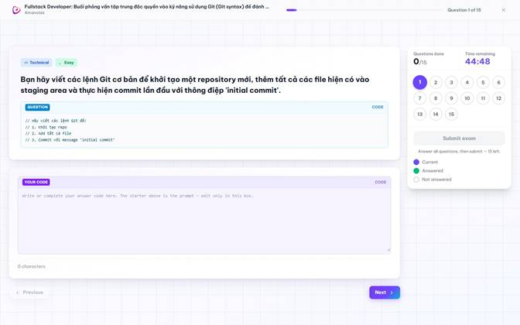
Figure 3.2.34. Code-answer question in an active session.
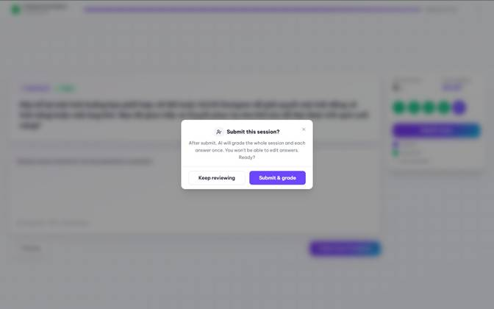
Figure 3.2.35. Submit-session confirmation.
3.2.3.4 AI Result and Practice History
Route: /candidate/practice/[id]/result; /candidate/history. The completed result shows overall score, AI insight, skill dimensions, improvement plan and per-question review. History lists completed and unfinished sessions with links back to results.
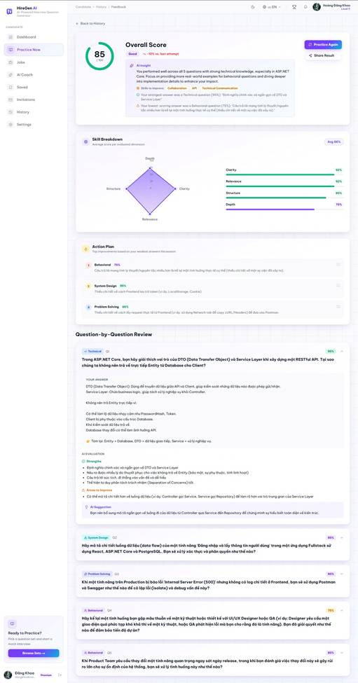
Figure 3.2.36. AI result for a completed live practice session.
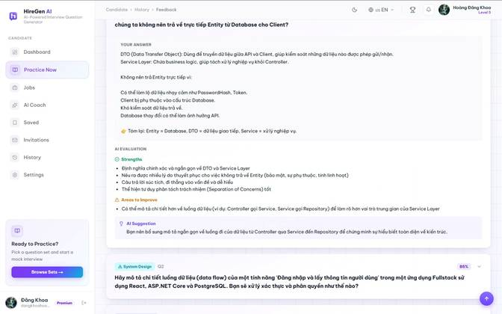
Figure 3.2.37. Per-question AI feedback and improvement advice.
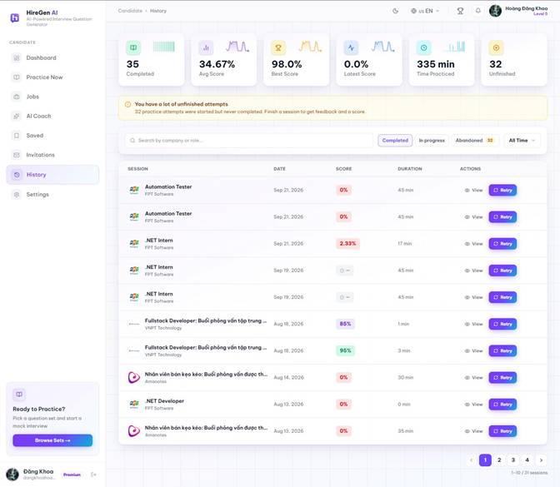
Figure 3.2.38. Practice history with two completed sessions.
3.2.3.5 Recruitment Listings and Detail
Route: /candidate/jobs; /candidate/jobs/[id]. The recruitment view lists live openings and shows a selected role beside the list. The full detail page shows the JD, skills, company information and assessment entry.
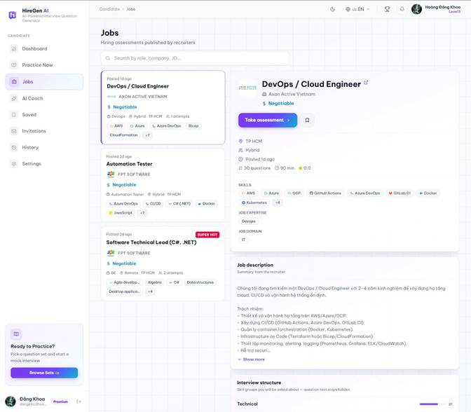
Figure 3.2.39. Recruitment list with selected role.
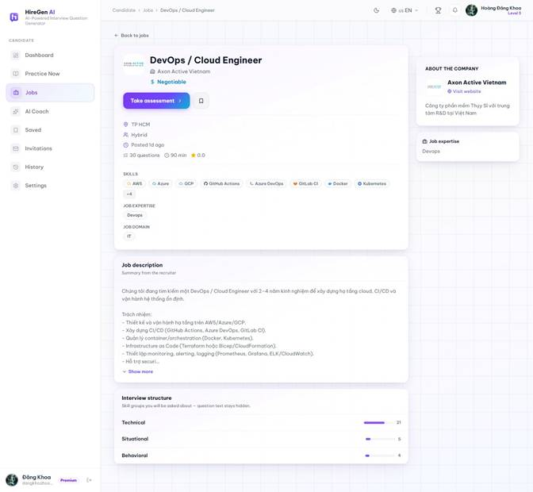
Figure 3.2.40. Full role detail.
3.2.3.6 AI Coach: Skill Profile and Diagnostic
Route: /candidate/coach; /candidate/practice/[id]?mode=coach. AI Coach builds a skill profile from CV or entered technologies, confirms the role and level target, then generates a framework-based diagnostic set. The captured test account used C#, SQL and .NET skills; the UI noted that the diagnostic inferred questions from blueprint/CV because the account's test-candidate system folder had no knowledge documents. The diagnostic has 15 timed questions and does not award XP. The legacy /candidate/roadmap route redirects to Coach.
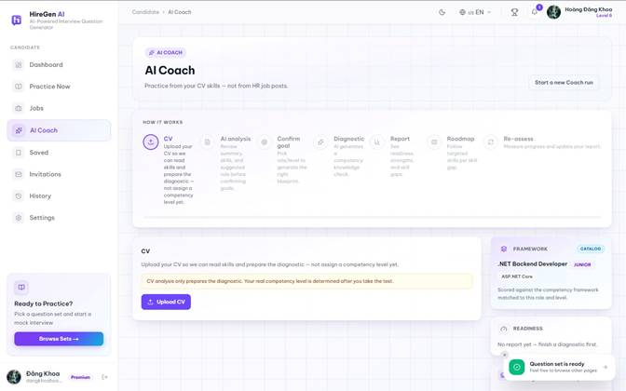
Figure 3.2.41. AI Coach CV entry.
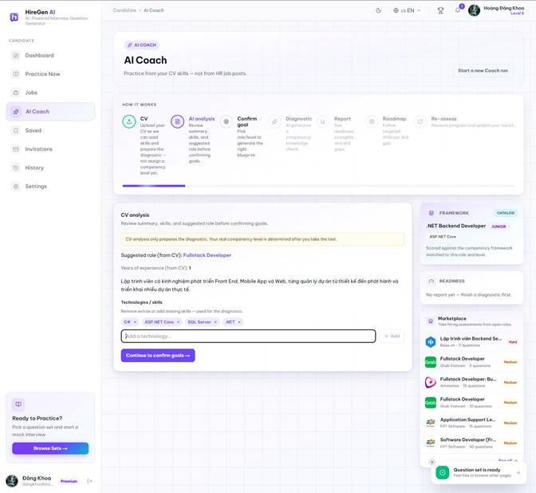
Figure 3.2.42. Analyzed skill profile.
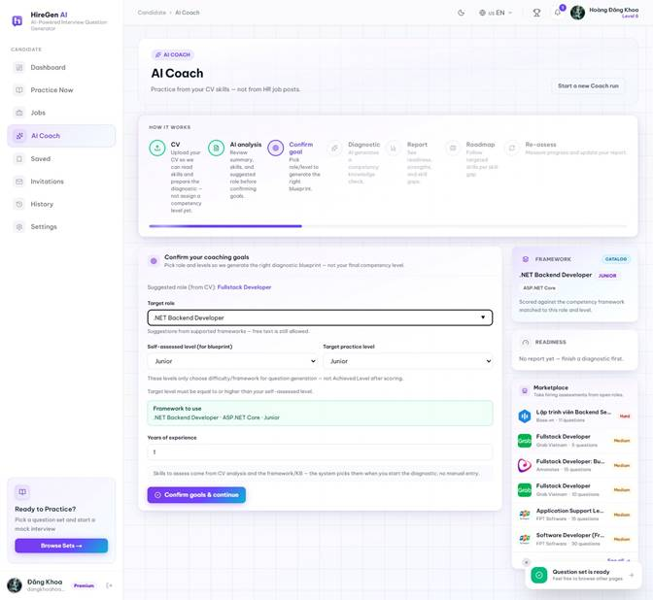
Figure 3.2.43. Role and level confirmation.
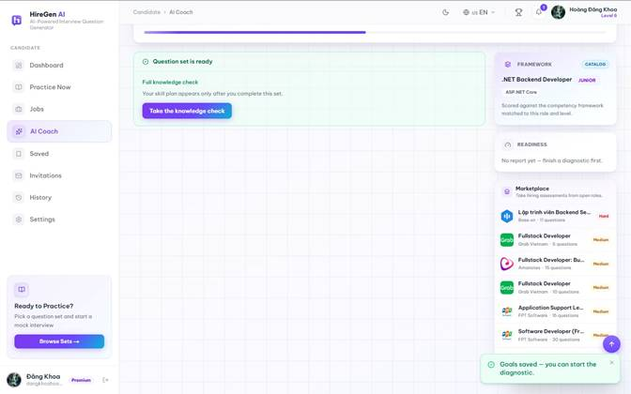
Figure 3.2.44. Diagnostic question generation.
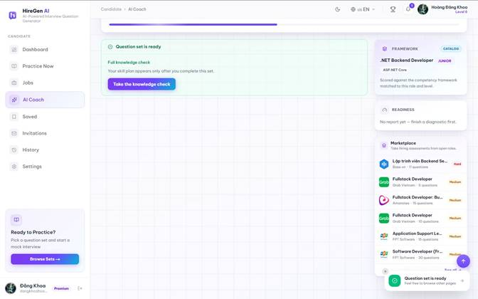
Figure 3.2.45. Framework diagnostic ready.
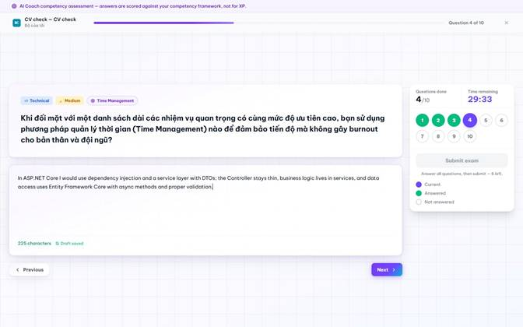
Figure 3.2.46. Coach diagnostic in progress.
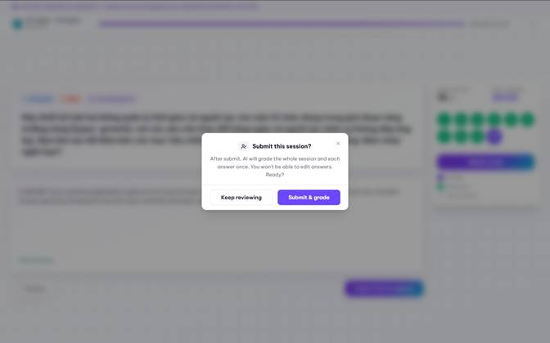
Figure 3.2.47. Diagnostic submission confirmation.
3.2.3.7 AI Coach: Result and Roadmap
Route: /candidate/practice/[id]/result?mode=coach; /candidate/coach?step=6; /candidate/coach/roadmaps/[id]. The completed 15-question diagnostic produced an AI-scored result with per-question feedback. Coach subsequently calculated readiness and suggested a 5-skill, 20-topic roadmap for the selected .NET Backend Developer Junior target. The test account accepted the roadmap, revealing ordered topic drills and a reassessment gate. The application warned that roadmap topics were inferred from the framework because no matching system knowledge was retrieved. Once a roadmap exists, the current frontend locks earlier Coach steps, including its report tab; readiness remains visible in the Coach context panel and the scored diagnostic result remains accessible from practice history.
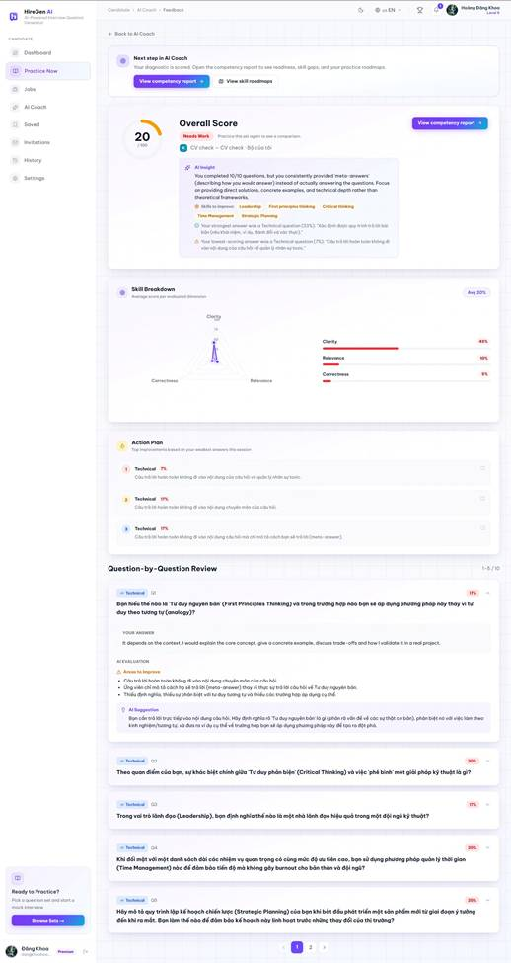
Figure 3.2.48. AI Coach diagnostic score and feedback.
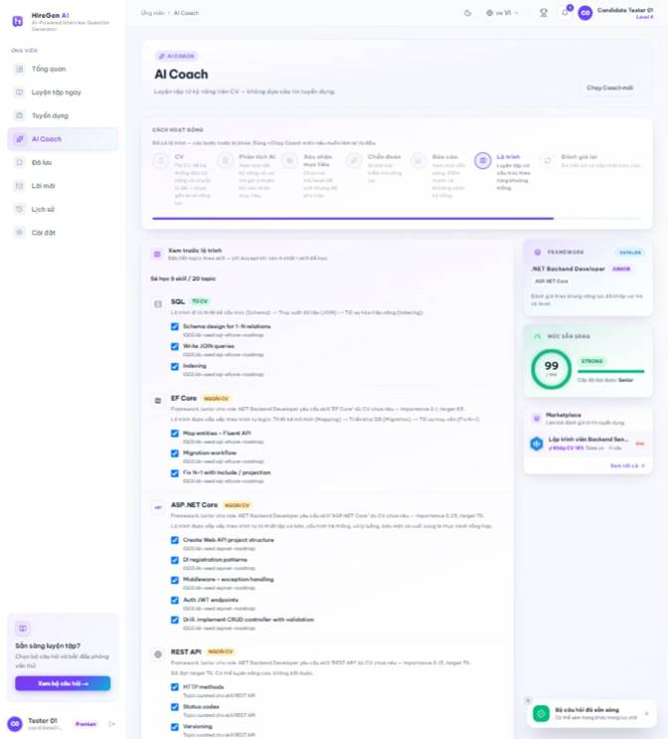
Figure 3.2.49. Suggested skill roadmap before acceptance.
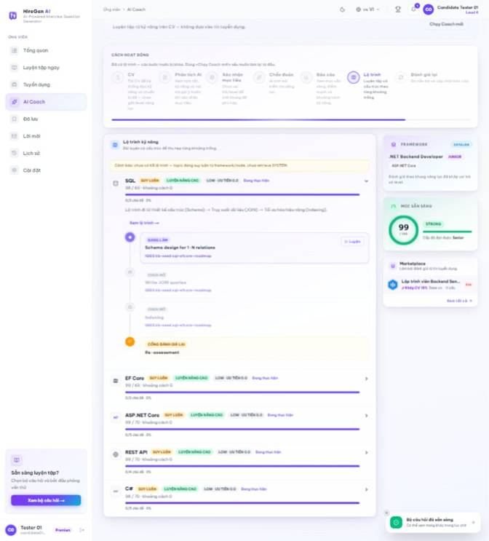
Figure 3.2.50. Accepted skill roadmap and topic progress.
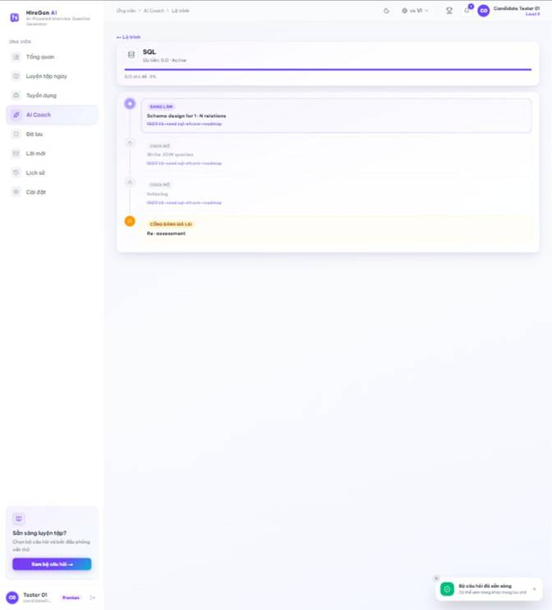
Figure 3.2.51. Skill roadmap detail and reassessment gate.
3.2.3.8 Saved Sets and Invitations
Route: /candidate/saved; /candidate/invitations. Candidates bookmark published sets for later practice and review interview invitations. The saved-set view was captured after saving a live set; this account has no current invitations.
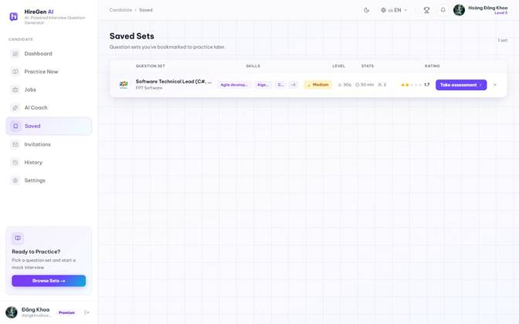
Figure 3.2.52. Saved question set.
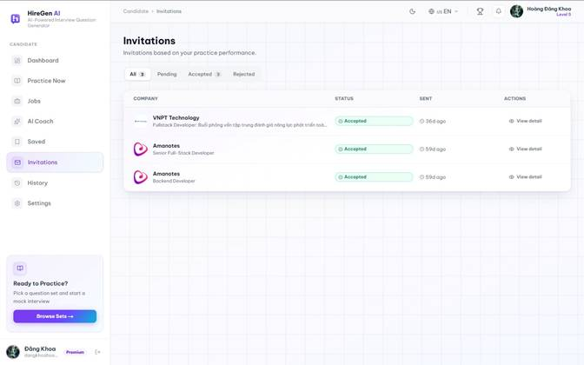
Figure 3.2.53. Invitation empty state.
3.2.3.9 Leaderboard and Profile
Route: /candidate/leaderboard; /candidate/profile. The leaderboard ranks candidate XP and streaks. Profile displays practice statistics, XP progress, achievements and editable personal details.
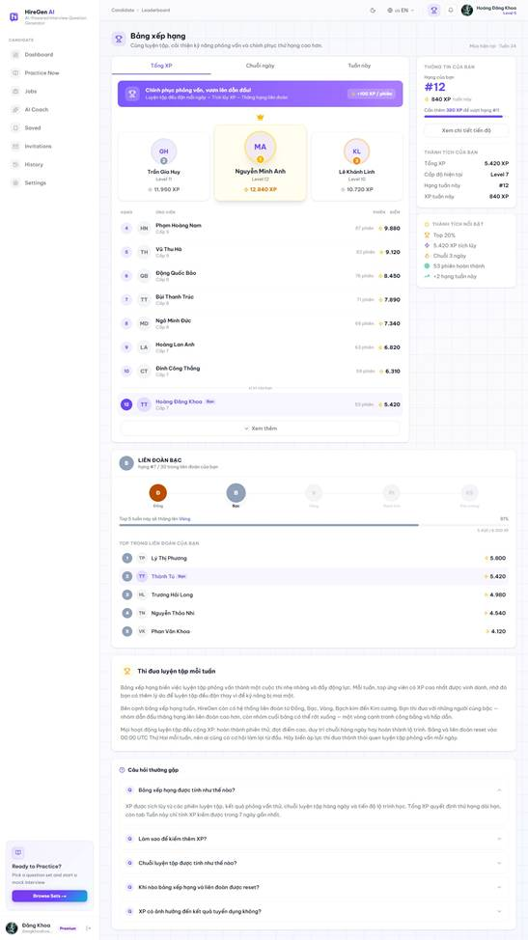
Figure 3.2.54. Candidate leaderboard.
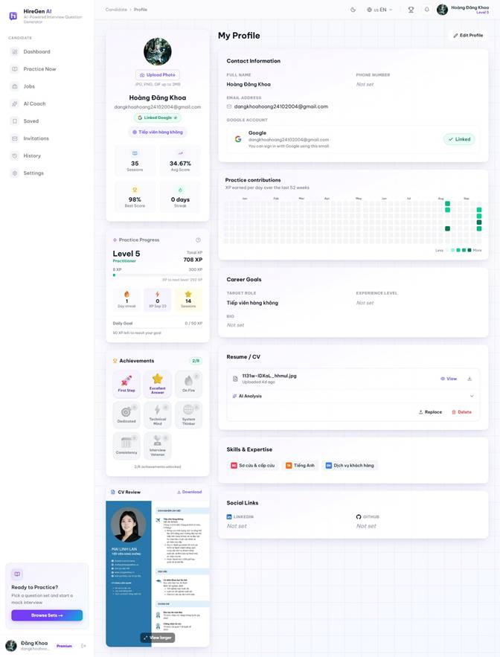
Figure 3.2.55. Candidate profile and progress.
3.2.3.10 Candidate Settings
Route: /candidate/settings. Settings include profile, general preferences, password security, recruiter recommendation consent, XP history and subscription billing. The captured account has Candidate Premium; no payment or cancellation was made.
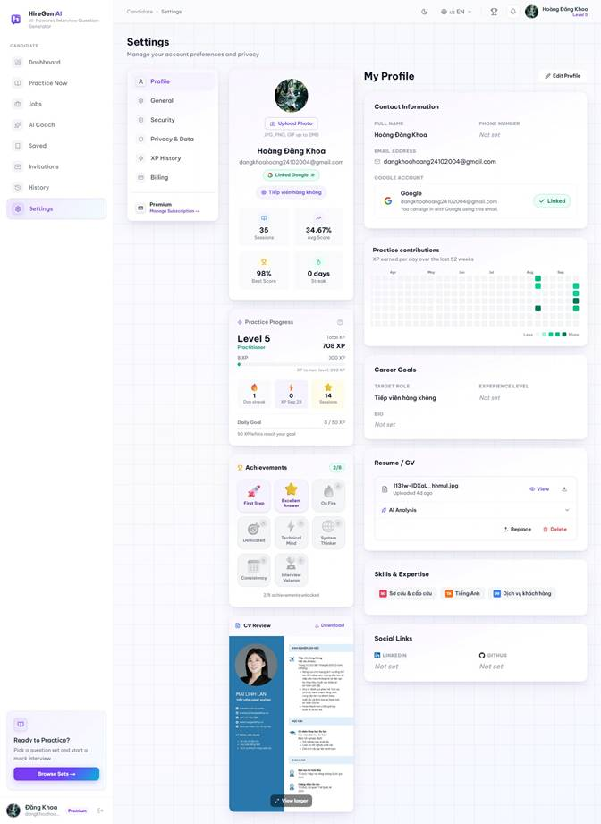
Figure 3.2.56. Profile tab.
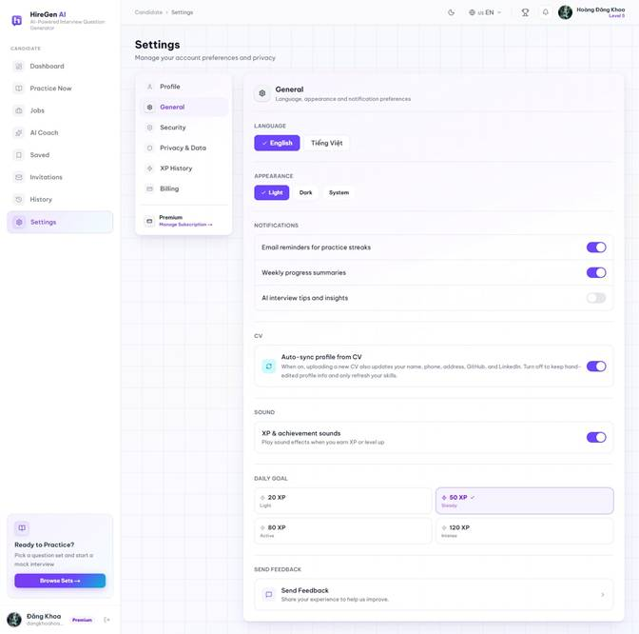
Figure 3.2.57. General preferences.
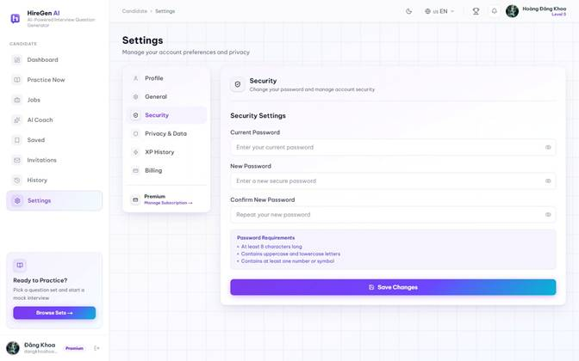
Figure 3.2.58. Security tab.
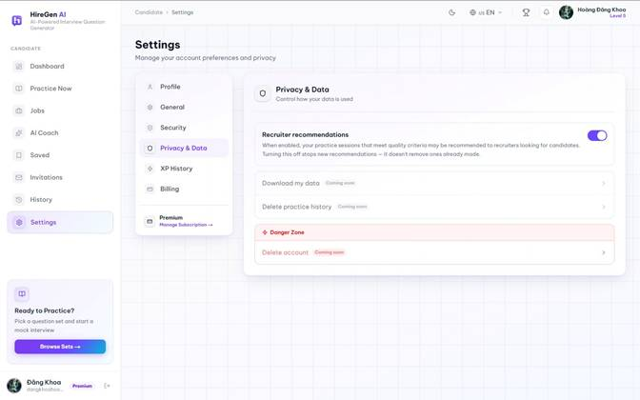
Figure 3.2.59. Privacy and recruiter-consent tab.
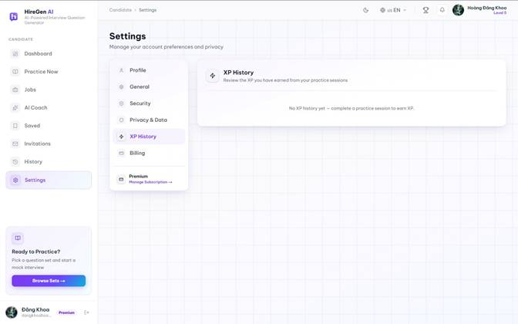
Figure 3.2.60. XP transaction history.
Figure 3.2.61. Candidate Premium billing view.

3.2.4 Administrator Workspace
3.2.4.1 Operations Dashboard and Analytics
Route: /admin/dashboard; /admin/analytics. The operations dashboard shows account and content summaries and current service status. The analytics page is present in the frontend; its displayed charts are static frontend data in the current code and should not be read as live metrics.
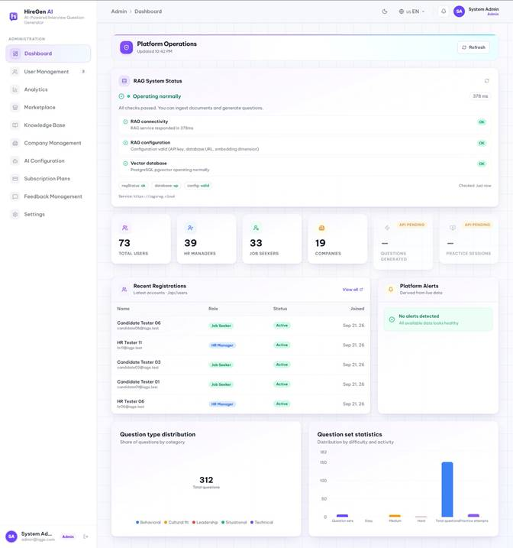
Figure 3.2.62. Admin operations dashboard.
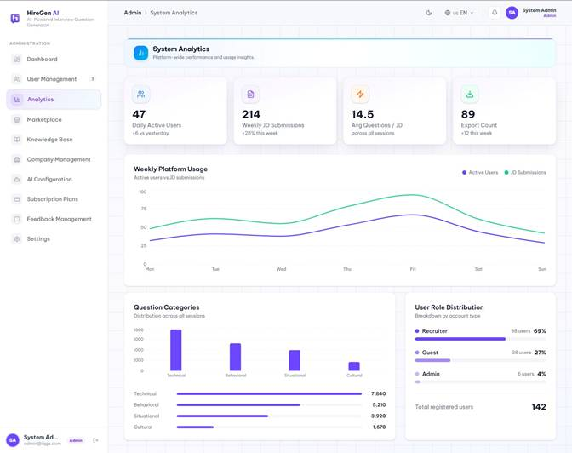
Figure 3.2.63. Admin analytics page.
3.2.4.2 User Management
Route: /admin/users. Administrators filter accounts, inspect a user and manage approval and subscription entitlements. HR01 and Candidate01 already had Premium when inspected.
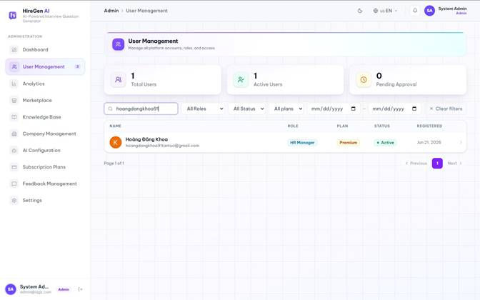
Figure 3.2.64. User-management list.
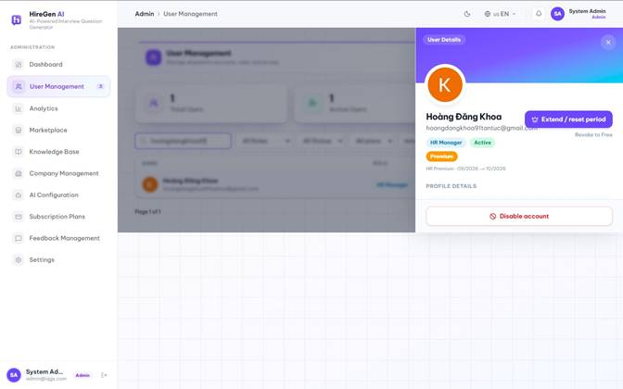
Figure 3.2.65. HR account detail and Premium entitlement.
3.2.4.3 Company Management
Route: /admin/companies. The company workspace lists organizations and provides create and edit forms. The captures show those forms without submitting a new company or changing an existing one.
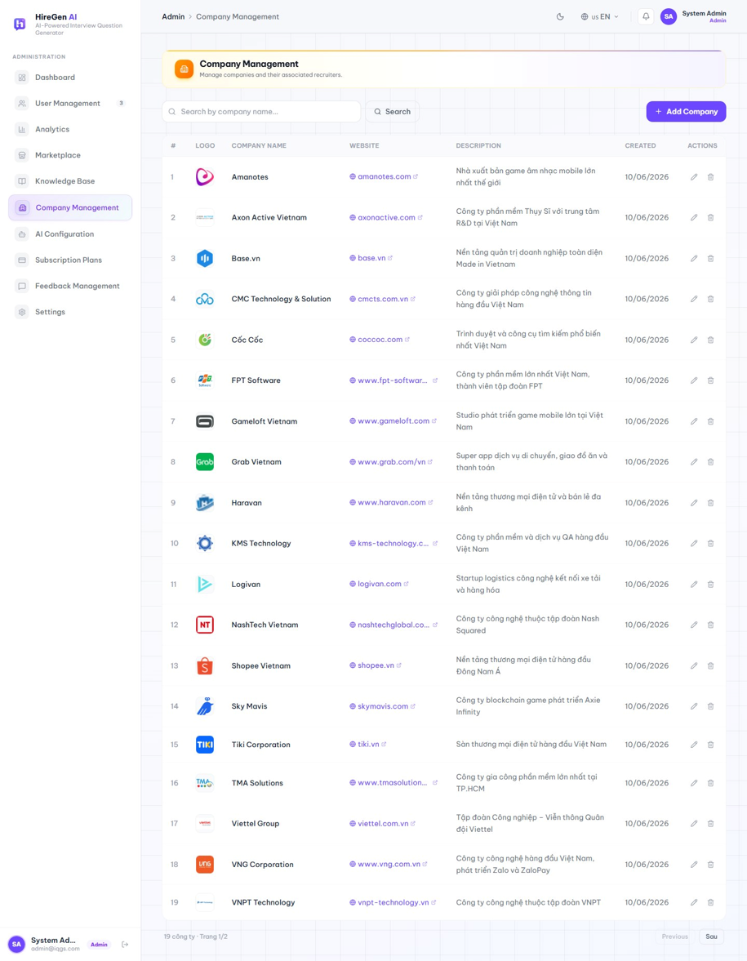
Figure 3.2.66. Company list.
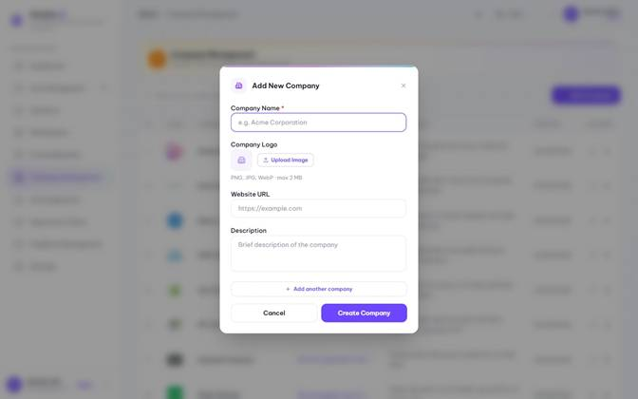
Figure 3.2.67. Create-company form.
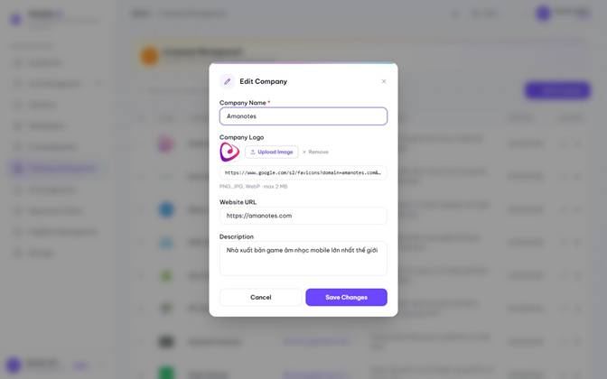
Figure 3.2.68. Edit-company form.
3.2.4.4 System Knowledge Library
Route: /admin/knowledge. Admin manages system-wide knowledge documents, folders and RAG ingestion states. File detail exposes chunks and metadata; the move dialog changes folder placement only when confirmed.
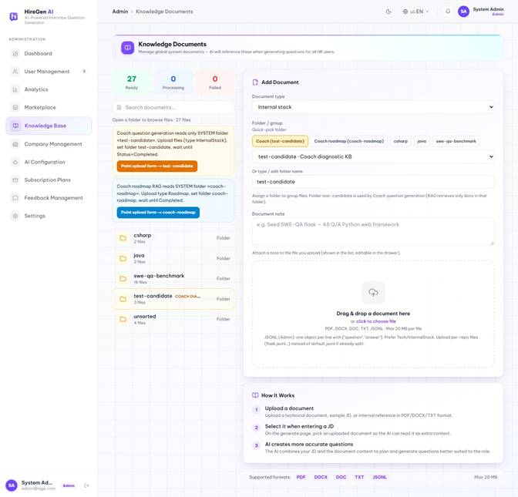
Figure 3.2.69. System knowledge library.
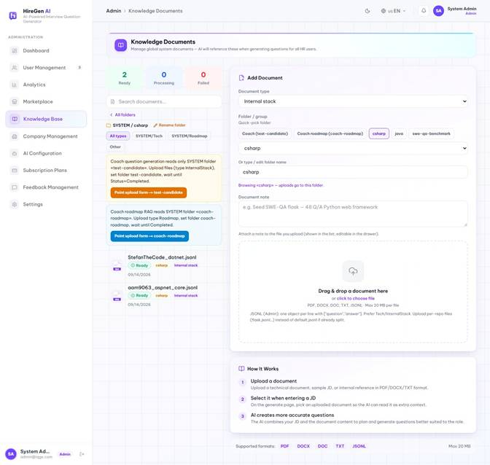
Figure 3.2.70. Folder view.
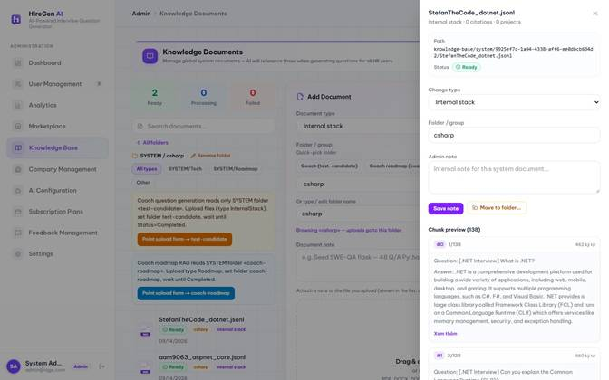
Figure 3.2.71. Knowledge document and chunks.
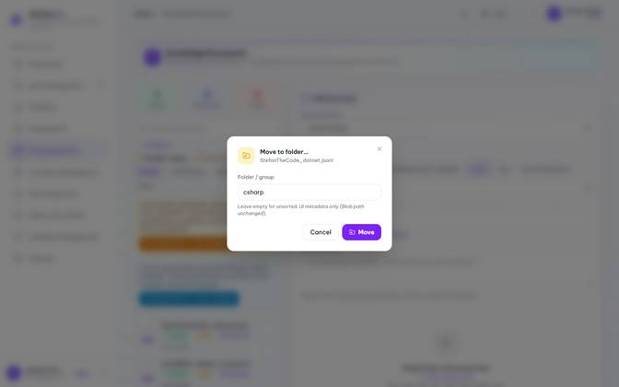
Figure 3.2.72. Move-document dialog.
3.2.4.5 Marketplace Management
Route: /admin/marketplace. Administrators inspect published question sets and their marketplace visibility. The detail view provides moderation and listing controls.
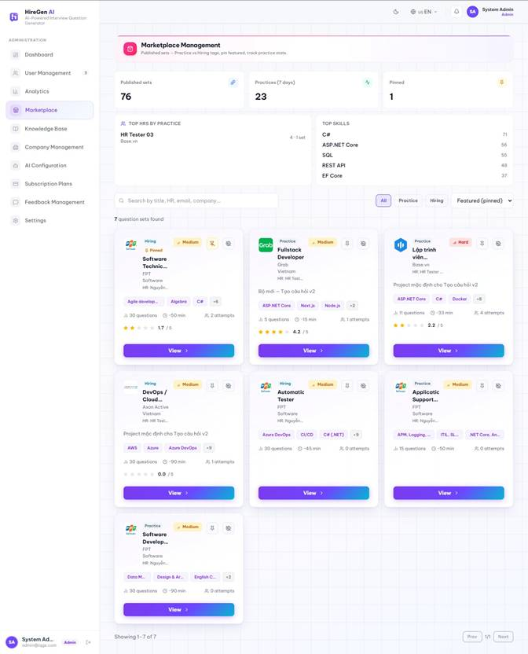
Figure 3.2.73. Marketplace management list.
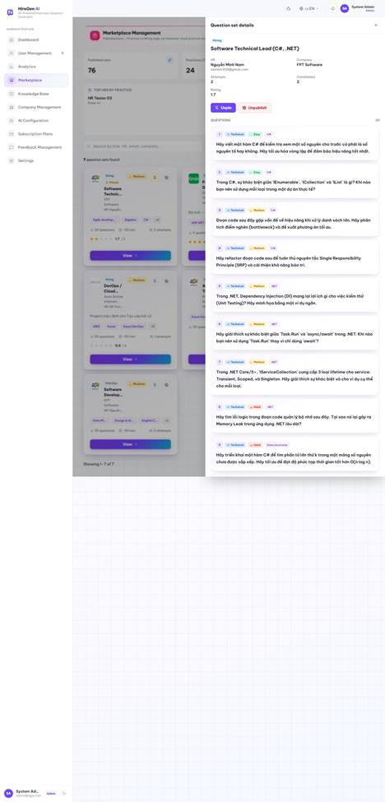
Figure 3.2.74. Marketplace set detail.
3.2.4.6 AI and RAG Status
Route: /admin/ai-config. The current AI configuration page displays live RAG status and configuration information. It is a status view in this frontend, rather than an editable model-parameter form.
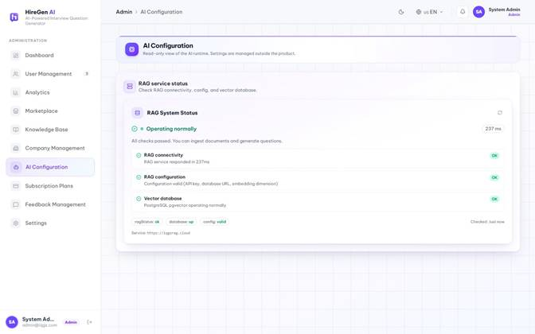
Figure 3.2.75. AI and RAG status.
3.2.4.7 Subscription Plans and Feedback
Route: /admin/plans; /admin/feedbacks. The plan page lists HR and Candidate subscriptions and payment statistics. Feedback management lists submitted feedback and exposes an edit form.
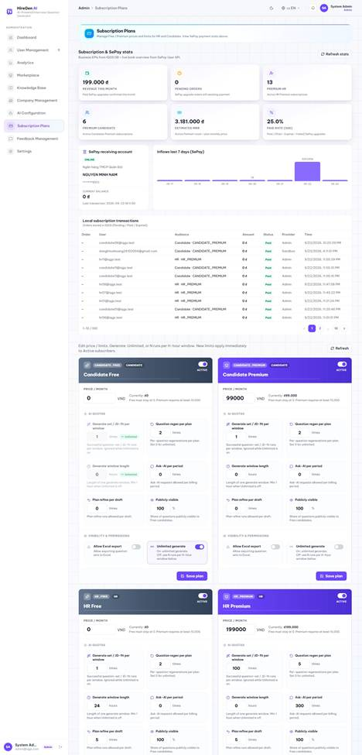
Figure 3.2.76. Subscription plan management.
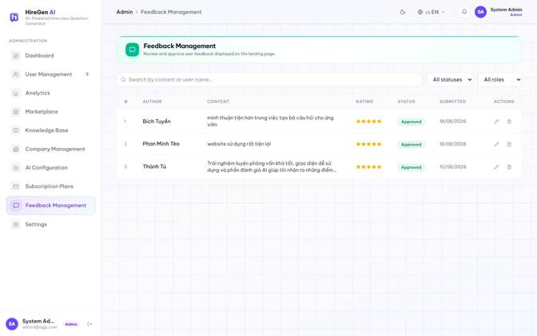
Figure 3.2.77. Feedback list.
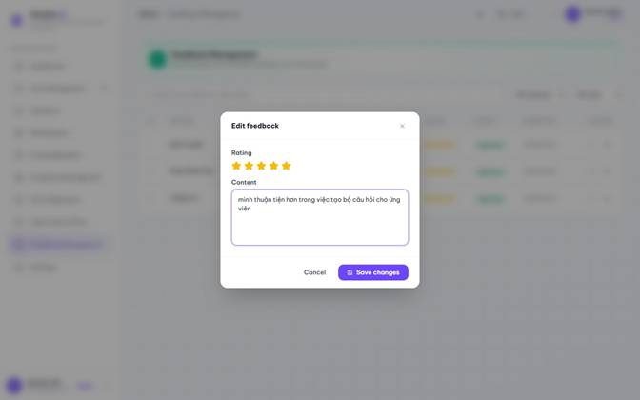
Figure 3.2.78. Feedback edit form.
3.2.4.8 Platform Settings
Route: /admin/settings. General platform settings are read from the API. The permissions and notification tabs are present in the UI, but their save controls are disabled in the current implementation.
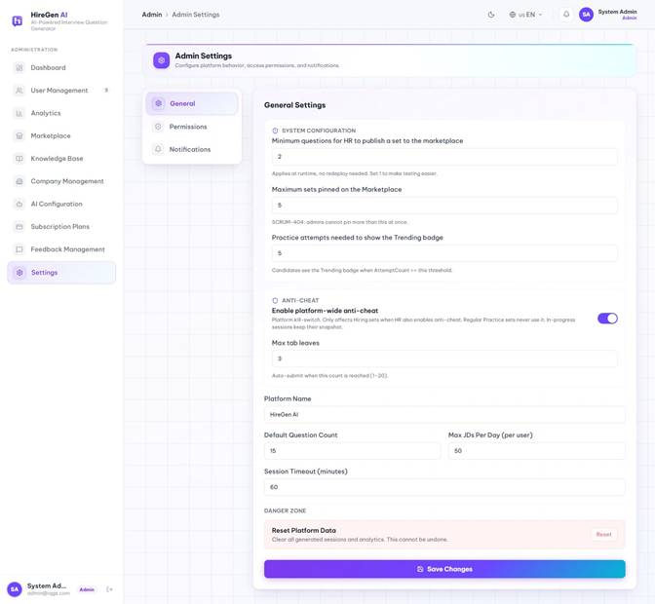
Figure 3.2.79. General platform settings.
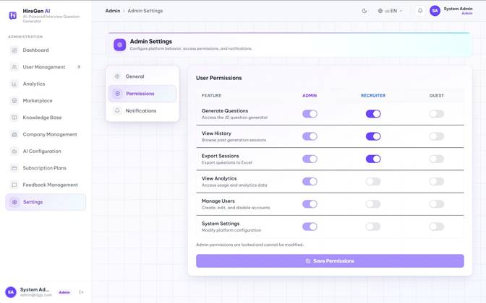
Figure 3.2.80. Permissions tab.
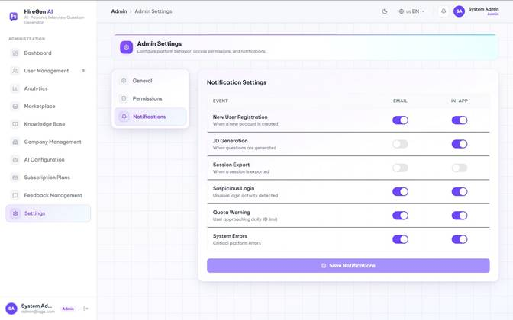
Figure 3.2.81. Notification tab.
Conditional screens: HR01 has no owned knowledge files or published sets, so published-set practitioner detail and recommendation comparison require other eligible records. Admin /admin/audit and /admin/content redirect to the dashboard in the current frontend.

4. Non-Functional Requirements

4.1 External Interfaces
User Interface :
● HR/Admin: role-specific workspaces with navigation, forms, tables and background-job status. Some dashboard, analytics and audit widgets remain frontend placeholders and are identified as such.
● Candidate: responsive marketplace and set detail, timed practice and feedback, saved sets, history, CV and privacy settings, jobs and AI Coach. Subscription gates determine feedback and other premium actions.
Email Service Interface
The backend sends transactional mail for verification, password recovery, invitations and offers through configured SMTP. Delivery failures are logged; successful delivery depends on the deployed provider configuration.
Payment Service Interface
SePay upgrades use an expiring order and an asynchronous webhook. The backend validates the callback and processes payment idempotently; a recurring job expires unpaid orders after their configured deadline. The frontend can observe confirmed payment through SignalR.
LLM Service Interface
The private FastAPI RAG service performs JD and CV parsing, retrieval, plan and question generation, answer evaluation and Coach support. Chat uses a configurable OpenAI-compatible endpoint (Ollama by default, or OpenRouter), while embeddings use Ollama's nomic-embed-text model at 768 dimensions by default. The default request timeout is 120 seconds; SYSTEM and selected HR retrieval each default to top 5. Administrators may change supported runtime settings.
Vector Database Interface
Knowledge chunks and embeddings are stored in PostgreSQL with pgvector. Retrieval uses cosine distance, owner and scope filters, optional document IDs and optional metadata filters. HR-scoped retrieval is skipped when no HR documents are selected.
File Storage Interface
Candidate CVs and HR knowledge files use Azure Blob Storage through backend storage services. The backend validates applicable file types and sizes and issues access URLs according to each workflow.

4.2 Quality Attributes
4.2.1 Usability
The candidate portal and the HR/Admin workspace follow a consistent, simple layout so users can complete core tasks without training.
4.2.2 Reliability
Hangfire handles asynchronous ingestion and generation. Recurring jobs expire practice sessions and unpaid upgrade orders and fail stuck knowledge ingestion. The registered legacy generation watchdog currently skips its check, so Studio run recovery must not be described as implemented. Payment callbacks are designed to be idempotent.
The interface uses labeled forms, role-specific navigation and confirmation for sensitive actions. No formal usability study or named accessibility-conformance audit is claimed by this report.
4.2.3 Performance
Interactive API requests return a job or status rather than waiting for long-running generation or ingestion. The FE polls job status where applicable. Exact latency, throughput and concurrent-user guarantees require measured deployment tests and are not asserted by this specification.
No measured response-time, availability or concurrent-user service-level target is established in the repository; performance and reliability statements above describe implementation mechanisms rather than benchmark results.

5. Requirement Appendix

5.1 Business Rules
ID | Rule Definition
1 | If user.IsActive = false, the system rejects login even if the password is correct.
2 | If consecutive failed password attempts reach the threshold, the account is temporarily locked.
3 | An account registered with email/password that has not verified its OTP cannot log in.
4 | A user linked only to Google cannot log in with a local email/password.
5 | Registration only accepts HR or Candidate roles. Admin must be granted within the system.
6 | HR must provide a CompanyId or CompanyName. After registration, the system assigns a Free subscription based on the account type.
7 | Each protected portal uses a frontend role guard and each protected API endpoint enforces authorization. Current route prefixes are /candidate, /hr and /admin.
8 | When a subscription is Active, the quota/feature gate reads the frozen snapshot, not the live Plan.
9 | An HR Free-plan user can only create a new set after the cooldown since LastSuccessfulGenerateAt has elapsed.
10 | Each draft/progress can regenerate the plan a maximum of N times (for both Free and Premium).
11 | HR Free has AskAiPerMonth=0. Premium uses AskAiPerMonth + ExtraFromPack; once the quota is exhausted, the system returns 403.
12 | Only plans with CanExport=true (HR Premium) can export question sets.
13 | Free: CanDetailedAiFeedback=false, only grades/shows FreeTeaserFeedbackCount questions; Premium gets full feedback plus insights.
14 | When the period expires, the system downgrades the user to the Free plan and resets usage for a new 1-month period.
15 | Cancellation does not take effect immediately; CancelAtPeriodEnd is set, and the user remains Premium until the end of the period.
16 | The webhook/confirm process only marks a transaction as Paid when the signature, amount, and currency match; a Paid transaction is not processed again.
17 | Publishing requires at least PlatformSettings.MinQuestionsToPublish questions. The current publish service does not enforce CanPublish, so that entitlement is not stated as an active publishing restriction.
18 | The legacy FeedbackOnlyOnVisible / CheckFeedbackAsync is currently a no-op; the teaser is only applied when the session completes.
19 | Purchasing additional Ask-AI quota must go through a real payment gateway. Currently, it is a sandbox (HR controller).
20 | JD text must meet: min/max character and word counts, printable ratio, no duplicate/trivial bullets, and at least 2 of 4 signal groups (role, requirements, responsibilities, level).
21 | When creating/refining settings, the number of questions and minutes must be within the allowed range; adding more questions is blocked once the maximum is reached.
22 | There must be an Approved plan with settings applied; a new run cannot be created while a run is already in progress.
23 | Chat messages that deviate from the interview topic are rejected (PLAN_CHAT_OFF_TOPIC).
24 | The Studio JD upload endpoint has a 20 MB request limit. Supported extensions and limits vary by workflow (JD, knowledge document, CV or image); one global whitelist must not be assumed.
25 | A share token must grant view/edit permission according to the shared role, not just to the owner. Currently, EnsureProjectAccessAsync only checks the owner.
26 | RAG retrieves SYSTEM context and only the explicitly selected HR document IDs. If no HR documents are selected, HR-scoped retrieval is skipped.
27 | Publishing is only allowed when the number of questions >= PlatformSettings.MinQuestionsToPublish (configurable at runtime by Admin).
28 | A PUBLISHED set is locked for editing. HR must unpublish it back to DRAFT before making changes.
29 | A set must retain at least 1 question. Reordering must be complete and have unique order values.
30 | The time limit can only be edited while in DRAFT status, and must be within the allowed minute range.
31 | Do not overwrite a set if it is PUBLISHED or already has candidate answers.
32 | When HR unpublishes a set, related practice sessions cannot continue (SCRUM-408).
33 | The backend allows a practice session only for an eligible published question set and enforces ownership and session state; the FE also checks the visible set state.
34 | The UI should use the platform's current minimum-publish threshold; a hardcoded value of 10 can drift from the backend setting.
35 | SYSTEM scope: OwnerId is null (Admin). HR scope: OwnerId is required. RAG ingest rejects an incorrect scope.
36 | Upload -> QUEUED -> asynchronous RAG ingest via Hangfire -> callback COMPLETED/FAILED. If PROCESSING exceeds 90 minutes -> FAILED.
37 | RAG embeds the JD and optional focus text, searches pgvector by cosine distance, scope and owner, and applies separate top-k limits for SYSTEM and selected HR documents. The SQL does not apply a minimum similarity score.
38 | All /internal/rag/* endpoints and /internal/* callbacks on the BE require the X-Internal-Api-Key header. /health does not require the key.
39 | RAG parses PDF/DOCX/images; skill deduplication is case-insensitive; on AI error -> 502, BE keeps the existing TechStack.
40 | A minimum cosine-similarity threshold is a future quality improvement. Current retrieval is ranked by distance and top-k without a score cutoff.
41 | A soft cap on the number of KB files per company/HR is needed to prevent unlimited ingestion.
42 | The registered V1 generation watchdog currently skips execution. Studio QuestionGenerationRun recovery needs a separate implemented watchdog before it can be claimed as automatic.
43 | Uploading a new CV replaces the old one; RAG parsing updates TechStack; profile auto-sync excludes fields the user has manually edited.
44 | On start: resume a still-valid session or create a new one. When TimeLimitMinutes expires, AutoSubmit occurs. Only 1 IN_PROGRESS session per set is allowed.
45 | AllowRecruiterRecommendation defaults to true. If consent is turned off, HR recommendations are not pushed (together with CanPersistHrRecommendation).
46 | The backend validates CV size and extension. Some FE subscription figures and feedback previews are hardcoded or derived differently from the backend entitlement model; the backend is authoritative.
47 | A recommendation is created when the score >= 70, the session is COMPLETED, Premium persistence is enabled, consent is ON, and the set is published. A retake only updates the record if the new score is higher. An Invited recommendation cannot be shortlisted/dismissed; a Dismissed one must be shortlisted before inviting; each recommendation can be invited only once.
48 | The offer token defaults to a 7-day expiry; no further email is sent if the offer is Sent and still valid, or already Accepted. The public GET endpoint only shows a preview; only POST accepts the offer (to prevent prefetch bots from accepting it).
49 | Admin can only pin PUBLISHED sets, up to MaxPinnedSets. The Trending badge is shown when AttemptCount >= MinAttemptsForTrending.
50 | XP is awarded per question/set/score/streak; the daily goal must be one of the allowed values; achievements unlock by code.
51 | Admin analytics and audit screens include frontend placeholder data. They must not be represented as fully backed by persisted analytics or audit events.
52 | A monthly Candidate Free practice-session limit is a future proposal, not an enforced rule in the current backend.

5.2 Common Requirements
ID | Category | Requirement
1 | Pagination | List endpoints use the pagination contract of each controller; a single global default of 20 and maximum of 100 is not enforced across every endpoint.
2 | Date / Time | Backend timestamps are handled as UTC where modeled; the FE formats local display values. Exact response serialization and local display rules are defined per endpoint and UI component rather than by one global ICT-only rule.
3 | Soft Delete | Deletion behavior is entity-specific. Some records use inactive/status transitions and others use explicit delete operations; no blanket soft-delete guarantee applies to every entity.
4 | Audit Logging | There is no dedicated audit-log table today; user actions are only captured through standard application logging (ILogger), not a queryable audit trail. Adding a structured audit log (actor, action, target entity, timestamp) is a gap to close.
5 | Error Response Format | Error responses are not yet standardized: the global exception handler currently returns three different JSON shapes depending on the exception type { code, error } for most exceptions, RFC 7807 ProblemDetails for Studio/subscription errors, and a structured { code, error, detail, stage, source, errors } for Studio pipeline errors. None of them include a timestamp or path field.
6 | Language Support | Per LI-03 (Report 1), the system supports Vietnamese and English for JD input, question generation, and AI evaluation. JDs submitted in Vietnamese must be processed correctly through the RAG pipeline.
7 | File Upload Validation | File validation is workflow-specific. Backend upload paths validate supported extensions and size; MIME checks and accepted formats differ among JD, knowledge and CV endpoints.
8 | Data Export Format | Question sets exported by HR Managers are available as an Excel (.xlsx) file, including order, question text, type, difficulty, skill, focus area, rationale, sample answer, evaluation criteria, and citations.
9 | API Versioning | The API does not currently use path-based versioning; all endpoints are unversioned under /api/... (e.g. /api/auth, /api/admin/...). Introducing /api/v1/ versioning is a future consideration, not the current implementation.
10 | Subscription Quota Reset | There is no scheduled reset job. Each subscription's billing period instead rolls forward lazily: the next time the subscription is accessed, if the current period has ended, the system resets usage and, for Premium, downgrades it to the Free plan for that audience.

5.3 System Messages List
The following message list contains proposed UX copy. The message codes are specification identifiers, not a claim that every literal code exists in the FE or BE.
# | Message Code | Message Type | Context (Trigger Condition) | Content (Display Text)
I Authentication
1 | MSG_AUTH_01 | Toast Message | User successfully logs in with valid credentials. | "Login successful. Welcome back!"
2 | MSG_AUTH_02 | Inline (Red) | User submits incorrect email or password. | "Invalid email or password. Please try again."
3 | MSG_AUTH_03 | Toast Message | JWT signature expires during an active session. | "Session expired. Please log in again to continue."
4 | MSG_AUTH_04 | Toast Message | User successfully logs out of the platform. | "You have been successfully logged out."
II Validation
5 | MSG_VAL_01 | Inline (Red) | A required input field is left empty upon submission. | "This field is required and cannot be left blank."
6 | MSG_VAL_02 | Inline (Red) | Input string exceeds the database character limit. | "Input exceeds the maximum allowed length."
7 | MSG_VAL_03 | Inline (Red) | Password fails complexity policies (length/characters). | "Password must contain at least 8 characters, including a number and a special character."
III AI Generation
8 | MSG_GEN_01 | Toast Message | User triggers the AI question generation pipeline. | "AI generation started. Processing in the background..."
9 | MSG_GEN_02 | Toast Message | Hangfire async job completes successfully. | "Interview questions generated successfully!"
10 | MSG_GEN_03 | Toast Message | LLM API times out or fails to return a valid schema. | "AI generation failed or timed out. Please try again."
11 | MSG_GEN_04 | Toast Message | The user quota for AI generation has been depleted. | "AI generation quota exceeded. Please upgrade your plan."
IV Question Set Management
12 | MSG_SET_01 | Toast Message | User successfully saves a new question set. | "Question set saved successfully."
13 | MSG_SET_02 | Toast Message | User deletes an existing question set. | "Question set deleted successfully."
14 | MSG_SET_03 | Toast Message | Set visibility is toggled to 'Published' (Marketplace). | "Question set is now published to the Marketplace."
V Payment & Subscription
15 | MSG_PAY_01 | Toast Message | Financial gateway confirms successful transaction. | "Payment successful. Your subscription has been upgraded!"
16 | MSG_PAY_02 | Toast Message | Payment gateway rejects the transaction. | "Payment failed. Please check your billing information."
VI File Uploads
17 | MSG_FILE_01 | Inline (Red) | User uploads an unsupported file extension. | "Unsupported format. Please upload PDF, DOCX, or TXT."
18 | MSG_FILE_02 | Inline (Red) | Uploaded file size exceeds the system payload limit. | "File size exceeds the 10MB maximum limit."
19 | MSG_FILE_03 | Toast Message | Document chunking and vectorization succeeds (RAG). | "File processed and indexed successfully."
VII Practice Session (Candidate)
20 | MSG_PRAC_01 | Inline (Info) | Candidate starts the mock practice environment. | "Practice session started. The timer is now active."
21 | MSG_PRAC_02 | Toast Message | Candidate submits answers for AI evaluation. | "Answers submitted. Generating AI feedback..."
22 | MSG_PRAC_03 | Toast Message | AI feedback generation completes. | "Your AI evaluation report is ready to view!"
VIII Admin Actions
23 | MSG_ADM_01 | Toast Message | Admin successfully updates a user's role. | "User role updated successfully."
24 | MSG_ADM_02 | Toast Message | Admin bans or suspends a user account. | "User account has been suspended."
25 | MSG_ADM_03 | Toast Message | Admin removes a violating public question set. | "Content flagged and removed from the marketplace."
26 | MSG_ADM_04 | Toast Message | Admin successfully saves new system configurations. | "System configurations updated successfully."

